DSP Recommendations for I-39 Mega Project

- Reduce speed limit both northbound and southbound to 55 mph from the WI/IL state line to Highway 12/18 in Dane County. Immediate implementation

  - We realize that speed reduction alone will not eliminate crashes. However, we believe the reduction in speed will decrease the overall number of crashes as well as their severity. With the speed to 55 mph, the 85th percentile of motorists will fall within a speed range that allows for decreased stopping distance and increased reaction. These factors allow a greater opportunity for collision avoidance.

  - Post those speed limit signs more frequently along the work zones.

- Emergency pull off zones approximately every mile in the work zones.

  - Currently, there is an average of one emergency pull off zone for every two miles of work zone. The goal in 2017 put forth by DTSD was to have one pull off for every mile. We concur with that goal and would like to see it implemented. The goal would be to accomplish this within 60 days.

- Continue working to provide emergency access points along the counter-directional zones for emergency responders.

  - The current work zone configuration with narrow shoulders makes it nearly impossible for emergency responders to get through stopped traffic. Emergency access points strategically placed along the corridor will allow for quicker access to injured parties, quicker assessment of the scene and ultimately quicker clearance times. We had a few access points implemented in 2017 and would like this to continue.

- Additional speed trailers placed at identified high risk or high crash areas of the work zone. Immediate implementation.
  - Speed trailers provide motorists with feedback of their current driving speeds and how it relates to posted limits. This feedback differs from the barrage of posted signs motorists experience when traveling in a work zone of this magnitude and can better influence motorist behavior.
  - We recommend the trailers be placed strategically in high crash areas.

- Creative Signage

  - Orange “WORK ZONE” signs placed on top of the 55 mph speed limit signs.
    - It is designed to get a driver’s attention (See photo for example)

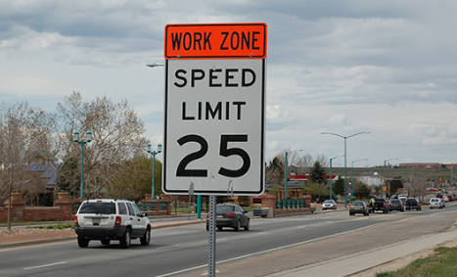

  - Signs advising CMVs to travel in the left lane
    - Moving CMVs to the left lane prevents them from passing each other as often, keeps the entrance and exit ramps more visible to motorists and hopefully reduces the speed disparity at those exchanges. Suggested timeline – as soon as the signs can be placed.

  - Use of DMS signage to indicate a work zone and reduced speed
    - Use portable message boards with creative messages indicating conditions are different and speeds reduced, the better the chances of reducing crashes. Messaging example could be: “1 MPH over limit = $200 FINE” or “Tailgating is for ball parks” Suggested timeline – as soon as message boards arrive.

  - More orange signs/lime green signs indicating motorists are in a work zone. This also includes signage to warn about distracted driving and following too closely.

- DSP resource allocation. Immediate implementation

  - Allocate and creatively schedule our mitigation resources to target visibility and/or enforcement efforts during the peak travel times and in the specific zones that are proving the most challenging.
    - We will attempt to add more resources to work zones, but they are limited. This would also require an increase in mitigation funds to cover the cost of increased resources.
    - Currently, we have 39 troopers per week assigned Sunday through Saturday to the I-39 project. We are adding 8 more four hour shifts per week for a total number of 47 troopers, an increase of 20%. Sergeants are allowed to work these shifts as well.
    - Bring in teams of troopers from other regions to focus on patrol for one week (5 – 8 hr. shifts) at a time. Pros: Add more resources to the project. Cons: incurred hotel costs.

    - Increase radius for overtime call outs
      - Currently we are at 60 mile radius for call outs.
      - Extend call outs to 75 miles which would have to include extra cost for travel time to ensure maximum amount of time in the work zones. Currently, travel is not included for personnel within 60 miles.

  - Utilize inspectors in work zones more efficiently
    - With the closing of the SWEFs, inspectors can be assigned during normal shifts to travel the work zones providing a level of visibility as well as conducting inspections on CMVs at the various exchanges and off ramps throughout the work zones.

- Aerial Enforcement. Immediate implementation.

  - Use aircraft to target erratic driving in the work zones during peak travel times and take enforcement action.

  - Strategically place “Aerial Enforcement Detail” signs at the entrances to the counter-directional work zones to deter speeding.

- Communicate with major motor carrier companies. Immediate implementation

  - DSP suggested this in 2017. Communications with companies will make them aware of the work zones, potential delays, narrow shoulders, the signage and afford them the opportunity to relay the information to their drivers who may choose a different route.

- Freeway Service Trucks (FSTs)

  - Trucks (like the one pictured) are used throughout Dane and Milwaukee Counties and may give law enforcement additional opportunities for scene response and clearing including:
    - The ability to manipulate barriers quickly, allowing emergency vehicles to enter the opposite lane for easier access to a scene. Current conditions dictate emergency vehicles traveling to an exit to turn around and negotiate through stopped traffic or to travel against normal traffic flow; this delays response times and increases the danger potential.
    - The ability to temporarily move disabled vehicles from traffic lanes allowing for traffic queues to clear.

    - Provide better visibility for approaching traffic encouraging safer travel.

  - The trucks could be operated by law enforcement during their assigned mitigation period and would serve a better suited purpose than the traditional cruisers. The two vehicles in service are extended cab, four-wheel drive pickup trucks with special equipment to assist motorists and provide scene security. The vehicles are equipped with a changeable message sign, appropriate fluids,
traffic cones and other equipment needed to assist disabled vehicles and warn approaching traffic.

  - The photo below is a Dane County FST truck that moved the barrier wall on a recent crash. This allowed Fire and EMS to access the six car crash for extrication of two subjects.

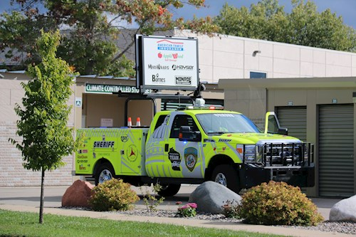

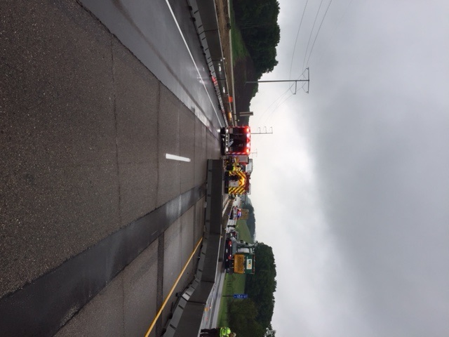

- Oversize Load Restrictions. Immediate implementation.

  - Oversize loads wider than 12 feet should be prohibited from traveling through the work zone. When crashes occur, even if one lane remains open, their width makes it impossible for the load to pass the incident scene or traffic to get around the load to continue. The backup then stays in place until the scene is completely clear.

  - ANY oversize loads should be restricted from traveling on a Friday, Saturday, Sunday or Monday of holiday weekends due to extraordinary traffic volume.

  - DSP, DTSD and DOT Permits can work together to provide clear and concise restrictions

