DSP Recommendations for I-39 Mega Project

DTSD has reviewed the information provided by DSP. A summary of responses is provided below in red.

- Reduce speed limit both northbound and southbound to 55 mph from the WI/IL state line to Highway 12/18 in Dane County. Immediate implementation

  - We realize that speed reduction alone will not eliminate crashes. However, we believe the reduction in speed will decrease the overall number of crashes as well as their severity. With the speed to 55 mph, the 85th percentile of motorists will fall within a speed range that allows for decreased stopping distance and increased reaction. We have speed plots and 85th percentile These factors allow a greater opportunity for collision avoidance.

  - Post those speed limit signs more frequently along the work zones.

- Emergency pull off zones approximately every mile in the work zones.

  - Currently, there is an average of one emergency pull off zone for every two miles of work zone. The goal in 2017 put forth by DTSD was to have one pull off for every mile. We concur with that goal and would like to see it implemented. The goal would be to accomplish this within 60 days.

There are a total of 39 emergency pullouts and safe refuge areas along the I-39/90 corridor. This includes the 21 access points that exist via interchanges, Safety Weight Enforcement Facilities (SWEF), and rest areas. In addition to these, there are also 18 emergency parking/pullout locations along the 45-mile corridor that have been constructed for the 2018 construction season. The exact spacing of these is based on proximity to interchanges, entrance/exit ramps, Safety Weight Enforcement Facility (SWEF), and other geographic considerations (e.g., steep slopes, wetlands, hillsides, streams, etc.) along the corridor. The following maps provide the locations of the emergency pull-out locations and spacing distances.

In addition, the design of emergency pullouts were greatly enhanced as part of the I-39/90 project. These additional enhancements include providing a paved surface, providing emergency access, and extending the pull-out distance from 150 to 450 feet in length. Standard detailed drawings depicting these conditions (original and improved) are included for review.

The concept of emergency pull off zones is included in the Strategies Matrix; see #9.

- Continue working to provide emergency access points along the counter-directional zones for emergency responders.

  - The current work zone configuration with narrow shoulders makes it nearly impossible for emergency responders to get through stopped traffic. Emergency access points strategically placed along the corridor will allow for quicker access to injured parties, quicker assessment of the scene and ultimately quicker clearance times. We had a few access points implemented in 2017 and would like this to continue.

There are numerous emergency access points throughout the I-39.90. This includes the 21 points of access using exit/entrance ramps within the corridor. In addition, another 21 emergency access points from local roads have been constructed. Further, there are also 11 armor gate access points through the median barrier wall and 11 emergency access points through locked vehicle gates through the barrier wall that separates the traveling public from the work zone.

The concept of additional emergency access is included in the Strategies Matrix, see #7, 8, and 61.

- Additional speed trailers placed at identified high risk or high crash areas of the work zone. Immediate implementation.

  - Speed trailers provide motorists with feedback of their current driving speeds and how it relates to posted limits. This feedback differs from the barrage of posted signs motorists experience when traveling in a work zone of this magnitude and can better influence motorist behavior.

DTSD agrees that speed trailers provide motorist feedback of the current travelling speeds; however, there are numerous studies that indicate the benefits of these trailers slow traffic in short proximity relative to where they are stationed. They do not slow traffic over a long stretch of roadway along the entire corridor. Furthermore, research has proven that the effectiveness of these devices lessens after two to three weeks of use. Finally, there are limited areas where these can safely be placed alongside the roadway.

  - We recommend the trailers be placed strategically in high crash areas.

It is difficult to determine statistically significant high crash locations in the I-39/90 workzone. Because crashes are random events, crash frequencies naturally fluctuate over time at any given site. The randomness of crash occurrence indicates that short term crash frequencies alone are not a reliable estimator of long term crash frequency. WisDOT typically uses 3-5 years of data to determine high crash locations, but this length of analysis is not possible in an I-39/90 workzone that changes yearly.

Rather than attempt to identify high crash locations, WisDOT proposes to identify locations in the I-39/90 corridor where speeds are higher than the average for the corridor. These locations are areas where the risk of speed related crashes is the highest and would experience the greatest benefit from the reduction in speed associated with the speed trailers.

Studies have shown the speed trailers lose their effectiveness if they remain in the same location for 3-4 weeks. WisDOT proposed moving the speed trailers monthly to other locations that have high measured speeds. WisDOT is constrained in the placement of the trailers by their size, and visibility over the barrier. WisDOT has identified 10 locations where the speed trailers can be placed and proposes to rotate the 6 available speed boards through those 10 locations. As data indicates, WisDOT may try to create additional locations for the speed trailers.

- Creative Signage

  - Orange “WORK ZONE” signs placed on top of the 55 mph speed limit signs.
    - It is designed to get a driver’s attention (See photo for example)

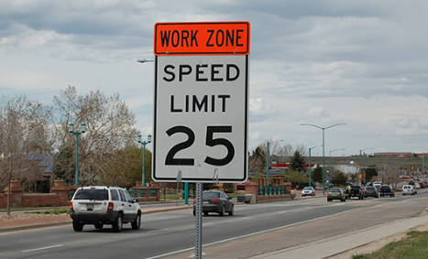

  - Signs advising CMVs to travel in the left lane
    - Moving CMVs to the left lane prevents them from passing each other as often, keeps the entrance and exit ramps more visible to motorists and hopefully reduces the speed disparity at those exchanges. Suggested timeline – as soon as the signs can be placed.

  - Use of DMS signage to indicate a work zone and reduced speed
    - Use portable message boards with creative messages indicating conditions are different and speeds reduced, the better the chances of reducing crashes. Messaging example could be: “1 MPH over limit = $200 FINE” or “Tailgating is for ball parks” Suggested timeline – as soon as message boards arrive.

  - More orange signs/lime green signs indicating motorists are in a work zone. This also includes signage to warn about distracted driving and following too closely.

- DSP resource allocation. Immediate implementation

  - Allocate and creatively schedule our mitigation resources to target visibility and/or enforcement efforts during the peak travel times and in the specific zones that are proving the most challenging.

    - We will attempt to add more resources to work zones, but they are limited. This would also require an increase in mitigation funds to cover the cost of increased resources.

DTSD is in strong support of having additional law enforcement presence throughout the Corridor. However, increasing mitigation funds has not been a concern in the past. This should not be a determining factor in limiting law enforcement presence throughout the corridor. DTSD takes efforts to ensure that the traffic control through a construction zones meet the standards set forth in the Manual of Uniform Traffic Control Devices (MUTCD) and other traffic manuals.

    - Currently, we have 39 troopers per week assigned Sunday through Saturday to the I-39 project. We are adding 8 more four hour shifts per week for a total number of 47 troopers, an increase of 20%. Sergeants are allowed to work these shifts as well.

DTSD acknowledges that DSP provides 8 hours per segment per day of law enforcement mitigation in two, four-hour blocks (e.g., 7:00 am to 11:00 am and 3:00 pm to 7:00 pm shifts). Each segment is approximately 15 miles in length. This equates to one trooper providing eight hours of service per segment per day. Based on the three segments within the corridor and 8 hours per day per segment, the amount of trooper coverage is 21 per week.

DTSD recommends adding four times as much law enforcement mitigation service to each corridor segment (e.g., an additional 24 hours per day per segment). The County Sheriff’s Office is available to provide a portion of these additional hours. The cost for county law enforcement services are comparable to DSP costs.

Dane County, which includes the North Segment, could provide 24 hours per day of law enforcement mitigation coverage.

Rock County, which includes the South and Central Segments, could provide 8 hours per day of law enforcement mitigation coverage (56 hours per week).

The current DSP cost for providing law enforcement mitigation services for all three segments is approximately $482,000 per year. If the level service were increased, the cost would be as follows:

 | ~ ANNUAL COST
2X current coverage | $964,000
3X current coverage | $1,450,000
4X current coverage | $1,930,000

Based on input from the County Sheriff Offices (Dane and Rock), it appears that they could provide more law enforcement coverage if desired in the future.

    - Bring in teams of troopers from other regions to focus on patrol for one week (5 – 8 hr. shifts) at a time. Pros: Add more resources to the project. Cons: incurred hotel costs.

The concept of a dedicated troop of 10-12 (or up to 35) troopers was originally proposed to serve the corridor. This would have provided knowledgeable law enforcement personnel that is familiar with the entire 45-mile corridor; ongoing construction work and contractor practices; knowledge of construction project specific emergency access points; relationships with corridor-wide first responders, project staff, and local municipal staff; and dedicated service for five years or more for the duration of the construction project. Ultimately, DSP determined this strategy was not feasible due to recruit classes, statutory limits on the number of sworn officers, the inability to have more than one recruit class in any given year, and the inability of DSP to fill their vacancies in general.

As stated above, the concept of a construction troop is included in the Strategies Matrix, see #19.

Aside from this concept, DTSD has continually made requests to DSP for additional law enforcement mitigation services to increase visibility and law enforcement efforts.

    - Increase radius for overtime call outs
      - Currently we are at 60 mile radius for call outs.
      - Extend call outs to 75 miles which would have to include extra cost for travel time to ensure maximum amount of time in the work zones. Currently, travel is not included for personnel within 60 miles.

This is a DSP policy issue per their current union contract.

  - Utilize inspectors in work zones more efficiently
    - With the closing of the SWEFs, inspectors can be assigned during normal shifts to travel the work zones providing a level of visibility as well as conducting inspections on CMVs at the various exchanges and off ramps throughout the work zones.

Similar to 6.a.iv. above, this is a DSP union policy issue. Further, the closing of the SWEFs was done by the Bureau of Highway Maintenance.

- Aerial Enforcement. Immediate implementation.

  - Use aircraft to target erratic driving in the work zones during peak travel times and take enforcement action.

Central Office BTO removed aerial enforcement from the mitigation strategies worksheet. This was a mitigation strategy in the past, but was removed earlier this year (2018). Further, DSP has stated there is not a suitable location to perform enforcement activities along the I-39/90 corridor. Finally, DSP has previously stated that there are not enough pilots to provide adequate aerial enforcement service.

  - Strategically place “Aerial Enforcement Detail” signs at the entrances to the counter-directional work zones to deter speeding.

This is a misleading practice as the signs remain along the corridor for several consecutive days. The traveling public eventually becomes immune to these signs and this measure becomes ineffective.

  - DTSD has made two different attempts at exploring aerial surveillance equipment. The first attempt to assist DSP in this effort dates to September of 2013. DSP determined at this time that aerial surveillance would not be used as a traffic control strategy.

Based on further consideration by DTSD, another effort to explore the use of aerial surveillance technology for improved traffic operations and incident response was initiated in September of 2014. As part of this effort, DTST staff met numerous times with DSP, DNR, and other personnel to evaluate options for the use of aerial surveillance. This included drone technology and fixed camera use on state-owned aircraft. Supplemental funding options through grants were evaluated as part of this effort (e.g., Homeland Security grants). A chronology of the meetings held is included for reference. In February of 2016, this effort was suspended by DSP after they stated they would no longer support this initiative and not participate in future aerial surveillance meetings.

The use of aerial surveillance technology is included in the Strategies Matrix, see #21 and #22.

- Communicate with major motor carrier companies. Immediate implementation

  - DSP suggested this in 2017. Communications with companies will make them aware of the work zones, potential delays, narrow shoulders, the signage and afford them the opportunity to relay the information to their drivers who may choose a different route.

- Freeway Service Trucks (FSTs)

  - Trucks (like the one pictured) are used throughout Dane and Milwaukee Counties and may give law enforcement additional opportunities for scene response and clearing including:

The FST Truck pictured below (e.g., Beltline Bob truck) has limited tow and relocation capabilities. It does not have the ability to relocate a vehicle other than pushing it since it does not have a wheel lift or flatbed. The FST trucks that serve the three segments of the corridor were specifically requested because they can relocate two vehicles at one time if there is a stalled vehicle in the travel lanes. Given the current work zone configurations, this is a critical need.

The FST used in Dane County is provided by the Dane County Sheriff’s Office and limited to a specific segment along the Beltline; not throughout all of Dane County. This is similar for Milwaukee County as FST is provided by the Milwaukee County Sheriff’s Office and it’s use is limited to selected roads and not serving the entire county. Purchasing a truck similar to what is used by the Dane County Sheriff’s Office costs approximately $80,000 furnished. This truck could be outfitted to provide additional towing services such as adding a wheel lift or other equipment to relocate stalled vehicles.

As part of the I-39/90 Corridor Project, there currently are three FST trucks throughout the corridor to provide motorist assistance. One truck is allocated per segment covering a 15-mile length of I-39/90. Coverage per segment totals 86 hours of coverage per truck per week for a total of 258 hours of FST per week for the entire Corridor.

The cost of this service for this construction season is $237,000 per segment for a total of $711,000 for the entire corridor.

The use of freeway service trucks is included in the Strategies Matrix, see #19 and #26.

    - The ability to manipulate barriers quickly, allowing emergency vehicles to enter the opposite lane for easier access to a scene. Current conditions dictate emergency vehicles traveling to an exit to turn around and negotiate through stopped traffic or to travel against normal traffic flow; this delays response times and increases the danger potential.

As stated above in #3, numerous Emergency Access points are provided in the construction zones throughout the entire Corridor. These emergency access points in construction zones provide access to safely travel on the grade. As shown below, other first responding agencies are using the emergency access points to safely respond to incidents via the work zone; however, DSP has limited the use of this resource despite having the use of four-wheel drive SUVs in their fleet.

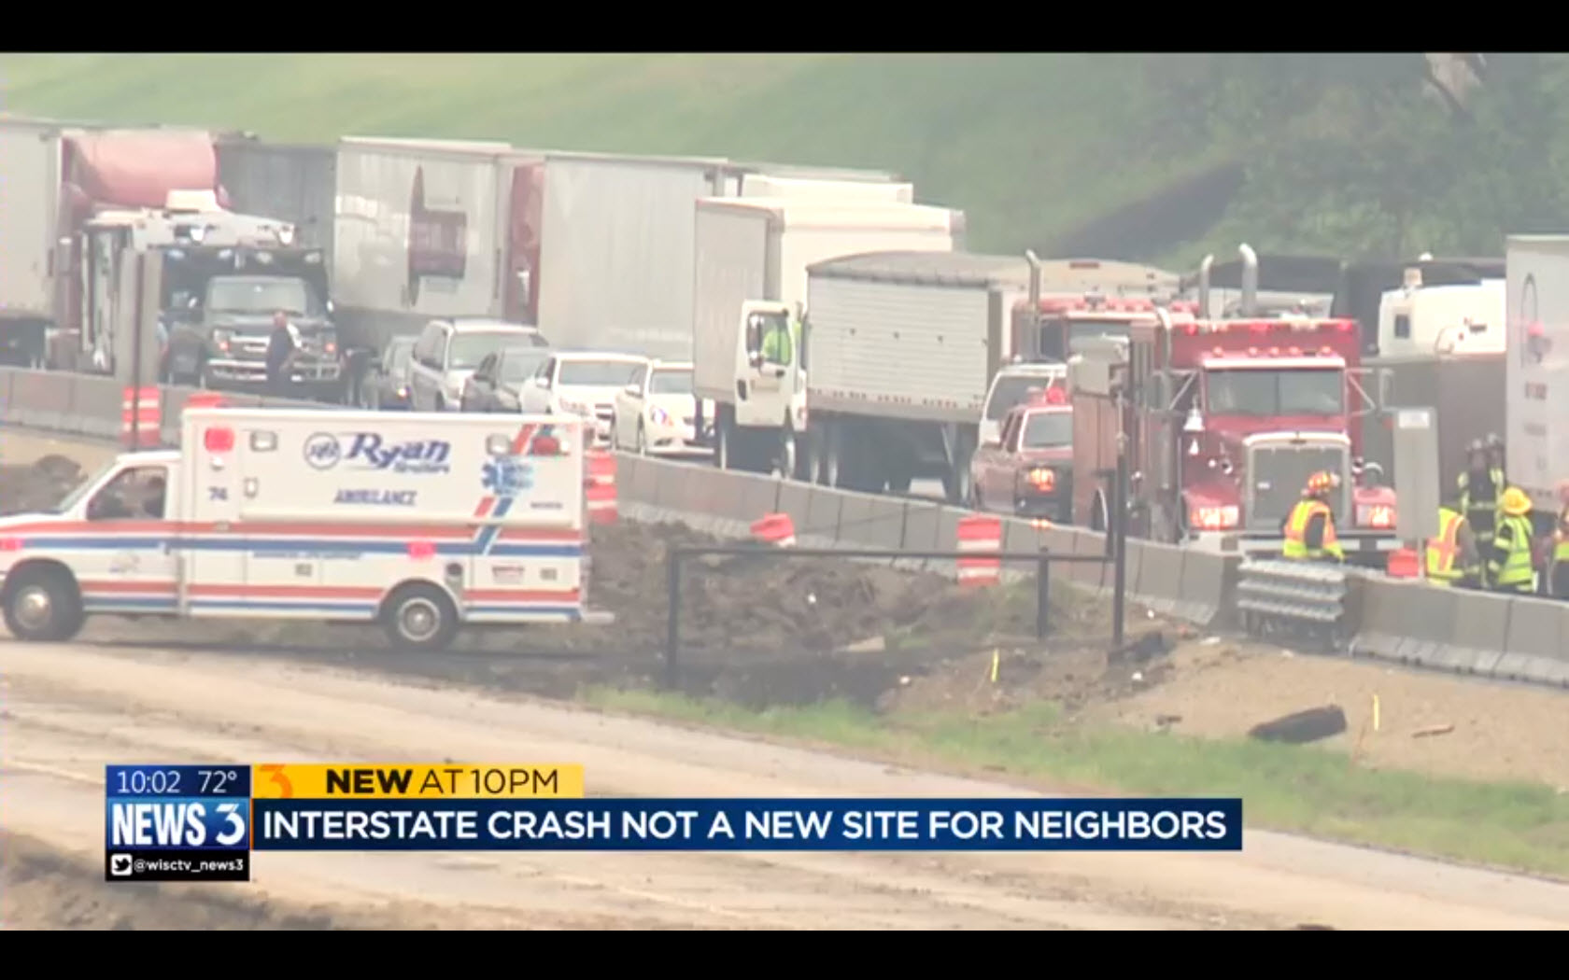

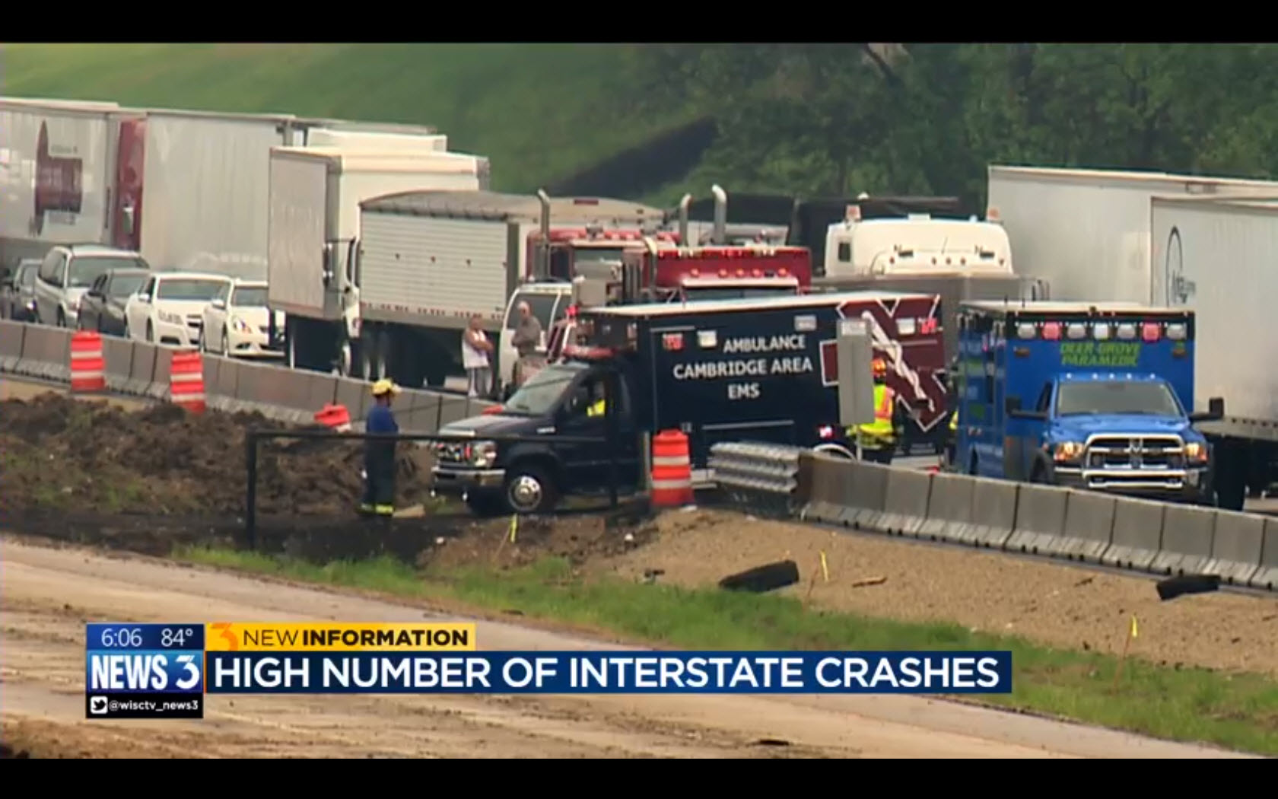

    - The ability to temporarily move disabled vehicles from traffic lanes allowing for traffic queues to clear.

DSP currently has a limited number of vehicles equipped with push bumpers. The use of push bumpers on DSP vehicles was suggested as a tool in the Strategies Matrix (see #13). Push bumpers would provide DSP the ability to safely and efficiently move disabled vehicles out of the travel lanes. DTSD recognizes that push bumpers and other equipment cannot be purchased using mitigation funds.

    - Provide better visibility for approaching traffic encouraging safer travel.

All I-39/90 FST have a consistent and uniform look for consistency purposes. This is based on the agreement with State Farm Insurance as a partner in this effort. Increasing the visibility of these trucks may make it more noticeable for motorists.

  - The trucks could be operated by law enforcement during their assigned mitigation period and would serve a better suited purpose than the traditional cruisers. The two vehicles in service are extended cab, four-wheel drive pickup trucks with special equipment to assist motorists and provide scene security. The vehicles are equipped with a changeable message sign, appropriate fluids,
traffic cones and other equipment needed to assist disabled vehicles and warn approaching traffic.

DSP declined the opportunity to operate the FST in the past. DTSD is open to having DSP operate the FST; however, the current I-39/90 FST are operated by professional tow truck operators.

  - The photo below is a Dane County FST truck that moved the barrier wall on a recent crash. This allowed Fire and EMS to access the six car crash for extrication of two subjects.

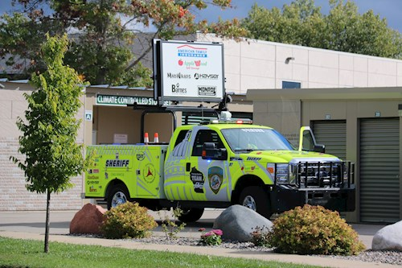

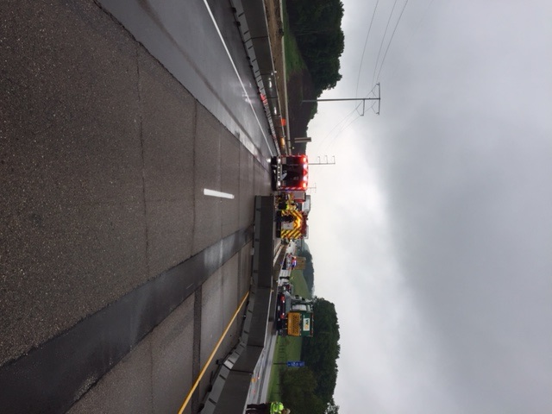

The I-39/90 FSTs are flatbed tow trucks that can relocate two disabled vehicles at once. The Dane County FST shown below this section can only push a disabled vehicle and is unable to relocate it from the incident scene. A picture of the I-39/90 FST is shown immediately below.

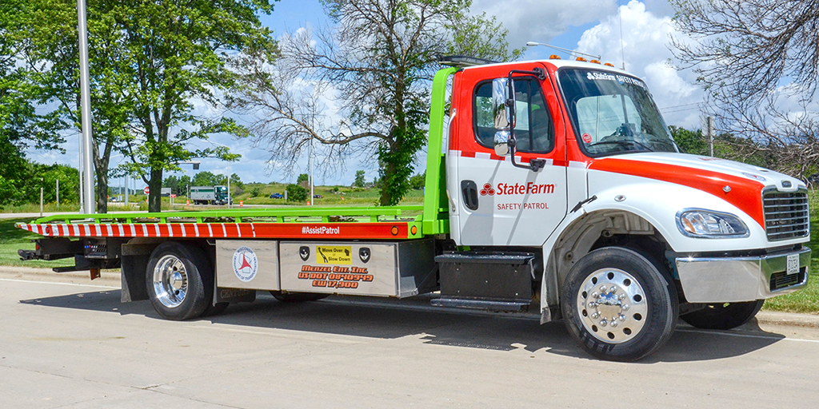

- Oversize Load Restrictions. Immediate implementation.

  - Oversize loads wider than 12 feet should be prohibited from traveling through the work zone. When crashes occur, even if one lane remains open, their width makes it impossible for the load to pass the incident scene or traffic to get around the load to continue. The backup then stays in place until the scene is completely clear.

This issue has been evaluated by the Bureau of Highway Maintenance and clarification from the Administrator’s Office and the Secretary’s Office have stated that the current policy of allowing OSOW through the corridor will remain in effect.

  - ANY oversize loads should be restricted from traveling on a Friday, Saturday, Sunday or Monday of holiday weekends due to extraordinary traffic volume.

See 10a above; same response.

  - DSP, DTSD and DOT Permits can work together to provide clear and concise restrictions

See 10a above; same response.

