R |  |  | Division of Transportation System Development  Southwest Region  3550 Mormon Coulee Road  La Crosse, WI 54601 | Jim Doyle, Governor  Frank J. Busalacchi, Secretary  Internet: www.dot.wisconsin.gov  Telephone: 608-785-9022  Facsimile (FAX): 608-785-9969  E-mail: lacrosse.dtd@dot.state.wi.us
 |  | July 31, 2026
Ho-Chunk Nation
Attn: William Quackenbush, THPO
P.O. Box 667 405 Airport Road
Black River Falls, WI 54615
5783-03-00/71
STH 131 Village of Gays Mills
Dellamater Hollow Creek Bridge & Approach
Crawford County

The Wisconsin Department of Transportation (WisDOT) is in the process of developing plans for a proposed project located in the Village of Gays Mills on the Dellamater Hollow Creek Bridge on STH 131 in Crawford County. The project will consist of replacing the existing structure in its existing location traffic will be handled with a temporary bypass.

A public information meeting will be held sometime later this year to familiarize interested parties with the project. In the near future, cultural resource investigation studies will be conducted for the above project. These investigations will enable WisDOT to determine whether historical properties as defined in 36 CFR 800 are located in the project area. Other environmental studies will also be conducted and include; endangered species survey, contaminated material investigations, soil testing and right-of-way surveys. Information obtained from these studies will assist the engineers in the design to avoid, minimize or mitigate the proposed project’s effect upon cultural and natural resources.

WisDOT would be pleased to receive any comments regarding this project or any information you wish to share pertaining to cultural resources located in the area. If your tribe wishes to become a consulting party under Section 106 of the National Historic Preservation Act or would like to receive additional information regarding this proposed project, please contact James Becker; Bureau of Equity and Environmental Services; 4802 Sheboygan Avenue; Room 451; Madison, Wisconsin 53707 (608) 261-0137.

Sincerely,

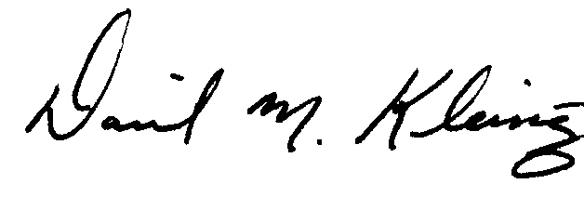
Daniel Kleinertz
Project Manager

cc: Eugene S. Johnson, Bureau of Equity and Environmental Services
Roger Larson, SW Region – Madison Tribal Coordinator

