**Scope Meeting ~~Agenda~~ Notes (Phase 2)**

**5770-02-00/70**

**STH 130**

**STH 23 to STH 133**

**Iowa County**

**~~RSRF20 – Resurfacing (Overlay >= 2.5 and < 4 inches)~~**

**RSRF30 – Resurfacing (Overlay ≥ 4 inches)**

**November 20, 2019**

**PROJECT DESCRIPTION AND NEED:**

The pavement is deteriorated with cracking. Treatment is needed to extend the pavement service life.

Treat the pavement with a 4” mill and overlay. Replace guard rail end terminals as needed.

**Highway:** STH 130

**Termini/Limits:** STH 23 to STH 133

**Project Length:** 10.98 Miles

**Programmed Improvement Concept:** ~~RSRF20 – Resurfacing (Overlay >= 2.5 and < 4 inches)~~ RSRF 30

**Program Level Estimate:** $5,161,000 w/out delivery funding 80/20

**PS&E Date:** 8/1/2026 Adv: 5/1/2025

**LET Date:** 12/8/2026 Adv: 8/12/2025

**Functional Class:** Rural Major Collector

**Connecting Highway:** No

**OSOW Freight Route:** No

**OSOW High Clearance Route:** No

**Wind Tower Route:** No

**Corridors 2030:** No

**NHS Route:** No

**Long Truck Route:** 65-ft restricted route

**Posted Speed Limit:** 55 mph

**AADT:** (META, 2017): 1,100-1,290 (META, 2037): 1,260-1,470

**Truck Percentage** (META, 2017): 5.4% (META, 2037): 5.4%

**LOS:** 2.21-2.60 (META, 2017)2.24-2.55 (META, 2037)

**Existing Access Type:** Not controlled

**Federal Oversight:** No

**Project Directory**: \\Mad31zp1\Projects\state\STH_130\5770-02-00_70

**Existing Cross Section & Pavement Structure:**

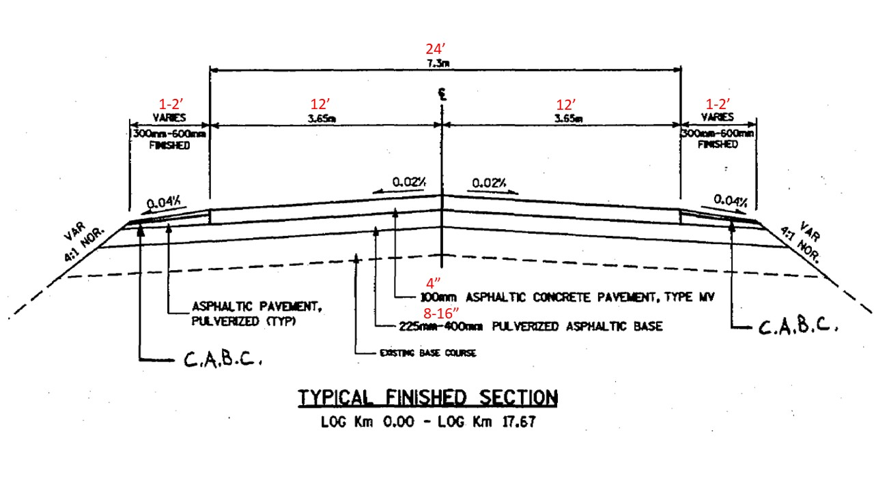

5770-00-60 (2000):

* Typical Section consists of 12’ lanes and 1’ to 2’ unpaved shoulders on each side.
* Typical pavement structure consists of 4” asphaltic concrete pavement Type MV, over 8” – 16” pulverized asphaltic base, over base course. Shoulders are crushed aggregate base course over pulverized asphaltic pavement.

**Asbuilts:**

* [**sp9408-0(000)**](https://iisgtwyp.wi.gov/gisimage1/project/sp9408-0(000)/) (1932) – roadway construction
* [**5770-00-79**](https://iisgtwyp.wi.gov/gisimage1/project/57700079/) (1990) – B-25-934 Otter Creek Bridge repairs
* [**5770-00-71**](https://iisgtwyp.wi.gov/gisimage1/project/57700071/) (1994) – beam guard & shoulder widening
* [**5770-00-60**](https://iisgtwyp.wi.gov/gisimage1/project/57700060/) (2000) – pulverize and overlay
* [**5770-00-75**](https://iisgtwyp.wi.gov/gisimage1/project/57700075/)(2001) – beam guard installation
* [**5770-00-74**](https://iisgtwyp.wi.gov/gisimage1/project/57700074/)(2006) – B-25-151 Otter Creek Bridge & Approaches
* **5770-00-62** (2015) – LFA shoulder work (Maintenance)

**Existing Geometry:**

* Level and Rolling Terrain
* Many horizontal and vertical curves
* Steep grade signs, signs at curves, and many speed advisory signs ranging from 30-50 mph (18 northbound, 17 southbound).

**Existing Structures:**

**B-25-0151** – STH 130 over Otter Creek, south of CTH NN

* 3-span (45’, 60’, 45’) haunched slab structure, new structure in 2006 (5770-00-74), Polymer Overlay in 2007
* Total Length = 152.6’, Deck Width = 32.5’
* Approach roadway width = 36’, Bridge Roadway Width = 30’
* Approach pavement width = 24’, Shoulder width = 6’
* Deck area = 4959 sf
* Skew = 15 deg
* Design load rating = HS20, Inventory rating = HS25, Operating rating = HS42
* Ratings: Deck = 7, Superstructure = 7, Substructure = 8, Channel = 8
* Guardrail has EATs (4)
* Scheduled for polymer overlay in 2019

**B-25-0934** – STH 130 over Otter Creek, north of CTH NN

* Single-span (24’) flat slab structure, Constructed in 1923, New superstructure in 1990 (5770-00-79)
* Total Length = 25.5’, Deck Width = 28’
* Approach roadway width = 28’, Bridge roadway width = 26’
* Approach pavement width = 22’, Shoulder width = 3’
* Deck area = 714 sf
* Skew = 13 deg
* Design load rating = HS12, Inventory rating = HS23, Operating rating = HS39
* Ratings: Deck = 7, Superstructure = 7, Substructure = 6, Channel = 7
* Signed “Narrow Bridge”
* Guardrail has turndown ends (4). Bridge rail - ?? Check [SDD 14b51](https://wisconsindot.gov/rdwy/sdd/sd-14b51.pdf) for details

**C-25-3038** – STH 130 over Drainage, 0.7 mi north of CTH C

* Single-cell concrete box culvert, built in 1939
* Height = 5’, Width = 3’, Length = 6’, Barrel Length = 32’
* Deck area = 96 sf
* Ratings: Channel = 8, Culvert = 7

**C-25-3036** – STH 130 over Cattle Pass, 4.4 mi north of CTH M

* Single-cell concrete box culvert, built in 1939
* Height = 5’, Width = 3.5’, Length = 6’, Barrel Length = 32’
* Deck area = 80 sf
* Ratings: Culvert = 7

**C-25-3035** – STH 130 over Drainage, 3.5 mi north of CTH M

* Single-cell concrete box culvert, built in 1931
* Height = 4’, Width = 9’, Length = 6’, Barrel Length = 42’
* Deck area = 147 sf
* Ratings: Channel = 8, Culvert = 7

**C-25-3033** – STH 130 over Drainage/Cattle Pass, 0.5 mi north of STH 23

* Single-cell concrete box culvert, built in 1960
* Height = 6’, Width = 6’, Length = 6’, Barrel Length = 52’
* Deck area = 223 sf
* Ratings: Culvert = 7

**C-25-3032** – STH 130 over Cattle Pass, 0.1 mi north of STH 23

* Single-cell concrete box culvert, built in 1960
* Height = 5’, Width = 5’, Length = 6’, Barrel Length = 34’
* Deck area = 214 sf
* Ratings: Culvert = 7

**Level of Service (per Metamanager):**

|  |  |  |  |  |  |  |
| --- | --- | --- | --- | --- | --- | --- |
|  | **Year 1** | **Year 5** | **Year 10** | **Year 15** | **Year 20** | **Threshold** |
| STH 130 | 2.47-2.73 | 2.47-2.75 | 2.48-2.76 | 2.49-2.79 | 2.49-2.64 | 5.0 |

**Existing Traffic Control:**

* Speed limit 55 mph
* STH 130 at STH 23 is a T-intersection; southbound STH 130 traffic must stop.
* STH 130 at STH 133 is also a T-intersection; southbound STH 130/133 traffic must stop after crossing the Wisconsin River.
* All other intersections have stop control on the side roads.

**Existing Right of Way:**

* Typical ROW is 66’
  + [**9408**](https://iisgtwyp.wi.gov/gisimage1/project/9408/) – ROW plat for entire project length
  + [**5770-00-22**](https://iisgtwyp.wi.gov/gisimage1/project/57700022/)(2005) – Bridge project – 33’ minimum

**Proposed Improvements:**

**Proposed Pavement/Cross-Section:**

* *Comments from Pavement Engineer:*

*I talked with Tadd Owens who was the Project Engineer of the pulverize and overlay project in 1999/2000. Tadd recalls the existing asphalt pavement thickness being variable with one area exceeding 2’ (cores showed 8” to 16” of existing asphalt). After pulverizing was completed it rained for nearly a week. The grade (pulverized material) became saturated and soft. Spot location edge drains were added along with areas base repair. The lower layer of asphalt was placed in the fall of 1999 with the surface layer held over and paved the following spring (April/May). There may be some buried cable on the north end of the project (near boat landing?) that impeded grade repairs.*

*From driving the project, it appears to be undesirable to raise the grade (curves, profile, beam guard, shoulder width, etc.). Traffic was minimal. The Planning Level Forecast estimate 1300 AADT in 2026 on the north end of the project and 1160 AADT on the south end. Trucks were listed on the plan coversheet as 6.7% for the 2006 bridge project over Otter Creek.*

*I suggest that the mill and overlay depth be increased to 4” to remove and replace the existing 4” pavement. Detour the roadway. Require same day paving (or within 24-hours and/or weather related criteria) of the lower layer of HMA Pavement after milling. Tadd agreed with this project concept.*

* Change improvement concept to RSRF 30 (4” mill and overlay).
* Borings are not needed (data available from the 1999/2000 project).

**Pedestrian & Bicycle Accommodation:**

* *Comments from Multi Modal:*
  + *Absence of need for pedestrians since rural. Would it be possible to pave 3-foot shoulder? Currently appears that one foot is paved. There may be ROR crashes that could also benefit from a wider paved shoulder. Part of this project (Biglow Hill Road to end project is State Priority linkage and part of the project is a connection to State or local Priority linkages (STH 133 and County C). See attached bike map (in Scoping folder).*

**Proposed Structure Work:**

* B-25-0934 railing connection to beamguard?

**Safety Analysis/Screening:**

Six segments have safety flags:

* RP 130N001 000 to 130N003 000 (KABFLAG = 2.09) – segment length of 1.31 miles from STH 23 EB to Floyd Road. 4 crashes total.
* RP 130N004 236 to 130N008 000 (RATEFLAG = 4.50, KABFLAG = 4.74) – segment length of 1.10 miles from 0.3 miles south of Spring Valley Road to Limmex Hill Road. 17 crashes total. This was the only flagged segment that could not be vetted. Most crashes involved NB traffic at the first curve (posted with a 30mph advisory warning).
* RP 130N010 000 to 130N011 000 (KABFLAG = 1.42) – segment length of 0.47 miles from Burris Road to CTH I. 1 crash total.
* RP 130N011 000 to 130N012 000 (RATEFLAG = 2.23, KABFLAG = 1.66) – segment length of 0.88 miles from CTH I to CTH NN. 8 crashes total.
* RP 130N014 000 to 130N014M000 (RATEFLAG = 1.17) – segment length of 0.87 miles from Otter Creek Road to River Road. 4 crashes total.
* RP 130N014M000 to 130N015 000 (RATEFLAG = 1.61) – segment length of 0.58 miles from River Road to STH 133 NB. 4 crashes total.

**Traffic:**

* *Comments from Traffic:*
  + *TMP Type 2*
  + *Closed with detour – advance signing, changeable message signs, flagging. Possible detour for entire project or just for narrow section near river.*
  + *Proposed pavement marking: epoxy*

**Roadway Maintenance:**

* Numerous culverts on this project with many appearing in either poor or severe condition on the culvert inventory
* Several stretches of guardrail. Five ends need updating with EATs.
* Boat landing?
* Other?

**Real Estate:**

* Likely for any culvert replacements and guardrail ends.

**Utilities:**

* **Potential utility list in PMP.**

**Environmental:**

* *Comments from Environmental:*
  + *Environmental Document: likely PCE*
  + *Arch/Hist: No historical properties should be impacted by project, and project should make screening list for Hist. Four Arch sites exist within DOT ROW. Three of those sites are bisected by the existing roadway. Project will not make screening list for Arch, but considering scope Arch survey is unlikely.*
  + *Wetlands: wetland impacts possible around beam guard ends. Wetland determination can be conducted after grading extents and structure and beam guard work are defined.*
  + *Hazmat: exempt*
  + *Species: Project may be within 900’ protected buffer of Bald Eagle nest.*

**Survey and Mapping:**

* Some aerial imagery available near both bridge structures from 2002
* Some aerial imagery available near Lone Rock from 2015
* Some LiDAR available from 2015 near Lone Rock

**Railroad/Aeronautic Coordination:**

* Tri-County Regional Airport is within 5 miles of this project and Southwind Airport is within 2 miles of the project.
* No railroad crossings within or near project limits
  + *Comments from Railroads: There are no railroads affected by this project. If the project limits change, project detour includes RR, traffic control extends to the R ... R, haul road includes a RR crossing, RR RE is needed, or if a Rails to Trails corridor is affected then RR coordination will need to be readdressed. DT1804 Federal Railroad Cert and pseTrak signoff otherwise RR Coordination 100% complete.*

**Project Agreement:**

* No SMFA
* SMMA?

**Nearby Projects:**

2020

* 5770-01-61 – STH 130, Bridge Rehabilitation (BRRHB) – Wisconsin River Bridges
  + PS&E – 11/1/2019 LET – 2/11/2020

2021

* 5940-02-60 – STH 133, Resurfacing (RSRF 10) – STH 80 to STH 130
  + PS&E – 11/1/2021, adv. 11/1/2020 LET – 3/8/2022, adv. 3/9/2021

2024

* 5255-01-73 – STH 23, Resurfacing (RSRF 30) – WI River Bridge to USH 14
  + PS&E – 5/1/2023 LET – 11/13/2023

2027

* 5770-01-71 – STH 130, Bridge Replacement (BRRPL) – Wisconsin River Bridges
  + PS&E – 5/1/2026 LET – 11/10/2026

**Other:**

**Schedule:**

LC11/Phase 3 Scope Meeting date:

