*Royal & Associates 11/15/2019*

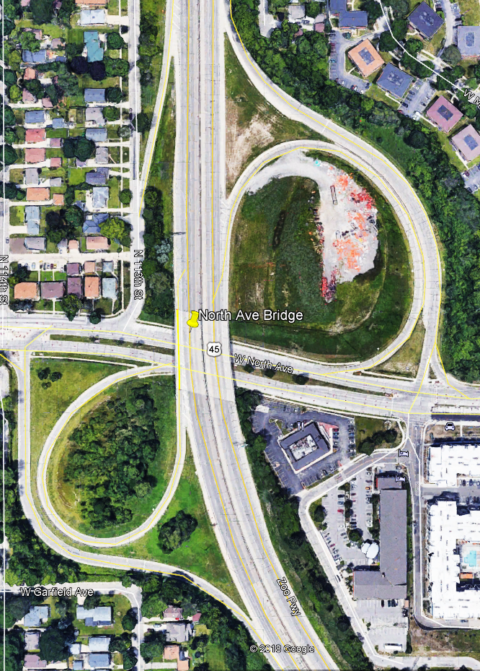Proposal for the Reconstruction of the IH41 North Avenue Interchange

Proposal for the Reconstruction of the IH41 North Avenue Interchange

**RAE**

Royal and Associate Engineers

Luke Royal

Taylor Mueller

Spencer Krautkramer

Leah Stewart

Ryan Neiheisel

Jordan Newson

# Letter of Transmittal

November 15th, 2019

Randolph M. Videkovich University of Wisconsin-Milwaukee College of Engineering and Applied Science

Dear Mr. Videkovich,

On behalf of Royal and Associates Engineers, we are pleased to submit the enclosed project proposal for the reconstruction of the IH41 North Avenue Interchange.

For further questions or information regarding this project, please email lroyal@uwm.edu or call (847) 529-1733

Sincerely,

Luke Royal,

Project Lead,

Royal and Associates Engineering

Luke Royal Spencer Krautkramer Leah Stewart Ryan Neiheisel Jordan Newson Taylor Mueller

# Table of Contents

Letter of Transmittal ii

Table of Contents iii

Table of Figures iii

Summary 1

Introduction 2

Work Breakdown Structure 8

Transportation Design 8

Structural Design 9

Environmental/Water Management 10

Geotechnical Design 11

Envision Checklist 12

Team Organization 13

References 14

# Table of Figures

[Figure 1: Site Location Map 3](https://panthers-my.sharepoint.com/personal/krautk22_uwm_edu/Documents/Senior%20Design%20(CE494)/RAE%20IH41%20North%20Ave%20Interchage%20Draft%20Proposal%20%20(Current%20Working%20Draft).docx#_Toc24660109)

[Figure 2: Site Plan View 4](https://panthers-my.sharepoint.com/personal/krautk22_uwm_edu/Documents/Senior%20Design%20(CE494)/RAE%20IH41%20North%20Ave%20Interchage%20Draft%20Proposal%20%20(Current%20Working%20Draft).docx#_Toc24660110)

[Figure 3: Preliminary Plan View Interchange Sketch with Roundabouts 5](https://panthers-my.sharepoint.com/personal/krautk22_uwm_edu/Documents/Senior%20Design%20(CE494)/RAE%20IH41%20North%20Ave%20Interchage%20Draft%20Proposal%20%20(Current%20Working%20Draft).docx#_Toc24660111)

[Figure 4: West Elevation IH41 SB Bridge at North Ave 6](https://panthers-my.sharepoint.com/personal/krautk22_uwm_edu/Documents/Senior%20Design%20(CE494)/RAE%20IH41%20North%20Ave%20Interchage%20Draft%20Proposal%20%20(Current%20Working%20Draft).docx#_Toc24660112)

[Figure 5: Plan View IH41 Bridge Over North Ave 6](https://panthers-my.sharepoint.com/personal/krautk22_uwm_edu/Documents/Senior%20Design%20(CE494)/RAE%20IH41%20North%20Ave%20Interchage%20Draft%20Proposal%20%20(Current%20Working%20Draft).docx#_Toc24660113)

[Figure 6: Traffic Count Map 7](https://panthers-my.sharepoint.com/personal/krautk22_uwm_edu/Documents/Senior%20Design%20(CE494)/RAE%20IH41%20North%20Ave%20Interchage%20Draft%20Proposal%20%20(Current%20Working%20Draft).docx#_Toc24660114)

[Figure 7: Team Organization 13](https://panthers-my.sharepoint.com/personal/krautk22_uwm_edu/Documents/Senior%20Design%20(CE494)/RAE%20IH41%20North%20Ave%20Interchage%20Draft%20Proposal%20%20(Current%20Working%20Draft).docx#_Toc24660115)

# Summary

The IH41 North Avenue Interchange (Figure 1 & Figure 2) shall consist of widening the roadways for one additional traveling lane on IH41 to accommodate the increase of traffic flows throughout the corridor. The NB and SB bridge shown in Figure 5 decks will have a widened footprint from 65 ft to 112 ft for the additional IH43 traveling lanes. Figure 4 shows the west side elevation of the SB bridge. Additional collector off-ramp lanes will be designed for transitioning into the newly designed North Ave roundabouts to help ease the transitional flow of traffic from the off ramps and bypassing traffic. The NB off ramp will be designed with tub girders to optimize collector/distributor functionality for high traffic volumes and act as an overpass for the NB on ramps.

The existing SB to EB North Ave off-ramp will be eliminated and the SB to WB off ramp will be redesigned to transition into a roundabout allowing traffic to flow in both the EB and WB direction. The SB on-ramp will be redesigned and accessible from the West North Ave roundabout. A preliminary plan view sketch is shown in Figure 3 which shows two overlays of 3 lane roundabouts. Two mechanically stabilized earth (MSE) walls will be designed for NB and SB bridge abutments for six lanes on North Ave underneath the IH41 bridge.

The North Ave EB and WB lanes will have three lanes in each direction to accommodate for roundabout footprint. To accommodate for the preliminary design, portions of the Denny’s parking lot and other parcels may need to be purchased upon the review and approval of the project owner. Storm sewer storage and mitigation has been considered for additional flow considering the increased pavement surface area. All roadway and construction design criteria shall be in accordance with WisDOT’s 2020 Standard Specifications for Highway and Structure Construction (**add other specifications needed)**.

The firm used an envision checklist to facilitate a preliminary design

# Introduction

Throughout the past decade, the Zoo Interchange has undergone many transformations with the successful project phase completions of Zoo Core 1 (ZC1) and Zoo Core 2 (ZC2). On July 14, 2020, the Wisconsin Department of Transportation (WisDOT) will LET the Zoo Interchange’s final phase, Zoo Core 3 (ZC3), which consists of a 2.03 mi stretch of lane widenings from Swan Blvd. to Burleigh Street located on the IH41 corridor. In 2013, WisDOT has determined the Average Annual Daily Traffic (AADT) between Watertown Plank Road and North Avenue was 137,820. In 2018, the AADT was increased to 154,110, an increase of 10.5% in just 5 years. Figure 6 shows the traffic counts for the off ramps for the interchange. As seen, there is no NB to EB off ramp on North Ave, so that’s where the newly designed interchange will eliminate the need for the Mayfair Road off ramp and still maintain a good Level of Service (LOS). This interchange is a key artery to many retail, commercial, and industrial buildings including Mayfair Mall in the surrounding area. Therefore, redesigning the IH41 North Ave Interchange is an absolute necessity to accommodate for increasing demand of traffic flow through the ZC3 corridor.

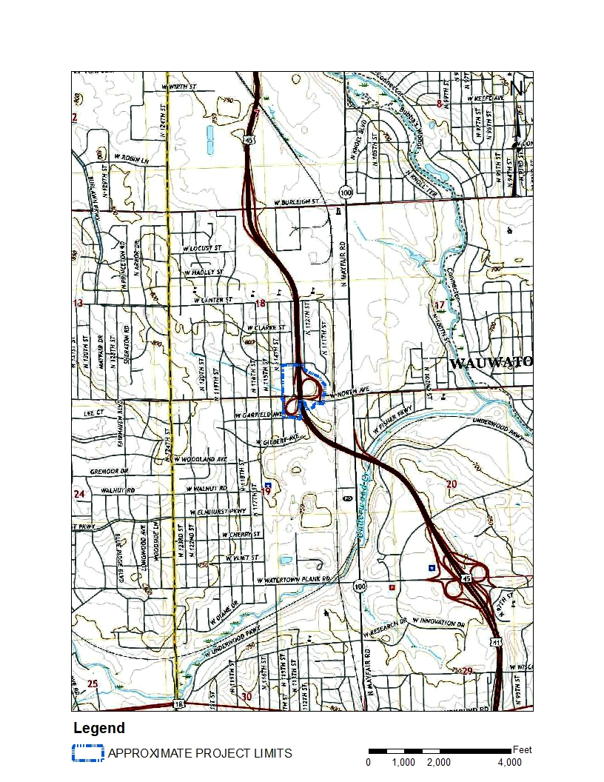

Figure : Site Location Map

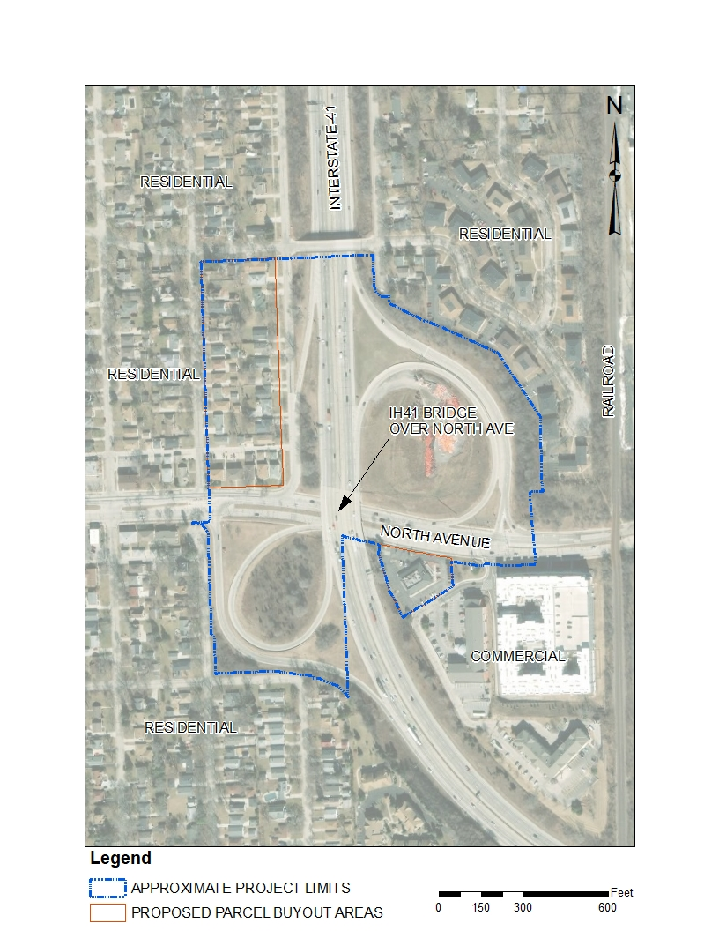

Figure : Site Plan View

Figure 3: Preliminary Plan View Interchange Sketch with Roundabouts

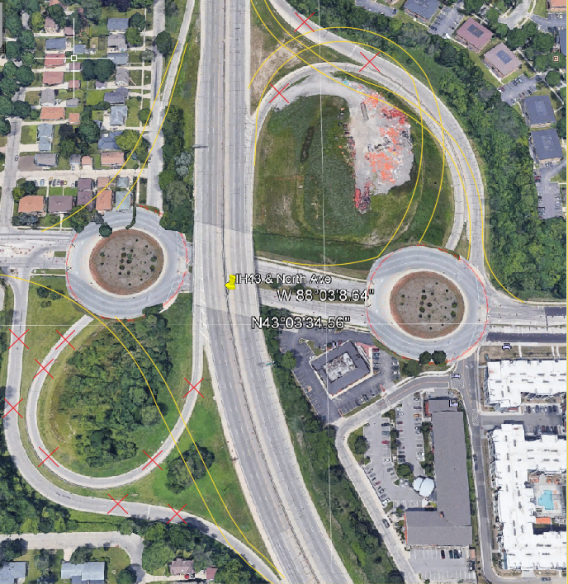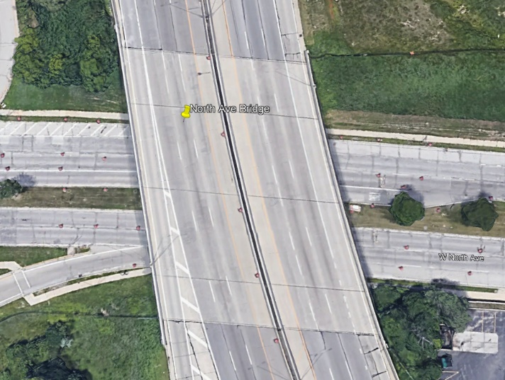

Figure 5: Plan View IH41 Bridge Over North Ave

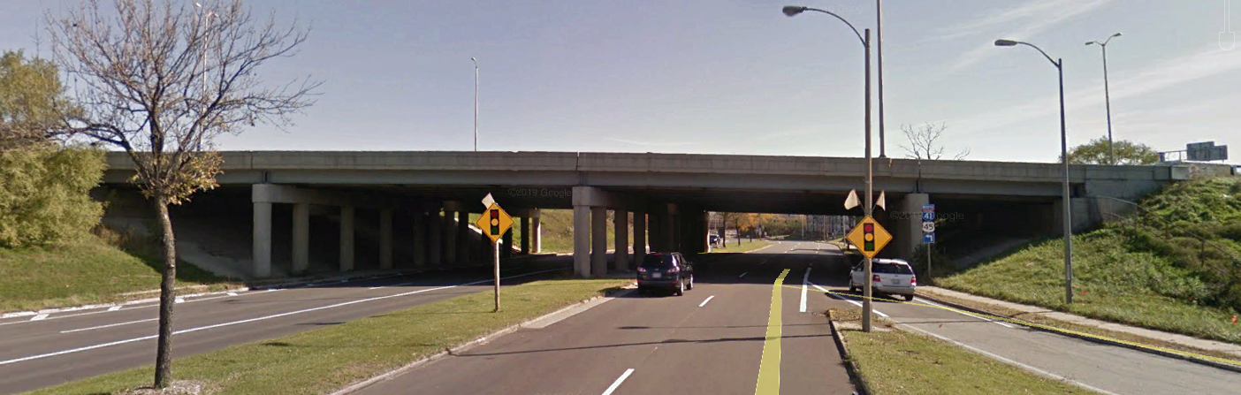

Figure 4: West Elevation IH41 SB Bridge at North Ave

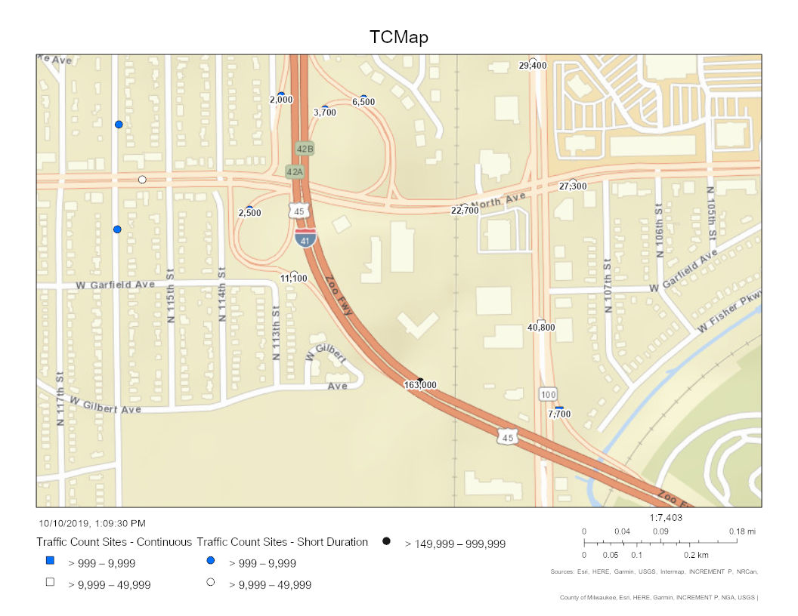

Figure : Existing Traffic Counts (AADT)

# Work Breakdown Structure

For the successful completion of this project the tasks required will be broken down by which discipline will focus on it; structural, transportation and environmental, and geotechnical. The team members will focus on their separate discipline and will complete the work in the order of data collection, data analysis, and the creating preliminary design. Once the preliminary design is created by each discipline it will be combined, reviewed, and finalized.

## Transportation Design

**1) Data Collection**

* (T.C.1) Obtain Existing Roadway Plans from WisDOT
* (T.C.2) Obtain traffic counts from WisDOT TC Website
* (T.C.3) Accident Data from WisDOT Traffic and Operations
* (T.C.4) Obtain Existing Roadway Plans from WisDOT
* (T.C.5) Obtain Future Forecasted Traffic Counts
* (T.C.6) WisDOT’s 2020 Standard Specifications for Highway and Structure Construction.

**2) Data Analysis**

* (T.A.1) Calculate ramp curves and roundabout curves.
* (T.A.2) Determine Optimal LOS for the roadway design
* (T.A.3) Determine Safe Geometry Cut and Fills
* (T.A.4) Determine Future Forecasted Traffic Counts **(Find from WISDOT-See Spread sheet)**
* (T.A.5) Determine TAZ Functionality
* (T.A.6) Analysis Review

**3) Preliminary Design**

* (T.PD.1) Design Roadway Features and Geometries using WisDOT’s 2020 Standard Specifications for Highway and Structure Construction
* (T.PD.2) Use AutoCAD/Civil 3D to establish a model of the project
* (T.PD.3) Estimate Quantity of Materials
* (T.FDR) Final Roadway Design Review

## Structural Design

**1) Data Collection**

* (SD.C.1) Obtain Existing Roadway Plans from WisDOT
* (SD.C.2) Obtain WisDOT Bridge Design Manual
* (SD.C.3) Obtain Traffic Count Data from Transportation Engineer
* (SD.C.4) Find the data for the live load, dead load, weather loads, safety factors, etc.
* (SD.C.5) Determine allowable safety factors using AASHTO LRFD Design
* (SD.C.6) WisDOT’s 2020 Standard Specifications for Highway and Structure Construction.

**2) Data Analysis**

* (SD.A.1) Determine allowable safety factors (WisDOT Bridge Manual)
* (SD.A.2) Calculate the Loads using WisDOT Bridge Manual (Excel)
* (SD.A.3) Analyze the loads using ANSYS and/or SAP2000
* (SD.A.4) Analyze wind, snow load with past records
* (SD.A.5) Analysis Review

**3) Preliminary Design**

* (SD.PD.1) Design Prestressed Structural Components using WisDOT’s 2020 Standard Specifications for Highway and Structure Construction
* (SD.PD.2) Design Structural Components using AASHTO LRFD Highway Bridge
* (SD.PD.3) Use AutoCAD/Civil 3D to establish Project Plans for Elevated Structures
* (SD.PD.4) Estimate Quantity of Materials
* (SD.FDR) Final Structural Design Review

## Environmental/Water Management

**1) Data Collection**

* (EW.C.1) Obtain Existing Roadway Plans from WisDOT
* (EW.C.2) Obtain site topography (County GIS), Soil Classification Data for Infiltration (USDA), and the existing water main depth
* (EW.C.3) Soil Classification Data for Infiltration (USDA)
* (EW.C.4) Identify and Locate Existing Utilities

**2) Data Analysis**

* (EW.A.1) Determine Approximate curve number for soils, and percent impervious surface
* (EW.A.2) Estimate volume of runoff for a 24 hr 100-year flood
* (EW.A.3) Determine Area of Drainage
* (EW.A.4) Calculate required size and dimensions of stormwater storage for design storm, check feasibility
* (EW.A.5) Analysis Review

**3) Preliminary Design**

* (EW.PD.1) Add Topography to Civil 3D as a surface, determine flow direction
* (EW.PD.2) Design Stormwater Storage and Sewer Changes
* (EW.PD.3) Utilized TR-55 to check feasibility
* (EW.PD.4) Use AutoCAD/Civil 3D to establish Project Plans
* (EW.PD.5) Meet Wisconsin DOT Standards
* (EW.PD.6) Estimate Quantity of Materials
* (EW.FDR) Final Design Review

## Geotechnical Design

**1) Data Collection**

* (G.C.1) Obtain Existing Roadway Plans from WisDOT
* (G.C.2) Obtain WisDOT Bridge Design Manual
* (G.C.3) Obtain data for the live load, dead load, weather loads, safety factors, etc.
* (G.C.4) Obtain WisDOT’s 2020 Standard Specifications for Highway and Structure Construction.

**2) Data Analysis**

* (G.A.1) Determine allowable safety factors (WisDOT Bridge Manual)
* (G.A.2) Determine Existing Subsurface Conditions
* (G.A.3) Determine if additional Subsurface Exploration is required
* (G.A.4) Determine Water Table Fluctuation for Winter and Summer Conditions
* (G.A.5) Determine Bearing Pressures of Soil
* (G.A.6) Analysis Review

**3) Preliminary Design**

* ( G.PD.1) Design Structural Components using AASHTO LRFD Highway Bridge Design Specifications
* (G.PD.2) Use AutoCAD/Civil 3D to establish Project Plans of Geotechnical Structures
* (G.PD.3) Estimate Quantity of Materials
* (G.FDR) Final Design Review

# Envision Checklist

The initial score received on the Envision Checklist is Silver. This score includes the credits for actions that have been planned for and are relevant to the project. This level is considered achievable for this project. However, this level can be improved on by digging deeper into the scope of the project and planning for future integrated technologies such as autonomous vehicles. For example, to plan for connected systems, the project team may include additional facilities such as empty distribution centers with conduits connecting pull boxes to loop detection raceways, future signal raceways, infrared sensors, camera and highway lighting poles. The score calculated was determined from expected plans and should viewed as a baseline. The final Envision score for this project will be determined upon completion of the build and can be revisited when design work begins.

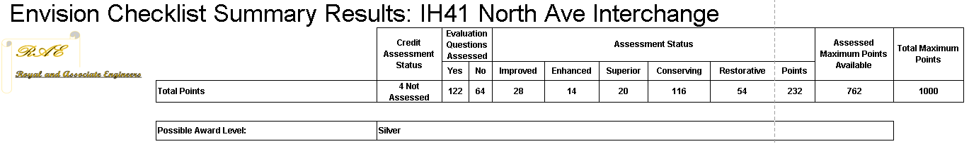

# Team Organization

Below is the figure displaying our Team Organization.  The Department of Transportation (DOT) is the client, and the two Project Mentors are Eric Perea (DOT) and Josh Mitchell (EMCS).  The (Structural) Project Manager is Luke Royal, alongside the team of Project Engineers consisting of Spencer Krautkramer (Structural), Taylor Mueller (Structural), Leah Stewart (Environmental/Water Resources), Ryan Neiheisel (Geotechnical), and Jordan Newson (Transportation).

Figure : Team Organization Chart

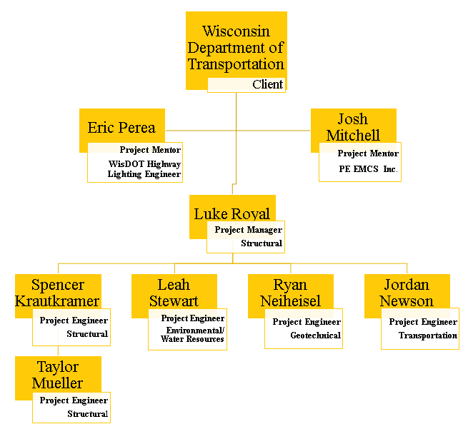

# References

Source: Esri, DigitalGlobe, GeoEye, i-cubed, USDA FSA, USGS, AEX, Getmapping, Aerogrid, IGN, IGP, swisstopo, and the GIS User Community

Google Maps, 2018. *Streetview of IH41 Bridge from North Avenue*, Google Maps [online] Retrieved from <https://maps.google.com>

Milwaukee County Land Information Office. (2019, July 16). *Parcels with Property Information.* [Shapefile]. Retrieved from <https://county.milwaukee.gov/EN/Administrative-Services/Land-Information-Office/GIS-Data-Downloads>

WisDOT (2012-2019) *Wisconsin Department of Transportation Traffic Count Interactive Map*. I-45 & North Ave. Retrieved from <https://wisconsindot.gov/Pages/projects/data-plan/traf-counts/default.aspx>

WisDOT (2018) *Wisconsin Department of Transportation Traffic Forecasting Planning-Level Forecasting Spreadsheet*. Retrieved from <https://wisconsindot.gov/Pages/projects/data-plan/traf-fore/default.aspx>

United States Geological Survey. Wauwatosa quadrangle, Wisconsin [geotif] (2018). 1:24000. 7.5 Minute Series. U.S. Department of the Interior, USGS, 2018. Retrieved from <https://ngmdb.usgs.gov/topoview/viewer/#4/40.00/-100.00>