CORRESPONDENCE/MEMORANDUM State of Wisconsin

Date: January 22, 2021

To: Beth Cannestra
Director, Bureau of Project Development
Attn: Richard Herrick

From: Bunmi Olapo
Southeast Region

Subject: PERPETUATION DESIGN STUDY REPORT
Project I.D. 3330-07-00
STH 31
Green Bay Road – City of Kenosha
STH 50 to CTH S
Kenosha County

Having considered the economic and social effects of this project, its impact on the environment, and its consistency with the goals of community planning, we request your approval of the attached design study report.

___________________________________________ _________
Region Project Development Chief Date

Concur:

___________________________________________ _________
Bureau of Project Development, Date
Design Oversight and Standards Services Chief

PERPETUATION DESIGN STUDY REPORT

1.0 Project Description and Need

1.2 Project Length and Termini
2.351 miles
Project Length:
Termini/Limits:
Green Bay Road- City of Kenosha
STH 50 to CTH S

1.3 Existing Roadway Information
Roadway | Functional Class (Principal or Minor Arterial, Collector or Local) | Surrounding Development Type? Rural, Urban or Transitional | Corridors 2030 or Backbone (No or State Which) | NHS Route (Yes or No) | Long Truck Route (No or State Federal or State) | Access Control Tier | On Ped. Trans. Plan (Yes or No) | On Bike Trans. Plan (Yes or No)
STH 31 | Principal Arterial | Urban | No | Yes | State/  Federal | 2A | Yes | Yes

Comments:

1.4 Need for Project
The last major rehabilitation for this segment of WIS 31 was performed in 2002. The non-reinforced, concrete pavement is in poor condition and experiencing longitudinal joint deterioration along center and edge lines, and transverse cracking resulting in an uneven surface. PCI ratings currently range from fair (56) to good (77) but are anticipated to decrease to very poor (43) to poor (55) by the time of construction. Existing IRI ratings (average of 2.856 mm/meter) along this corridor are outside of the acceptable range (0.8996 – 1.1364 mm/meter) and will worsen to an average of 3.140 mm/meter at the time of construction.
Underground loops, conduit and pull boxes have gone past their life expectancy at the intersections along WIS 31 at 67th Street, County K, WIS 158 and County S, respectively, and will need to be replaced.
Lastly, with the surrounding area adding sidewalk and a shared-use path as part of other abutting transportation projects, pedestrian accommodations will need to be addressed at the intersection of WIS 31 and County S to comply with ADA standards.

  - Proposed/Selected Alternative (State the Improvement Type and add brief description).
PSRS20, S-1

-Diamond grind existing concrete pavement
-Joint and crack repair
-Replace outdated traffic signal equipment
-Install ADA compliant curb ramps, crosswalks and median islands at STH 31/CTH S

2.0 Existing Facility Information

2.1 Posted Speed
Roadway or Roadway Segment | Posted Speed (MPH) | Advisory Speed (MPH)
STH 31 | 45 | NA
Comments:

2.4 Cross Section(s) Information
See Attachment 2 Existing Typical Sections

3.0 Traffic Information

3.1 Traffic Volumes/Conditions

Roadway or Roadway Segment | AADT⁽¹⁾
STH 31 | 31,700 – 35,200
- AADT = Average Annual Daily Traffic

3.2 Existing Crash Analysis
Was a Region Safety Certification Document completed? | x | Yes |  | No
Were any crash problems identified? | x | Yes |  | No
If Yes, did you discuss safety mitigation measures with the Region Safety Engineer? | x | Yes |  | No
Comments:
There will be no geometric improvements included in this project.

Pavement marking changes and additional signing will be added to mitigate the “assumed right turn rear end” crashes*.
*assumed right turn rear end crashes occur when a trailing vehicle incorrectly assumes the vehicle ahead is going to complete their right turn.

See attachment 3- Safety Certification Document.

4.3 Design Justifications (DJs)

4.3.1 Controlling Criteria Design Justifications (DJs)
None

4.3.2 Non-Controlling Criteria Design Justifications (DJs)
None

5.0 Proposed Design Improvements

5.1 Improvement Type:
Perpetuation S-1
PSRS20

Diamond grind existing concrete pavement, joint and crack repair, replace outdated traffic signal equipment

5.5 Proposed Cross Section/Pavement Structure Information
See attached Proposed Typical Section(s)

5.8 Permanent Traffic Control Information

Will permanent signs be installed? | x | Yes |  | No

5.9 Safety Enhancements/Mitigation Measures
Are Safety Mitigation Measures to be Implemented in these Crash Location Areas? | X | Yes |  | No
If so, Describe:
There will be no geometric improvements included in this project.

Pavement marking changes and additional signing will be added to mitigate the “assumed right turn rear end” crashes*.
*assumed right turn rear end crashes occur when a trailing vehicle incorrectly assumes the vehicle ahead is going to complete their right turn.

See attachment 3- Safety Certification Document.

5.11 Utilities
Is Project Trans 220 Utility Project (Yes or No)? Yes
Describe any special design features to accommodate utilities:
None

Major Utility Agreements:
None

Comments:

5.13 Financing and Scheduling Information
Construction I.D. | Cost Estimate | Type of Funding |  |  | Proposed Timeframe for Construction | Ties to Other Work or Projects | Alternative Contracting (Yes or No)
 |  | % Fed.¹⁴ | % State | % Local
3330-07-70 | $4,080,000 | 80% | 20% | 0% | 2023 | 3340-09-70 | No
¹⁴Fed. = Federal

Does Project Require a State/Municipal Agreement? |  | Yes | x | No

5.14 Unique Project Features
5.14.1 Does Project Require any Hazardous Waste Mitigation? | x | Yes |  | No
Comments:
2 HazMAT sites are located within the project limits

5.15.2 Does Project contain any Environmental Commitments? | x | Yes |  | No
Comments:
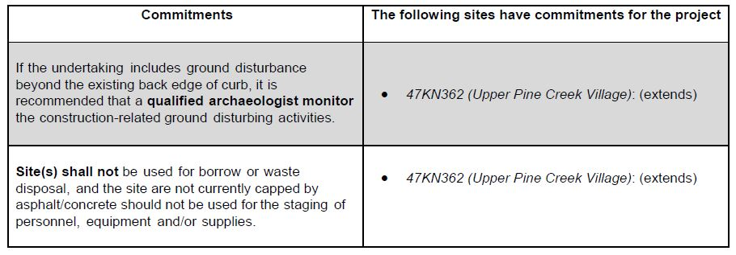

6.0 Synopsis
Reports, Documents and Coordination | Completion/ Approval Dates (xx/xx/xxxx) | Status of Coordination or Other Information as Needed
Concept Definition Report (CDR) | NA
Safety Certification Documentation (SCD) | 06/06/2019
Bridge or Structure Certification Document Approval (BOSCA) (if needed) | NA
Signed Pavement Design Report (PDR) | NA | Not required for diamond grinding
Public Involvement Plan (PIP) | 07/09/2019
Structure Survey Report (SSR) (if needed) | NA
Public Information Meeting(s) (PIM(s)) | 07/01/2020 | Project newsletter
Signed State Municipal Agreement(s) (SMA(s)) (if needed) | NA
Native American Lands of Interest (NALI) Scoping Determination | 02/06/2019
Final Scope Certification Document Approval (FSC) | 08/07/2019
SHPO Coordination Acceptance (Section 106, etc.) (SHPO) | 12/19/2019 | On screening list for Archaeology and History
DNR Coordination Acceptance (401 Cert., etc.) (DNR) | 07/02/2019
Preliminary Plan Review Complete (PPRC) | 06/09/2019
Preliminary Structure Plan Review Complete (PSPRC) (if needed) | NA
Signed Environmental Document (ED) Type: CEC | 01/11/2021
Interstate Access Justification Report (IAJR) | NA
Transportation Management Plan (TMP(s)) Type: 2 | Xx/xx/xxxx | In process of approval
Freight/ OSOW Accommodations Coordination (FOAC) | NA
Roadside Hazard Analysis Sheet (RHA) (if needed) | NA
Drainage Design Report (DDR) (if needed)
Status of Statutory Actions (SSA) (if needed) | NA
Comments:

7.0 Attachments
1- Project Location/Overview Map
2- Existing Typical Cross Section(s)/ Finished/Proposed Typical Cross Section(s)
3- Safety Certification Document (SCD)
4- Preliminary Plan Sheet(s)
5- Environmental Commitments Basic Sheet (if applicable) (include coordination letters)
- Roadside Hazard Analysis Sheet
- ADA Technically Infeasible documentation
- Non-Compliant Roadside design
6- 60% TMP (Transportation Management Plan)

