U.S. PUBLIC LAND SURVEY MONUMENT RECORD Wisconsin Department of Transportation
DT1291 2/2006

County Name |  | Name of Township, City, Village
Surveyor Name

Address, City, State, ZIP Code

Y (Northing) | X (Easting) | Latitude | Longitude
Project ID |  | Coordinate ID
HORIZONTAL DATUM | UNITS | COORDINATE SYSTEM
NAD 27  NAD 83 (1991)  NAD 83 (1997)  Other | English  Metric | Geodetic  State Plane Zone  County
Location Diagram, showing corner identification name, bearing and distance references to at least four witness monuments, fence or occupational lines, centerlines of roads, and other site details for reference. Also, show the bearings and distances between the witness monuments.
T. N.—R.
4th Principal Meridian
Corner
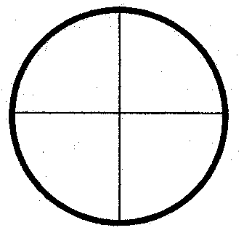
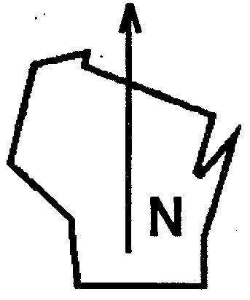

Indicate fd. = found or pl. = placed in the diagram below
Bearings used in the location sketch and basis for monument location are assumed, unless as noted.
Monumentation Legend / Description of Corner and Witness Monuments.

If applicable, show any discrepancy between the location of the corner as restored or re-established and the location of that corner as previously restored or re-established by bearing and distance. Also, show the bearings and distances between the previous corner and at least two of the witness monuments.

Basis for Monument Location
1. Describe any record evidence, monument evidence, occupational evidence or any other material evidence including traverse measurements that you considered, and whether the monument was found or placed. Explain below, be specific, and attach a separate sheet if necessary.
2. Was the corner:
a. found perpetuated,
b. restored through acceptance of obliterated evidence,
c. relocated by witness testimony, or
d. accepted as a remonumented corner of record and maintained with additional monumentation?
3. Was the corner re-established through lost corner proportionate methods? If so, show the method, including the directions and distances to other public land survey corners used as evidence or used in determining the corner location.

T. N.—R.
4th Principal Meridian
Corner
Affix Land Surveyor Seal
Certification
I, the undersigned, certify that the corner location shown on this record was determined by me or under my direction and control and that this U.S. Public Land Survey Monument Record is correct and complete to the best of my knowledge and belief, in accordance with Chapter A-E 7.08 of the Wisconsin Administrative Code.

Section Control Data Sheets have been filed in the County Surveyor’s office, showing final measurements by direction and distance between all remonumented corners. Section Control information is referenced by the following.
Date | Project ID |  | Sheet(s)
X
(Registered Land Surveyor Signature and Number) |  |  | (Date)

