Mix 160

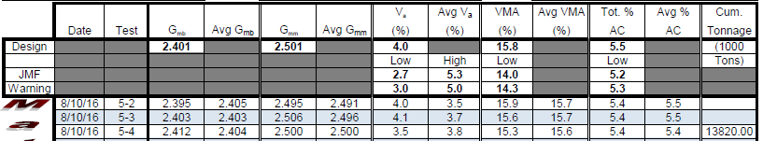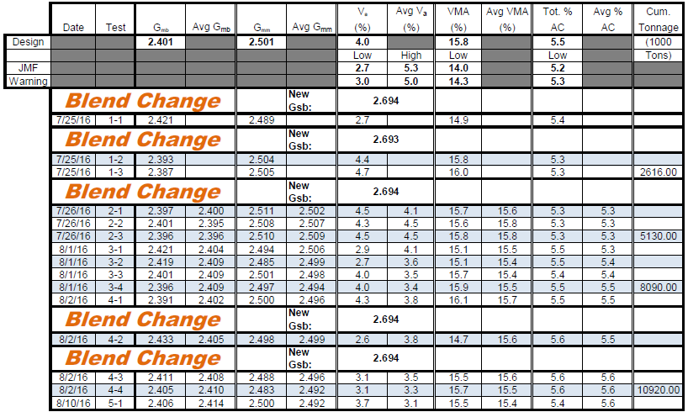

Sec. 6

Sec. 4

Sec. 3

Sec. 2

Sec. 1

Mix 161

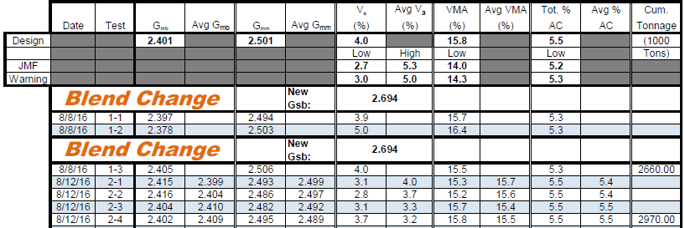

Sec. 7

Sec. 5

Mix 274

