**Town of Russell Project 8357-01-72 Status Update**

Northwest Region

**October 19, 2017**

**Overview:** The Northwest Region (NWR) of the Wisconsin Department of Transportation (WisDOT) is currently working with the Design Consultant Westbrook Associated Engineers, Inc. and the Management Consultant Knight E/A, Inc. to submit a design plan for Project 8357-01-72 for Little Sand Bay Road in the Town of Russell at the northern tip of Bayfield County (see figure below). The Town of Russell is currently not pleased with the status of this project. The design plan was originally submitted through the PS&E process on May 1, 2017 and went through the letting process on August 8, 2017. The low contractor bid was roughly $358,000 over Westbrook’s estimate of $746,085, so at the request of the Town and in agreement with WisDOT’s Central Office and NWR, that bid was rejected at the time. It was also agreed upon that the design plan would be resubmitted through the PS&E process on October 1, 2017 and then the letting process in early 2018. Leading up to the October 1st resubmittal, Westbrook was going to look for areas in the design plan where a cost savings could occur, but those cost savings were only going to be minimal in nature and clearly not enough to account for the $358,000. The Town expressed its displeasure to Westbrook, resulting in the design plan not being resubmitted on October 1st.

**Project Details:** As shown in the figure below, the project for Little Sand Bay Road was split into two sections receiving two different treatments. The beginning of the project from Old CTH K to Ridge Road would receive a full-depth pulverizing, a 2-inch base aggregate lift, and a 2.5-inch asphalt overlay, with shoulder widening included. The project from Ridge Road to the northern termini of Little Sand Bay Road would only receive a shoulder widening as the existing asphaltic surface was in acceptable condition. Roadway side slopes were minimized to 3:1 in order to lessen the grading limits with the shoulder widening throughout the project. The application for this project could not be found, but in general when local project applications are submitted to WisDOT, the local municipality chooses the treatment it desires and enters that on the application. Also included in each application is the original estimate for both design and construction as determined by the local municipality.

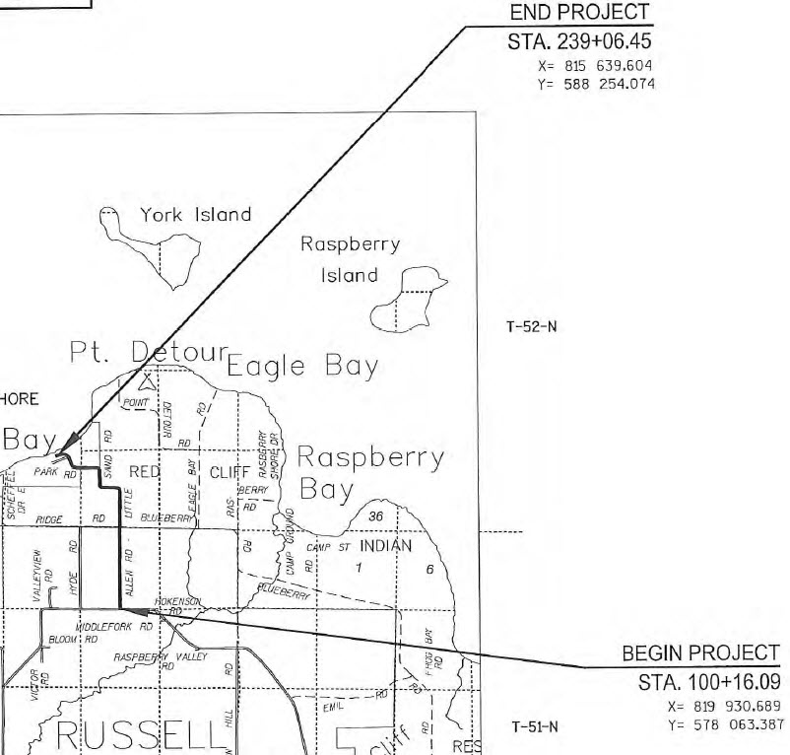**Project 8357-01-72**

Little Sand Bay Road

Ridge Road to Road Termini

No Pavement Work

Shoulder Widening Only

1.59 Miles

Little Sand Bay Road

Old CTH K to Ridge Road

Pulverize & Overlay

Shoulder Widening

1.04 Miles

**Funding, Estimate, and Bid Details:** A usual local project has 80% federal funds and 20% local funds. This project was different in that it has 100% federal funds: 71.21% Federal Lands Access Program (FLAP) funds and 28.79% National Park Service (NPS) funds. The total funding limit was set at $843,000 for design and construction in the State Municipal Agreement (SMA), with the Town agreeing to fund any project costs above that limit. Through the design process, Westbrook determined a construction estimate of $746,085. When the original letting process resulted in the low contractor bid being $358,000 over that estimate, Westbrook was required to submit a justification to WisDOT’s Central Office in regard to whether Westbrook’s estimate was reasonable and the contractor bids were reasonable. Westbrook stands by the quantities and bid prices contained within its estimate and does not believe the contractor bids were reasonable. Issues that may contribute to the contractor bids being considerably over estimate are listed below.

Issue #1: The Town requested that no project work be completed between Memorial Day and Labor Day as the northern termini of Little Sand Bay Road ends at a National Park with recreational facilities and campgrounds located on Lake Superior. Tourism to this location is vital to the area and peaks between those two holidays. The problem this presents is that there is a high likelihood of two scenarios: 1) the project starts before Memorial Day but cannot get completed by Memorial Day, so the project will need to then be completed after Labor Day following a work stoppage, or 2) the project starts after Labor Day but cannot get completed before winter weather starts, so the project will then need to be completed the following spring of the next year following a work stoppage. Contractors will bid such scenarios higher as this affects their overall company operations.

Issue #2: The location of this project is likely the main issue for the substantially-over-estimate bid. It truly is a remote outlier as it is at the very northern tip of Bayfield County near Lake Superior. Checking for aggregate sources nearest this project, the trucking costs will be greater than usual, and that is likely the driving force in the major items (Excavation Common, Base Aggregate Dense 1 ¼”, HMA Pavement, Mobilization) coming in substantially above Westbrook’s estimate. If bid prices for past projects in Bayfield County are compared, those past projects were likely located in the mid to southern portion of the County with closer proximity to aggregate sources, making a comparison to this project difficult.

Issue #3: There is a lack of contractor competition in general within NWR for the northern counties, but that lack can be further increased by project location and time of the letting process. The project location was discussed above. In regard to the time of the letting process, an August letting likely amplified the lack of competition for this remote project location. With an August 2017 letting for late 2017 construction, most contractors may have already had enough work and their construction season set, making this project a non-priority and resulting in fewer bids and/or high bids.

Issue #4: Because this project was scheduled to be 100% federally-funded, the Town likely did not plan ahead to fund any portion of this project, even though the Town did sign an SMA agreeing to fund any amount over the federal limit of $843,000. For example, even if the low contractor bid had come in $50,000 over Westbrook’s estimate, the Town may be unprepared to even fund that.

**Options Moving Forward:** There are several possible options moving forward as listed below. A short discussion of each follows.

|  |  |  |  |  |  |  |
| --- | --- | --- | --- | --- | --- | --- |
| Options | Option A | Option B | Option C | Option D | Option E | Option F |
| Description | Resubmit the PS&E as is and re-let in early 2018, hoping for lower bids. | Speak with the Town about completing work partially between Memorial Day and Labor Day. | Check if another funding source is available to cover the amount over $843,000. | Change the proposed treatment from pulverize & overlay & shoulder widening to mill & overlay. | Change the proposed treatment from pulverize & overlay & shoulder widening to cold in-place recycling. | Change the proposed treatment to pulverize & overlay with the shoulder widening eliminated. |

Option A: Resubmitting the PS&E as is with no changes and then reletting the project in early 2018 requires the least amount of effort. While the reletting of the project well before the upcoming full 2018 construction season would likely increase competition and/or result in lower bid prices, NWR expects the same result to happen, though, just to a lesser degree. Instead of the low contractor bid coming in $358,000 over Westbrook’s estimate, it may come in $100,000 over (or something similar). The Town will likely find this unacceptable and request to reject the bid for a second time.

Option B: Speaking with the Town about completing project work partially between Memorial Day and Labor Day would also require minimal effort. While the absence of any possible lengthy work stoppage would likely result in lower bid prices, NWR expects the same result to happen as described in Option A above. Option B could be combined with a couple of the following options and prove successful, though.

Option C: Checking if another funding source is available to cover the amount over $843,000 would also require minimal effort. Bill Zimmer could take the lead on this option to see if there are any other such sources.

Option D: Changing the proposed treatment from pulverize & overlay & shoulder widening to mill & overlay would take considerable effort. Because FLAP and NPS funds are used for this project, this change in project treatment would also have to be approved by those two entities. If approved, this change would result in considerably lower bids as the items Common Excavation (shoulder widening) and Base Aggregate (base aggregate lift and shoulder widening) would basically be eliminated. There would be a loss in roadway operations (less shoulder and overall width) and likely pavement life (less pavement substructure). This option could be combined with Option B for further bid reduction.

Option E: Changing the proposed treatment from pulverize & overlay & shoulder widening to cold in-place recycling would take considerable effort. Because FLAP and NPS funds are used for this project, this change in project treatment would also have to be approved by those two entities. If approved, this change would result in considerably lower bids as the items Common Excavation (shoulder widening) and Base Aggregate (base aggregate lift and shoulder widening) would basically be eliminated. There would be a loss in roadway operations (less shoulder and overall width) and likely pavement life (less pavement substructure). This option could be combined with Option B for further bid reduction.

Option F: Changing the proposed treatment to pulverize & overlay with the shoulder widening eliminated would take considerable effort. Because FLAP and NPS funds are used for this project, this change in project treatment would also have to be approved by those two entities. If approved, this change would result in considerably lower bids as the items Common Excavation (shoulder widening) and Base Aggregate (shoulder widening) would basically be eliminated, other than the base aggregate lift. There would be a loss in roadway operations (less shoulder and overall width) with the shoulder widths becoming less than even the existing widths due to the pulverize & overlay slightly raising the vertical profile. This option could be combined with Option B for further bid reduction.

|  |  |  |  |  |
| --- | --- | --- | --- | --- |
| Item Number | Item | Quantity* | Unit Cost | Item Cost |
| 205.0100 | Excavation Common |  |  |  |
|  |  |  |  |  |
|  |  |  |  |  |
|  |  |  |  |  |
|  |  |  |  |  |
| Total |  |  |  |  |

* Quantities are estimated at this time.

Current Issues and Risks:

|  |  |  |  |  |
| --- | --- | --- | --- | --- |
| Issue/Risk | Description | Probability | Impacts | Mitigation Measures |
| Traffic Impacts | Motorists and businesses will continue to be inconvenienced by construction operations into the 2018 season. | Moderate to High | Additional coordination with Village officials and local businesses. | Keep public informed via news releases and project website. Keep in close contact with Village officials and emergency services. Updates to the Lane Closure System. |
| Additional Costs | If traffic is not on final surface over winter shut down there will be additional costs incurred for: traffic control, temporary markings, asphalt wedging and removing within RAB, mobilization, etc. | Moderate | $25,000 – $75,0000 range | Project team will closely follow the construction schedule and the weather forecasts and will make a determination in mid-late October on revised TMP. |