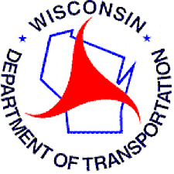

**MEMORANDUM** *Northwest Region Local Program*

**DATE:** December 22, 2016

**TO:** Lynn Cloud

Environmental Services

Room 451

HFSTB – Madison

**FROM:** Jeff Olson, P.E.

Local Program Project Manager

NW Region – Superior

**SUBJECT:** Section 106 Report

**Project ID # 8357-01-02**

Little Sand Bay Road

Old CTH K – Termini

Town of Russell

Bayfield County

Lynn,

Please process the attached Section 106 review for a Local Program town road project.

Thanks,

Jeff

715-395-3032