Appendix A: DRAFT Project Specific Impact Analysis Methodology

Project/Study title

**Impact Analysis Methodology Report**

I.D.

Highway Corridor

Limits (city – city)

Highway Limits

Counties

Table of Contents

Table of Contents

Revision History

Page

1.0 Introduction 1

1.1 Purpose of Impact Analysis Methodology 1

1.2 Project Background 1

1.3 Project Location 4

2.0 Agricultural Impact Methodology 6

2.1 Tier 1 6

2.2 Tier 2 6

3.0 Upland Habitat Impact Methodology 6

3.1 Tier 1 6

3.2 Tier 2 6

4.0 Threatened and Endangered Species Impact Methodology 6

4.1 Tier 1 6

4.2 Tier 2 7

5.0 Water Resource and Floodplain Impact Methodology 11

5.1 Tier 1 11

5.2 Tier 2 11

6.0 Wetland Impact Methodology 11

6.1 Tier 1 11

6.2 Tier 2 12

7.0 Air Quality Impact Methodology 12

7.1 Tier 1 12

7.2 Tier 2 12

8.0 Traffic Noise Impact Methodology 12

8.1 Tier 1 12

8.2 Tier 2 12

9.0 Construction Impact Methodology 12

9.1 Tier 1 12

9.2 Tier 2 13

10.0 Visual and Aesthetic Impact Methodology 13

10.1 Tier 1 13

10.2 Tier 2 13

11.0 Section 4(f), 6(f), and Other Unique Lands Impact Methodology 13

11.1 Tier 1 13

11.2 Tier 2 13

12.0 Historical Resources Impact Methodology 13

12.1 Tier 1 13

12.2 Tier 2 14

13.0 Archeological Resources Impact Methodology 14

13.1 Tier 1 14

13.2 Tier 2 15

14.0 Business and Residential Relocation Impact Methodology 16

14.1 Tier 1 16

14.2 Tier 2 16

15.0 Socio-Economic Impact Methodology 16

15.1 Tier 1 16

15.2 Tier 2 16

16.0 Environmental Justice Impact Methodology 16

16.1 Tier 1 16

16.2 Tier 2 16

17.0 Contaminated Sites Impact Methodology 16

17.1 Tier 1 16

17.2 Tier 2 16

18.0 Indirect Effects Impact Methodology 17

18.1 Tier 1 17

18.2 Tier 2 17

19.0 Cumulative Effects Impact Methodology 17

19.1 Tier 1 17

19.2 Tier 2 17

1. Introduction
   1. Purpose of Impact Analysis Methodology

Section 139 of Title 23 of the United States Code (USC) requires Lead Agencies for proposed federally funded transportation projects to determine the appropriate methodology and level of detail for analyzing impacts of these proposed transportation projects in collaboration with other state and local agencies. The Federal Highway Administration (FHWA) and the Wisconsin Department of Transportation (WisDOT) are Joint Lead Agencies for the Project/Study title, from Project/Study limits. Other federal, state and local agencies that are involved in the study process are designated as Cooperating or Participating Agencies.

Impact Analysis Methodology (IAM) for the Project/Study title is described in two reports, a General Impact Analysis Methodology Report, which is housed on the project’s website, and this Project Specific Impact Analysis Report which is included as Appendix A in the Coordination Plan for Agency and Public Involvement.

The General Impact Analysis Methodology Report contains two sections: the first section, laws, regulations and guidelines; and the second section, general methodologies commonly used on proposed WisDOT transportation projects to define, identify, and determine potential impacts to the resource.

This Project Specific Impact Analysis Methodology Report, includes project specific methodologies.

Consensus on the methodology[1] is not required, but the Joint Lead Agencies must consider the views of the Cooperating and Participating agencies with relevant interests before making a decision on a particular methodology. Well-documented, widely accepted methodologies, such as those for noise impact assessment and evaluation of impacts under Section 106 of the National Historic Preservation Act, would require minimal collaboration. If a Cooperating or Participating agency has concerns about the proposed methodology for a particular environmental factor, the agency should describe its preferred methodology and why it is recommended.

The purpose of the IAM Report is to communicate and document the Joint Lead Agencies’ structured approach to analyzing impacts of the proposed transportation project and its alternatives. Collaboration on the impact analysis methodology is intended to promote an efficient and streamlined process and early resolution of concerns or issues.

* 1. Project Background

Insert Study/project background description.

FHWA’s decision to prepare an EIS is based on the initial environmental investigation that indicates the proposed action is likely to have significant impacts on the environment, including wetlands. The study began preparing a Draft Environmental Impact Statement (DEIS) for the corridor, but was held from moving forward due to FHWA’s fiscal constraint requirements. Due to statewide priorities, it is unclear at this time whether funding for construction of the entire project will be available at the conclusion of the environmental process. Because this has the potential to conflict with FHWA’s fiscal constraint requirements, and because of the complexity of the project, WisDOT proposes to develop this project using the tiered NEPA approach. The tiered approach would allow WisDOT to bring forward portions of the project as needs dictate and as funding becomes available.

The Tier 1 EIS will primarily consist of the following aspects:

• The project's purpose and need

• Description and analysis results of a range of alternative corridors and representative impact alignments.

• Inventory of environmental resources and a broad, general evaluation of environmental impacts of the identified corridors or representative impact alignments.

• Strategies for minimizing or mitigating unavoidable impacts

• Identification of a preferred corridor alternative

As funding becomes available, subsequent Tier 2 environmental documents will be prepared with a greater degree of engineering detail for specific improvements in the remainder of the corridor. The alternative analysis in the Tier 2 documents will include, but is not limited to, the alternatives that have been developed as part of the previous EIS study.

The Tier 1 EIS will be prepared in accordance with 23 U.S.C. 139, 23 CFR 771, and 40 CFR parts 1500–1508. Completion of the Tier 1 EIS and the Record of Decision (ROD) is expected in year.

Public involvement is a critical component of the NEPA and will occur throughout the development of the draft and final Tier 1 EIS. All environmental documents will be made available for review by federal and state resource agencies and the public. Specific efforts to encourage involvement by, and solicit comments from, minority and low-income populations in the project study area will be made, with public involvement meetings held throughout the environmental document process. Public notice will be given as to the time and place of public involvement meetings. A public hearing will be held after the completion of the Draft Tier 1 EIS.

* 1. Project Location

Insert project location description.

The project termini are consistent with the Federal Highway Administration’s environmental regulations in 23 CFR 771. The proposed project is of sufficient length to ensure that environmental, social, and technical aspects are treated at a proper level of analysis; it allows for an analysis that has independence to all other projects; and it does not preclude future consideration of alternatives for other transportation improvements.

**Figure 2**

**Project Location Map**

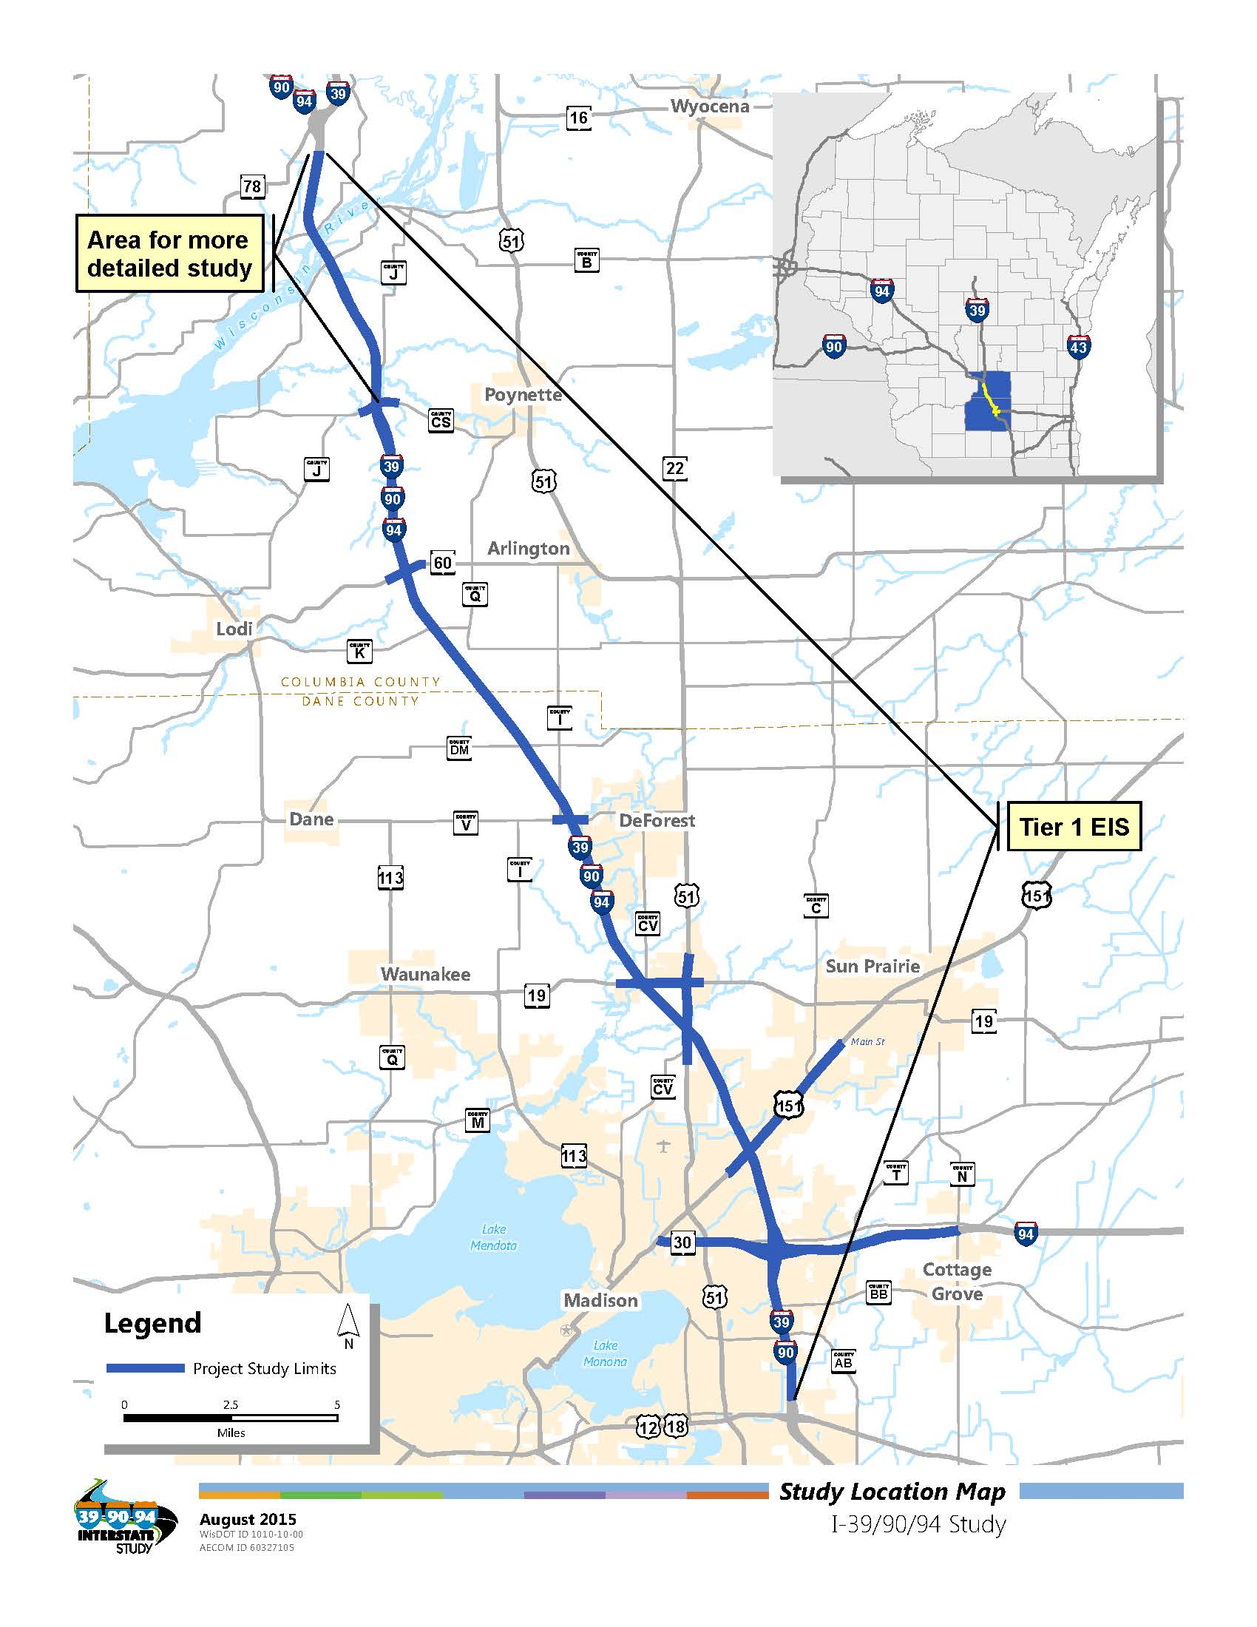

1. Agricultural Impact Methodology
   1. Tier 1

Agricultural lands will be inventoried using aerial photography and other secondary sources if available within the study area. No detailed Agricultural Impact Notice or Natural Resource Conservation Service (NRCS) CPA – 106 form will be prepared.

* 1. Tier 2

A detailed Agricultural Impact Notice will be prepared and submitted to the Department of Agricultural Trade and Consumer Protection (DATCP) if farm operations would be impacted. DATCP will determine whether an Agricultural Impact Statement is required. A CPA – 106 form will be completed and submitted to NRCS if farm operations would be impacted.

1. Upland Habitat Impact Methodology
   1. Tier 1

Upland habitat will be inventoried using aerial photography, data from the Wisconsin Department of Natural Resources (WDNR) Natural Heritage Inventory (NHI) Database, and the community types identified by Curtis in *Vegetation of Wisconsin* (1959). Applicable information from those resources and the results of the project’s habitat assessment within the project’s area of effect will be summarized in a natural habitat assessment report. The natural habitat assessment report will also be made available to interested agencies.

* 1. Tier 2

Field reviews will be conducted in areas identified to determine quality and classification of wildlife habitat.

1. Threatened and Endangered Species Impact Methodology
   1. Tier 1

A request will be made for WDNR to review the NHI database to identify if known species are located in the project area.

The United States Fish and Wildlife Service Midwest Region, Section 7(a)(2) Technical Assistance Website list will be reviewed periodically to identify any newly listed threatened or endangered species.

Natural habitats will be identified along the I-39/90/94 corridor and classified to vegetative community based on both WDNR Natural Heritage Inventory’s Natural Communities and the community types identified by Curtis in *Vegetation of Wisconsin* (1959). The community types will be compared to the preferred habitat of state and federally-protected species that are known to be present within or near the project corridor. A natural habitat assessment report will summarize the results of the survey, comparison of identified habitat to preferred habitat by protected species, and an assessment of the likelihood of the presence of protected species within the project’s area of effect. The natural habitat assessment report will also be made available to interested agencies.

* 1. Tier 2

Most, if not, all of the steps identified in Tier 1 will be updated in Tier 2. As Tier 2 documents are being prepared, WisDOT will coordinate with the regulatory agencies to determine the appropriate amount of data collection necessary to meet NEPA requirements.

If species or habitat areas are identified in the project area, WisDOT will consult with WDNR and/or USFWS to determine if specific field surveys are required. Timing of field investigations will vary depending on species or habitat areas identified and the future sequence of the Tier 2 segments being analyzed.

1. Water Resource and Floodplain Impact Methodology
   1. Tier 1

Water resources and floodplains will be inventoried using aerial photography, WDNR’s Surface Water Data Viewer, WDNR’s Lakes Page, Federal Emergency Management Agency’s (FEMA) Flood Insurance Rate Maps and other secondary sources if available within the study area. The 100-year floodplain will be identified on project maps.

The project will identify locations of water supply, wells and springs within a ¼ mile of the highway to inform the assessment of impacts.

* 1. Tier 2

For the segment between County CS and the I-39/WIS 78 interchange, a field review will be completed to identify water body characteristics for relevant waterway crossings; aquatic organism passage (AOP) issues will be assessed. A conceptual stormwater management plan will be developed within this segment. The conceptual plan will include the approximate type, size, and location of BMPs to control post-construction discharge rates, and a preliminary assessment of total suspended solids (TSS) removal in accordance with TRANS 401.

For project areas within the Lower Rock River Basin and Lower Wisconsin River Basin Total Maximum Daily Load (TMDL) study areas, a preliminary assessment of any required TMDL reductions will be completed. A final stormwater management plan will be developed in a future design phase when more detailed information is available with respect to drainage and other factors.

No new waterway crossing locations are anticipated; existing bridges and culverts may be lengthened, widened, and/or modified.

For relevant waterway crossings, AOP issues will be assessed using the draft WisDOT AOP guidelines. An assessment of existing culvert crossing locations will be completed for the corridor to address road crossing techniques that ensure aquatic organism passage, or the ability for fish and other aquatic creatures to move up or downstream under roadways.

If fill is placed into the 100-year floodplain, an analysis will be conducted to determine if changes to flood elevations have been made.

1. Wetland Impact Methodology
   1. Tier 1

Approximate wetland boundaries will be established using the Wisconsin Wetland Inventory (WWI) data maintained by WDNR, county soil survey, and farmed wetland maps produced by the USDA-NRCS statewide, and field surveys. For the Study Corridor corridor, approximate wetland boundaries will be mapped both within the existing highway right of way and outside of the existing right of way based on field observations and available mapping. The wetland identification report will be used to present information on affected wetland types and functional values. The wetland identification report will also be made available to interested agencies.

* 1. Tier 2

Wetland boundaries will be delineated in accordance with the US Army Corps of Engineers (USACE) Wetland Delineation Manual (1987 Manual), and appropriate regional subsequent guidance.

All unavoidable wetland losses will be compensated in terms of amount affected, type and functional value.

1. Air Quality Impact Methodology
   1. Tier 1

Dane and Columbia counties are in attainment for 1-hour and 8-hour ozone standards and for particulate matter (PM2.5) standards. Therefore neither an ozone analysis nor a (PM2.5) hot-spot analysis is required for the I-39/90/94 project.

* 1. Tier 2

For the section of the corridor from County CS to the I-39 and WIS 78 interchange, a qualitative mobile source air toxics (MSAT) analysis will be prepared in accordance with FHWA’s *Interim Guidance on Air Toxics Analysis in NEPA Documents**.*

No additional evaluation is needed if the project meets the exemption criteria located in the general impact analysis methodology guidelines located on the project website. If some of the Tier 2 segments do not meet the exemption criteria, then a MSAT analysis may be required and additional coordination between WisDOT and the WDNR will occur to determine the need of this analysis.

1. Traffic Noise Impact Methodology
   1. Tier 1

A determination would be made if the project qualifies as a Type 1 project per the guidelines in WisDOT’s Facilities Development Manual (FDM) Chapter 23 (Noise).

If the project is determined to likely be a Type 1 project per the guidelines in FDM Chapter 23, field measurements will be taken at locations along the corridor representative of active land uses. Field measurements will be taken at various distances perpendicular to the roadway (100’, 200’, 300’, 400, 500’) at 3 or 4 sites throughout the corridor to get an idea of how sound level change as you move away from the roadway. Field measurements will include traffic data (numbers and vehicle types) and speeds so TNM 2.5 model validation can be completed at this time.

* 1. Tier 2

If the project or section of the project being evaluated in the Tier 2 environmental document was determined to be a Type 1 project in the Tier 1 EIS, existing and design year traffic noise levels will be modeled at residential, commercial, and other sensitive receptors along the project corridor using FHWA’s Traffic Noise Prediction Model (TNM). Field measurements taken during the Tier 1 EIS will be utilized for model validation.

1. Construction Impact Methodology
   1. Tier 1

No project specific methodology has been identified.

* 1. Tier 2

Constructability considerations in order to appropriately and safely maintain traffic and other issues during construction could dictate project impacts and shape the alternative development.

A preliminary transportation management plan (TMP) for work zones will be developed.

1. Visual and Aesthetic Impact Methodology
   1. Tier 1

No project specific methodology has been identified.

* 1. Tier 2

Aesthetic features will be evaluated in subsequent Tier 2 environmental document(s) and be included in final design.

1. Section 4(f), 6(f), and Other Unique Lands Impact Methodology
   1. Tier 1

A preliminary Section 4(f) discussion/evaluation report identifying possible Section 4(f) involvement and special consideration related to use of publicly owned parks/facilities will be prepared toward the end of Tier 1.

The project team will request that WDNR identify Section 6(f) resources and any other resources that have received special funding in the project area.

Consultation with resource agencies may identify other unique lands with special funding associated and/or unique protection.

* 1. Tier 2

A Section 4(f) evaluation will be completed and included in subsequent Tier 2 environmental document(s).

1. Historical Resources Impact Methodology
   1. Tier 1

An archival literature search will be conducted for the project area.

Windshield surveys will be conducted following completion of the literature search, along the alternative corridors that may meet the purpose and need of the project. The surveys will follow the Wisconsin Historical Society (WHS) Survey Manual.

USACE has requested that they also be included in any Section 106 consultation because their regulations for processing permits also include procedures for protection of historic properties potentially affected by the permitted action (e.g. wetland excavation affecting an NRHP-eligible site).

In consultation with WisDOT, the State Historic Preservation Office (SHPO), and Indian American Tribes, FHWA may develop and execute a Project Specific Programmatic Agreement (PSPA) for inclusion in the Tier 1 Final EIS to establish a framework for the Tier 2 Section 106 studies and consultation. The PSPA would describe the studies and consultation undertaken in Tier 1 and outline the Tier 2 Section 106 methodology. The PSPA would establish that all of the work will conform to Section 106 and the SHPO’s reporting standards and formal NRHP determinations of eligibility will be submitted to SHPO for concurrence on any resources within the Area of Potential Effect (APE).

* 1. Tier 2

Historic investigations will be completed by qualified historians in accordance with established procedures developed jointly by WisDOT and the WHS. The investigations will include evaluation of the resources to determine eligibility to the NRHP, assessment of effects to determine whether an adverse effect will occur, consultation with the SHPO, Indian American Tribes, and other parties indicating an interest in the historic resources, and implementation of agreements reached to account for unavoidable adverse effect.

An architecture/history survey form will be completed documenting the survey in the area of potential effects. If resources will be adversely impacted, as per 36 CFR 800.11(e), a Section 106 summary report will be completed to document the undertaking’s effects on the historic properties, explain the applicable criteria of the adverse effect and to summarize the consulting parties and public views.

1. Archeological Resources Impact Methodology
   1. Tier 1

An archival literature search will be conducted for all corridors considered as part of the study.

The USACE has requested that they also be included in any Section 106 consultation because their regulations for processing permits also include procedures for protection of historic properties potentially affected by the permitted action (e.g. wetland excavation affecting an NHRP-eligible site). Phase 2 investigations will be completed after SHPO concurs with the archaeologist’s and historian’s recommendations.

In consultation with WisDOT, SHPO, and Indian American Tribes, the FHWA may develop and execute a PSPA for inclusion in the Tier 1 Final EIS to establish a framework for the Tier 2 Section 106 studies and consultation. The PSPA would describe the studies and consultation undertaken in Tier 1 and outline the Tier Two Section 106 methodology. The PSPA would establish that all of the work will conform to Section 106 and the SHPO’s reporting standards and formal NRHP determinations of eligibility will be submitted to SHPO for concurrence on any resources within the APE.

* 1. Tier 2

Archaeological investigations will be completed by qualified archaeologists in accordance with established procedures developed jointly by WisDOT and the WHS. The investigations will include evaluation of the resources to determine eligibility to the NRHP, assessment of effects to determine whether an adverse effect will occur, consultation with the SHPO, Indian American Tribes, and other parties indicating an interest in the archaeological resources, and implementation of agreements reached to account for unavoidable adverse impacts.

The Archeological Survey Field Report Form or detailed technical report will be completed documenting the survey in the area of potential effects. If resources will be impacted subsequent documentation will be completed.

1. Business and Residential Relocation Impact Methodology
   1. Tier 1

Businesses and residences will be identified using aerial photography and windshield surveys.

* 1. Tier 2

If businesses or residences would be displaced, a Conceptual Stage Relocation Plan (CSRP) will be prepared as part of the subsequent Tier 2 environmental document(s) if relocations are proposed. Impacts to businesses and homes due to changes in access during and after construction will also be evaluated.

1. Socioeconomic Impact Methodology
   1. Tier 1

Data for the socioeconomic impact assessment will be obtained using most current US Census Data and American Community Survey (ACS) and available supplemental data. Supplemental data will be obtained from local and regional land use plans, development plans, and discussion with local officials.

Local bicycle / pedestrian plans will be examined to inform a discussion of needs for bicycle and pedestrian accommodations.

* 1. Tier 2

No project specific methodology has been identified.

1. Environmental Justice Impact Methodology
   1. Tier 1

The analysis will be based on demographic information from the Wisconsin Demographic Services Center of the Department of Administration, the most current U.S. Census and the most recent American Community Survey. It will also be supplemented with information from local agencies/organizations and through public involvement and community outreach activities.

* 1. Tier 2

No project specific methodology has been identified.

1. Contaminated Sites Impact Methodology
   1. Tier 1

No project specific analysis will be completed during Tier 1.

* 1. Tier 2

No project specific methodology has been identified.

1. Indirect Effects Impact Methodology
   1. Tier 1

The Tier 1 effort will be a quantitative analysis for corridors under investigation. The effort will include public participation to inform the level and type of analysis performed. The study area will be limited to ¼ to ½ mile from corridors under investigation and use readily available data from local governments and agencies.

* 1. Tier 2

The Tier 2 effort will be more refined than the Tier 1 effort and specific for the Preferred Alternative. The effort will include public and stakeholder participation to inform the level and type of analysis performed. The study area will be limited to ¼ to ½ mile from the project limits and use readily available data from local governments and agencies.

An expert panel will be assembled in consultation with WisDOT staff consisting of local planners, developers, finance agencies and others in related professions that are knowledgeable of growth and development activities in the study area. The expert panel will be asked to provide local insight related to anticipated growth and development patterns.

Information about the purpose and need of the project, an explanation of the alternatives, and a summary of the direct effects of each alternative will be provided to each participant in advance of the meeting. Participants will be asked to determine the areas within their community that will be likely to experience indirect effects, including the magnitude of the effect, the certainty with which they feel the effect will happen, the timing of the potential effect, and what might be done to avoid or minimize the effect.

1. Cumulative Effects Impact Methodology
   1. Tier 1

The cumulative impacts assessment will include a geographic range no greater than the project area counties (Dane and Columbia) and a time frame no greater than the adopted local comprehensive plans in effect in those counties. “Other actions” and “past effects” to be considered in the analysis is limited to the public and private activities known by local governments or agencies to be “reasonably feasible”.

* 1. Tier 2

No project specific methodology has been identified.

1. The methodology used by the lead agency must be consistent with any methodology established by statute or regulation under the authority of another federal agency.