|  |  |  |
| --- | --- | --- |
| To |  | From |
| Patrick Laux, WisDOT  NE Region |  | Eric Youngblom  Jerry Shadewald |
|  |  | Date |
|  |  | 5/6/2012 - Original  7/6/2012 & 7/31/2013 - Revisions |
|  |  | Subject |
|  |  | US 41/WIS 441 Select Interchange  Analysis |
|  |  | HNTB Job Number |
|  |  | 44386 |
| Technical  Memorandum |  |  |



# Intro

Traffic forecasts were previously conducted in the US 41/WIS 441 corridor for years 2020 and 2035 based on 2008 traffic counts. A new set of traffic counts were collected in 2011 for the corridor. At five interchanges the traffic counts from 2008 to 2011 varied by more than 10% and require further analysis of recommended short and long term alternatives. These locations include: US 41/CTH BB, US 41/CTH N, US 41/CTH J, WIS 441/CTH OO, and US 41/WIS 96. The focus of the analysis is on the traffic operations of the intersections affected by the increased traffic counts. The updated 2020 traffic forecasts, the volume differences between the old and updated 2020 forecast, and the 2038 forecasts are shown in the appendix.

# US 41 and CTH N

The interchange of CTH N with US 41 was recommended for review of short term solutions due to an increase of traffic counts from 2008 to 2011 of 81%. Previous traffic forecasts did not warrant improvements on the US 41 ramps at CTH N. However, it was previously stated that the local intersections: CTH N and Moasis Drive, and CTH N and Evergreen Drive, will need improvements and should be coordinated with local officials.

The no build alternative (Figure 1) for CTH N was analyzed in Synchro using the updated 2020 and 2038 traffic forecasts; the LOS results are shown in Table 1 and Table 2. For the no build alternative the ramps are signalized and the local intersections are two-way stop controlled.

Figure 1: CTH N No Build

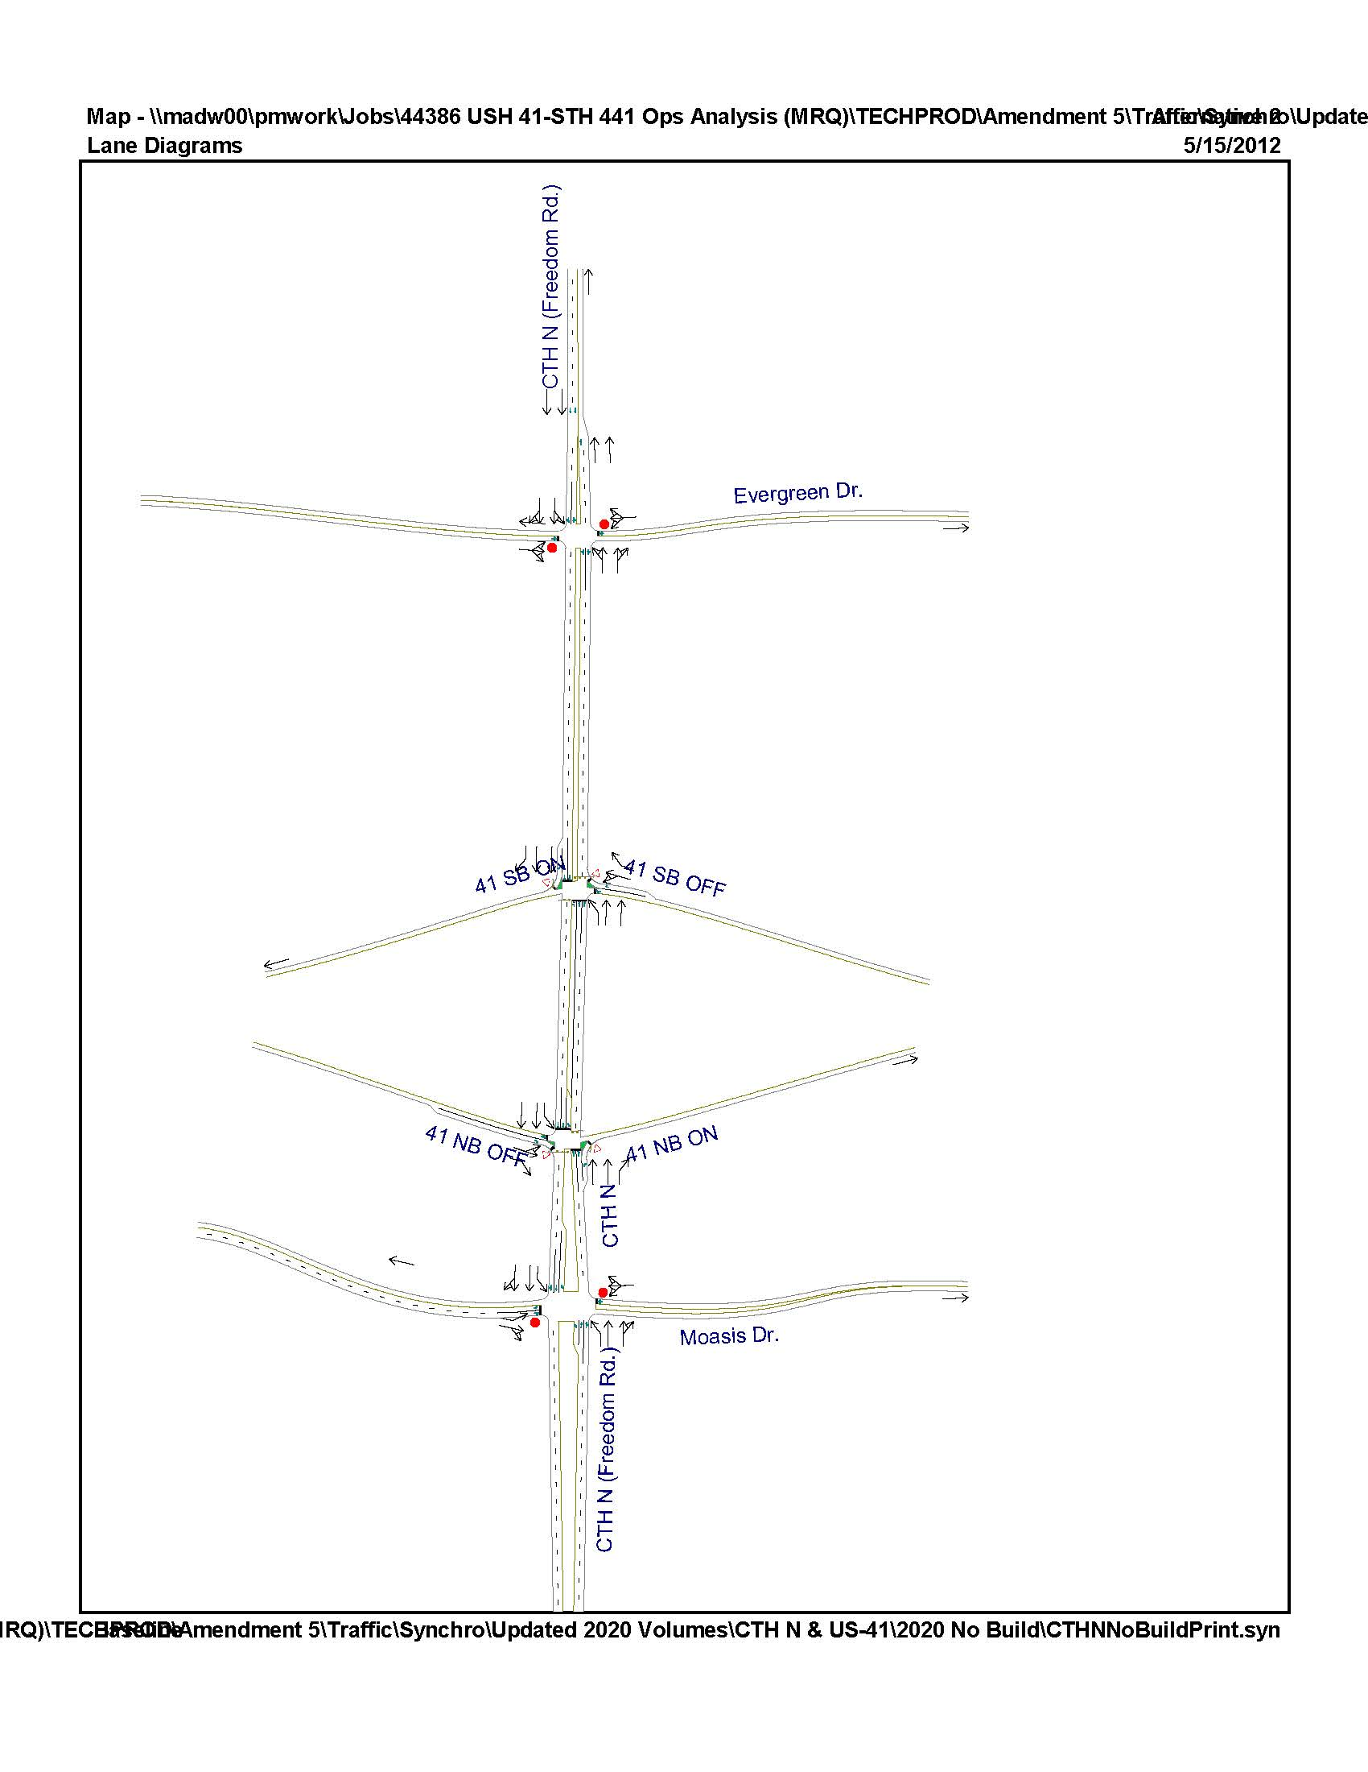

Table 1: LOS analysis of CTH N under no build alternative for forecast year 2020

|  |  |  |  |  |  |  |  |  |  |  |  |  |  |  |
| --- | --- | --- | --- | --- | --- | --- | --- | --- | --- | --- | --- | --- | --- | --- |
| **Intersection** | **Traffic Control** | **Peak Hour** | **Level of Service per Movement by Approach** | | | | | | | | | | | |
| **Eastbound** | | | **Westbound** | | | **Northbound** | | | **Southbound** | | |
| **LT** | **TH** | **RT** | **LT** | **TH** | **RT** | **LT** | **TH** | **RT** | **LT** | **TH** | **RT** |
| CTH N & Evergreen Dr. | Stop Sign | AM | C | C | C | **E** | **E** | **E** | A | A | A | A | A | A |
| 17.4 | 17.4 | 17.4 | **39.0** | **39.0** | **39.0** | 4.2 | 0.0 | 0.0 | 0.4 | 0.0 | 0.0 |
| PM | **D** | **D** | **D** | **F** | **F** | **F** | A | A | A | A | A | A |
| **32.1** | **32.1** | **32.1** | **>200** | **>200** | **>200** | 2.4 | 0.0 | 0.0 | 1.7 | 0.0 | 0.0 |
| CTH N & US 41 SB Off Ramp | Traffic Signal | AM |  |  |  | **D** | **D** | C | B | A |  |  | B | B |
|  |  |  | **35.6** | **35.6** | 24.8 | 11.4 | 1.5 |  |  | 17.4 | 18.2 |
| PM |  |  |  | **D** | **D** | C | A | A |  |  | B | B |
|  |  |  | **39.6** | **39.6** | 24.4 | 3.5 | 0.6 |  |  | 18.6 | 17.1 |
| CTH N & US 41 NB Off Ramp | Traffic Signal | AM | C | C | C |  |  |  |  | C | B | A | A |  |
| 32.5 | 32.5 | 26.6 |  |  |  |  | 20.7 | 17.7 | 7.8 | 4.1 |  |
| PM | **D** | **D** | C |  |  |  |  | C | B | C | A |  |
| **47.9** | **47.9** | 27.8 |  |  |  |  | 23.1 | 18.2 | 20.8 | 1.0 |  |
| CTH N  & Moasis Dr. | Stop Sign | AM | **F** | C | C | **E** | **E** | **E** | A | A | A | B | A | A |
| **>200** | 18.5 | 18.5 | **38.8** | **38.8** | **38.8** | 8.7 | 0.0 | 0.0 | 10.3 | 0.0 | 0.0 |
| PM | **F** | C | C | **F** | **F** | **F** | B | A | A | A | A | A |
| **>200** | 16.6 | 16.6 | **>200** | **>200** | **>200** | 10.2 | 0.0 | 0.0 | 0.0 | 0.0 | 0.0 |

Table 2: LOS analysis of CTH N under no build alternative for forecast year 2038

|  |  |  |  |  |  |  |  |  |  |  |  |  |  |  |
| --- | --- | --- | --- | --- | --- | --- | --- | --- | --- | --- | --- | --- | --- | --- |
| **Intersection** | **Traffic Control** | **Peak Hour** | **Level of Service per Movement by Approach** | | | | | | | | | | | |
| **Eastbound** | | | **Westbound** | | | **Northbound** | | | **Southbound** | | |
| **LT** | **TH** | **RT** | **LT** | **TH** | **RT** | **LT** | **TH** | **RT** | **LT** | **TH** | **RT** |
| CTH N & Evergreen Dr. | Stop Sign | AM | **F** | **F** | **F** | **F** | **F** | **F** | A | A | A | A | A | A |
| **>200** | **>200** | **>200** | **>200** | **>200** | **>200** | 5.7 | 0.0 | 0.0 | 0.6 | 0.0 | 0.0 |
| PM | **F** | **F** | **F** | **F** | **F** | **F** | A | A | A | A | A | A |
| **>200** | **>200** | **>200** | **>200** | **>200** | **>200** | 3.4 | 0.0 | 0.0 | 2.8 | 0.0 | 0.0 |
| CTH N & US 41 SB Off Ramp | Traffic Signal | AM |  |  |  | **E** | **E** | C | B | A |  |  | B | B |
|  |  |  | **72.6** | **72.6** | 25.7 | 13.2 | 1.5 |  |  | 18.5 | 19.4 |
| PM |  |  |  | **D** | **D** | C | A | A |  |  | C | B |
|  |  |  | **47.3** | **47.3** | 25.1 | 5.4 | 0.6 |  |  | 21.3 | 18.1 |
| CTH N & US 41 NB Off Ramp | Traffic Signal | AM | **E** | **E** | C |  |  |  |  | C | B | C | A |  |
| **59.6** | **59.6** | 27.6 |  |  |  |  | 23.0 | 19.6 | 23.9 | 4.4 |  |
| PM | **E** | **E** | **D** |  |  |  |  | C | C | C | A |  |
| **62.3** | **62.3** | **40.9** |  |  |  |  | 33.0 | 21.0 | 33.8 | 0.9 |  |
| CTH N & Moasis Dr. | Stop Sign | AM | **F** | **F** | **E** | **F** | **F** | **F** | A | A | A | B | A | A |
| **>200** | **>200** | **37.7** | **>200** | **>200** | **>200** | 9.5 | 0.0 | 0.0 | 11.0 | 0.0 | 0.0 |
| PM | **F** | **F** | **D** | **F** | **F** | **F** | B | A | A | B | A | A |
| **>200** | **>200** | **25.2** | **>200** | **>200** | **>200** | 11.2 | 0.0 | 0.0 | 13.7 | 0.0 | 0.0 |

The LOS on the ramps at CTH N did not fail under the no build alternative for forecast years 2020 and 2038,but did have poor operations in 2038 with many approaches receving LOS of D and E. The local intersections have operational issues in the 2020 and 2038 analysis.

The current interchange geometry at CTH N and US 41 was build to accommodate dual left turn lanes on both the northbound and southbound ramps. This alternative was analyzed in Synchro using year 2038 peak hour traffic forecasts (Table 3).

Table 3: LOS analysis of CTH N under alternative with dual lefts for forecast year 2038

|  |  |  |  |  |  |  |  |  |  |  |  |  |  |  |
| --- | --- | --- | --- | --- | --- | --- | --- | --- | --- | --- | --- | --- | --- | --- |
| **Intersection** | **Traffic Control** | **Peak Hour** | **Level of Service per Movement by Approach** | | | | | | | | | | | |
| **Eastbound** | | | **Westbound** | | | **Northbound** | | | **Southbound** | | |
| **LT** | **TH** | **RT** | **LT** | **TH** | **RT** | **LT** | **TH** | **RT** | **LT** | **TH** | **RT** |
| CTH OO & Evergreen Dr. | Stop Sign | AM | **F** | **F** | **F** | **F** | **F** | **F** | A | A | A | A | A | A |
| **>200** | **>200** | **>200** | **>200** | **>200** | **>200** | 5.7 | 0.0 | 0.0 | 0.6 | 0.0 | 0.0 |
| PM | **F** | **F** | **F** | **F** | **F** | **F** | A | A | A | A | A | A |
| **>200** | **>200** | **>200** | **>200** | **>200** | **>200** | 3.4 | 0.0 | 0.0 | 2.8 | 0.0 | 0.0 |
| CTH OO & US41 SB Off Ramp | Traffic Signal | AM |  |  |  | C | C | C | B | A |  |  | B | B |
|  |  |  | 32.6 | 32.6 | 25.7 | 13.5 | 2.3 |  |  | 18.5 | 19.4 |
| PM |  |  |  | C | C | C | A | A |  |  | C | B |
|  |  |  | 30.3 | 30.3 | 25.1 | 5.5 | 0.9 |  |  | 21.3 | 18.1 |
| CTH OO & US41 NB Off Ramp | Traffic Signal | AM | C | C | C |  |  |  |  | C | B | C | A |  |
| 31.6 | 31.7 | 27.6 |  |  |  |  | 23.0 | 19.6 | 24.3 | 6.4 |  |
| PM | C | C | **D** |  |  |  |  | C | C | C | A |  |
| 31.9 | 31.9 | **40.9** |  |  |  |  | 33.0 | 21.0 | 33.9 | 1.7 |  |
| CTH OO & Moasis Dr. | Stop Sign | AM | **F** | **F** | **E** | **F** | **F** | **F** | A | A | A | B | A | A |
| **>200** | **>200** | **37.7** | **>200** | **>200** | **>200** | 9.5 | 0.0 | 0.0 | 11.0 | 0.0 | 0.0 |
| PM | **F** | **F** | **D** | **F** | **F** | **F** | B | A | A | B | A | A |
| **>200** | **>200** | **25.2** | **>200** | **>200** | **>200** | 11.2 | 0.0 | 0.0 | 13.7 | 0.0 | 0.0 |

Adding duals lefts at the off ramps to the existing geometry improved the LOS at the ramp intersections significantly with only minimal improvements to the interchange.

The short term recommendation for CTH N/US 41 is to maintain existing geometry and to coordinate with local officials for the improvements of CTH OO at Evergreen Drive and Moasis Drive. Medium to long term recommendation is to add dual left turn lanes at the off ramps.

# US 41 and CTH BB

The interchange of CTH BB with US 41 was recommended for review of short term solutions due to an increase of traffic counts from 2008 to 2011 of 18%. Previously, alternative 2 (Figure 2) was recommended for implementation between years 2015-2017 with a useful life extending to 2028. The recommended alternative was analyzed with Synchro for year 2020 (Table 4) and 2038 (Table 5).

Figure 2: CTH BB Alternative 2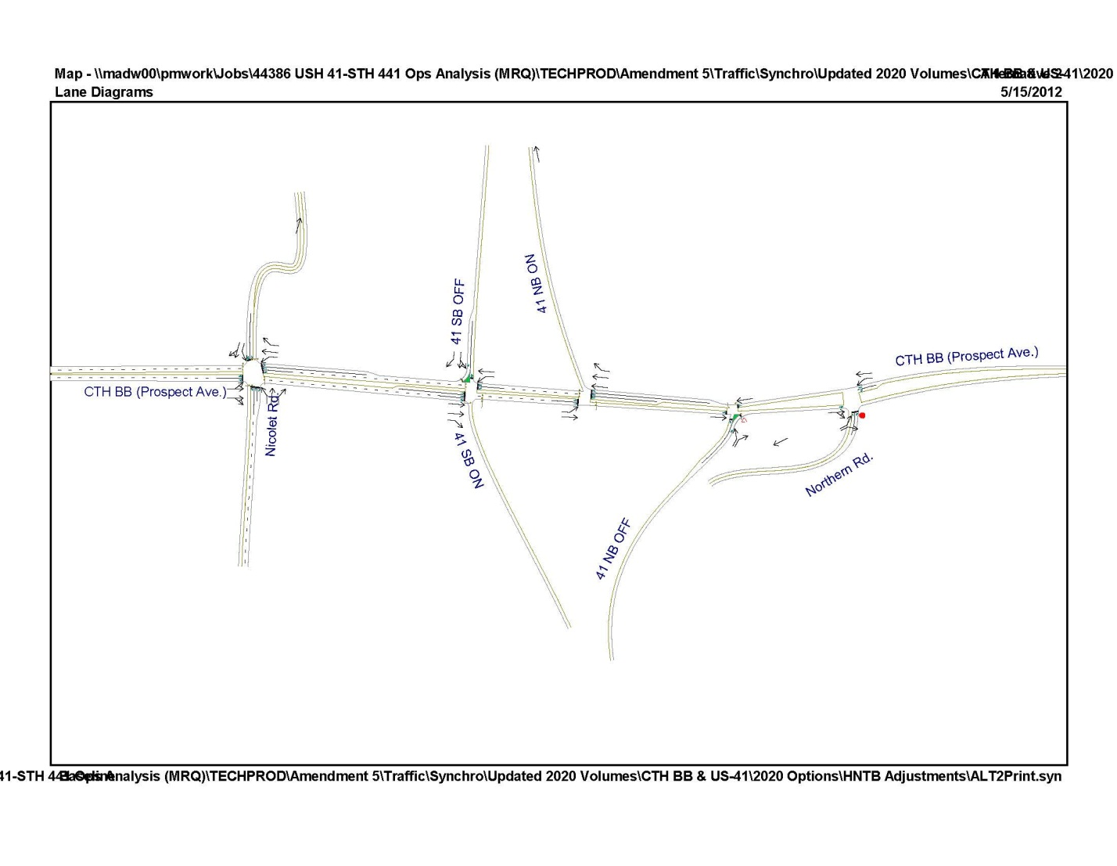

Table 4: LOS analysis of CTH BB under alternative 2 for forecast year 2020

|  |  |  |  |  |  |  |  |  |  |  |  |  |  |  |
| --- | --- | --- | --- | --- | --- | --- | --- | --- | --- | --- | --- | --- | --- | --- |
| **Intersection** | **Traffic Control** | **Peak Hour** | **Level of Service per Movement by Approach** | | | | | | | | | | | |
| **Eastbound** | | | **Westbound** | | | **Northbound** | | | **Southbound** | | |
| **LT** | **TH** | **RT** | **LT** | **TH** | **RT** | **LT** | **TH** | **RT** | **LT** | **TH** | **RT** |
| CTH BB & American Dr. | Traffic Signal | AM | **E** | **E** | **E** | **F** | A | A | **D** | **D** | **D** | **E** | **E** | **E** |
| **78.4** | **78.4** | **78.4** | **104.6** | 8.4 | 5.3 | **51.4** | **52.6** | **52.7** | **57.4** | **58.1** | **58.1** |
| PM | **F** | **F** | **F** | **F** | C | B | C | **D** | **F** | **D** | **D** | **D** |
| **104.8** | **104.8** | **104.8** | **180.2** | 22.7 | 16.4 | 32.5 | **35.3** | **173.7** | **35.3** | **37.4** | **37.4** |
| CTH BB & US 41 SB Off Ramp | Traffic Signal | AM |  | B | B | C | C |  |  |  |  | C | C | A |
|  | 17.7 | 12.4 | 31.7 | 20.3 |  |  |  |  | 31.9 | 31.9 | 0.3 |
| PM |  | C | C | **E** | A |  |  |  |  | C | C | A |
|  | 29.6 | 25.7 | **56.2** | 8.5 |  |  |  |  | 32.1 | 32.1 | 0.1 |
| CTH BB & US 41 NB On Ramp | Traffic Signal | AM | **D** | A |  |  | C | C |  |  |  |  |  |  |
| **54.3** | 0.4 |  |  | 29.1 | 21.0 |  |  |  |  |  |  |
| PM | **D** | A |  |  | C | B |  |  |  |  |  |  |
| **52.7** | 0.3 |  |  | 20.7 | 17.0 |  |  |  |  |  |  |
| CTH BB & US 41 NB Off Ramp | Traffic Signal | AM |  | B |  |  | B |  | C |  | C |  |  |  |
|  | 11.6 |  |  | 14.9 |  | 32.3 |  | 20.7 |  |  |  |
| PM |  | A |  |  | C |  | **D** |  | C |  |  |  |
|  | 5.5 |  |  | 21.5 |  | **37.4** |  | 22.5 |  |  |  |
| CTH BB & Northern Rd. | Stop Sign | AM |  | A | A | B | A |  | C |  | C |  |  |  |
|  | 0.0 | 0.0 | 10.1 | 0.0 |  | 19.1 |  | 19.1 |  |  |  |
| PM |  | A | A | B | A |  | **D** |  | **D** |  |  |  |
|  | 0.0 | 0.0 | 11.2 | 0.0 |  | **25.5** |  | **25.5** |  |  |  |

Table 5: LOS analysis of CTH BB under alternative 2 for forecast year 2038

|  |  |  |  |  |  |  |  |  |  |  |  |  |  |  |
| --- | --- | --- | --- | --- | --- | --- | --- | --- | --- | --- | --- | --- | --- | --- |
| **Intersection** | **Traffic Control** | **Peak Hour** | **Level of Service per Movement by Approach** | | | | | | | | | | | |
| **Eastbound** | | | **Westbound** | | | **Northbound** | | | **Southbound** | | |
| **LT** | **TH** | **RT** | **LT** | **TH** | **RT** | **LT** | **TH** | **RT** | **LT** | **TH** | **RT** |
| CTH BB & American Dr. | Traffic Signal | AM | **F** | **F** | **F** | **F** | B | A | **D** | **D** | **D** | **E** | **E** | **E** |
| **>200** | **>200** | **>200** | **>200** | 15.2 | 7.3 | **52.6** | **49.7** | **50.9** | **58.2** | **63.7** | **63.7** |
| PM | **F** | **F** | **F** | **F** | **D** | B | C | C | **F** | C | C | C |
| **>200** | **>200** | **>200** | **>200** | **36.6** | 15.7 | 24.8 | 27.9 | **>200** | 28.1 | 30.9 | 30.9 |
| CTH BB & US41 SB Off Ramp | Traffic Signal | AM |  | C | B | **D** | C |  |  |  |  | **D** | **D** | A |
|  | 25.5 | 15.2 | **43.6** | 23.8 |  |  |  |  | **38.9** | **38.9** | 0.6 |
| PM |  | **F** | **E** | **F** | B |  |  |  |  | C | C | A |
|  | **104.7** | **57.1** | **>200** | 18.1 |  |  |  |  | 30.0 | 30.0 | 0.3 |
| CTH BB & US41 NB On Ramp | Traffic Signal | AM | **F** | A |  |  | C | C |  |  |  |  |  |  |
| **107.4** | 0.4 |  |  | 26.7 | 21.0 |  |  |  |  |  |  |
| PM | **F** | A |  |  | **E** | **E** |  |  |  |  |  |  |
| **>200** | 0.5 |  |  | **70.6** | **60** |  |  |  |  |  |  |
| CTH BB & US41 NB Off Ramp | Traffic Signal | AM |  | C |  |  | C |  | **D** |  | C |  |  |  |
|  | 25.3 |  |  | 28.1 |  | **51.6** |  | 24.7 |  |  |  |
| PM |  | A |  |  | **D** |  | **E** |  | C |  |  |  |
|  | 9.0 |  |  | **45.3** |  | **70.8** |  | 30.4 |  |  |  |
| CTH BB & Northern Rd. | Stop Sign | AM |  | A | A | B | A |  | **D** |  | **D** |  |  |  |
|  | 0.0 | 0.0 | 11.6 | 0.0 |  | **29.9** |  | **29.9** |  |  |  |
| PM |  | A | A | A | A |  | **F** |  | **F** |  |  |  |
|  | 0.0 | 0.0 | 2.3 | 2.3 |  | **>200** |  | **>200** |  |  |  |

In year 2020 alternative 2 has LOS of E or better at all approaches with the exception of the intersection of American Drive/CTH BB. In year 2038 the alternative has failing movements at all intersections with the exception of US 41 NB off ramp, which has LOS of E or better. Alternative 2 was previously recommended to have a useful life through year 2028, however with the updated volume set the ramp intersections start to become congested in year 2020 and fail at some turning movements with 2038 volumes. The intersection of American Drive/CTH BB will need improvements in 2020 and should be coordinated with local officials. Alternative 2 can be viewed as a short term solution, however other alternatives need to be considered for implementation before 2028.

# WIS 441 and CTH OO

The interchange of CTH OO with WIS441 was recommended for review of short term solutions due to an increase in traffic counts from 2008 to 2011 of 41%. It was identified that the NB left turn movement during the AM peak was especially large, due to a new development to the west. It was recommended to reanalyze short to medium term alternative solutions. Previous recommendations called for a two phase approach to address operational concerns. The first phase (Alternative 1, Figure 3) was suggested to be implemented in year 2012-2014 with a useful life to 2020. For intersection improvements this phase called for an additional right turn lane at NB and SB ramp terminals. The second phase (Alternative 3,Figure 4) was suggested to be implemented in year 2018-2020 and had a useful life past year 2035. This alternative moved French Road 800 feet to the east and signalized the intersection with CTH OO. Also, additional turn lanes were proposed at the NB off ramp intersection and French Road intersection.

Alternative 1 was analyzed with updated 2020 traffic forecasts. Alternative 3 was analyzed with 2038 traffic forecasts. Additionally, a roundabout alternative (Alternative 5,Figure 5) was analyzed for year 2038 using HCS 2010 (HCS worksheets are in the Appendix).

Figure 3: CTH OO Alternative 1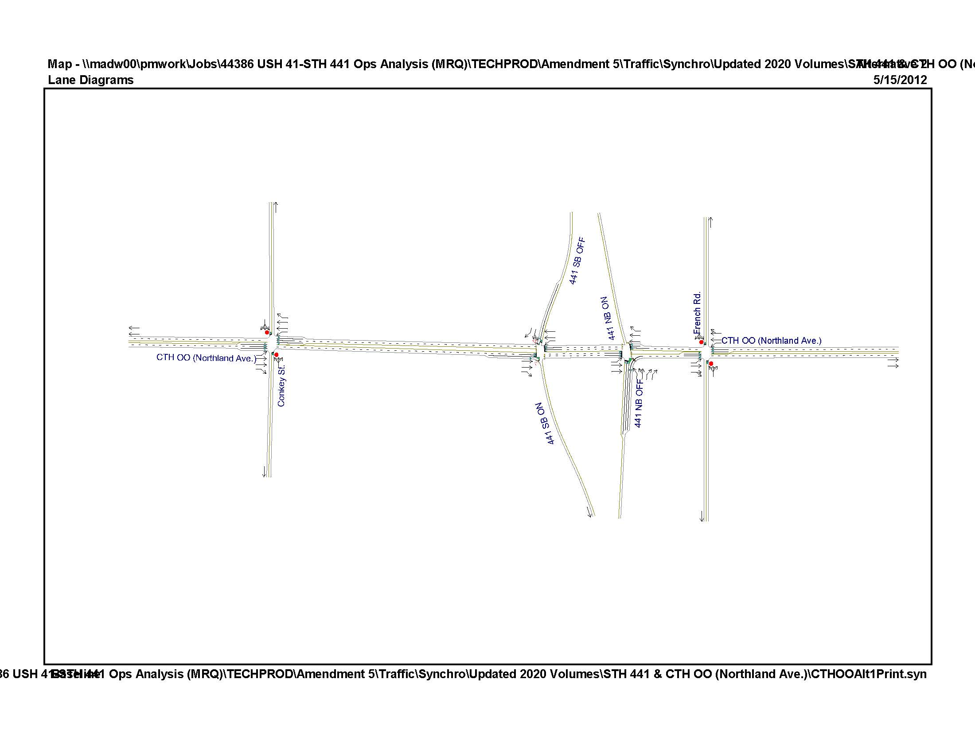

Figure 4: CTH OO Alternative 3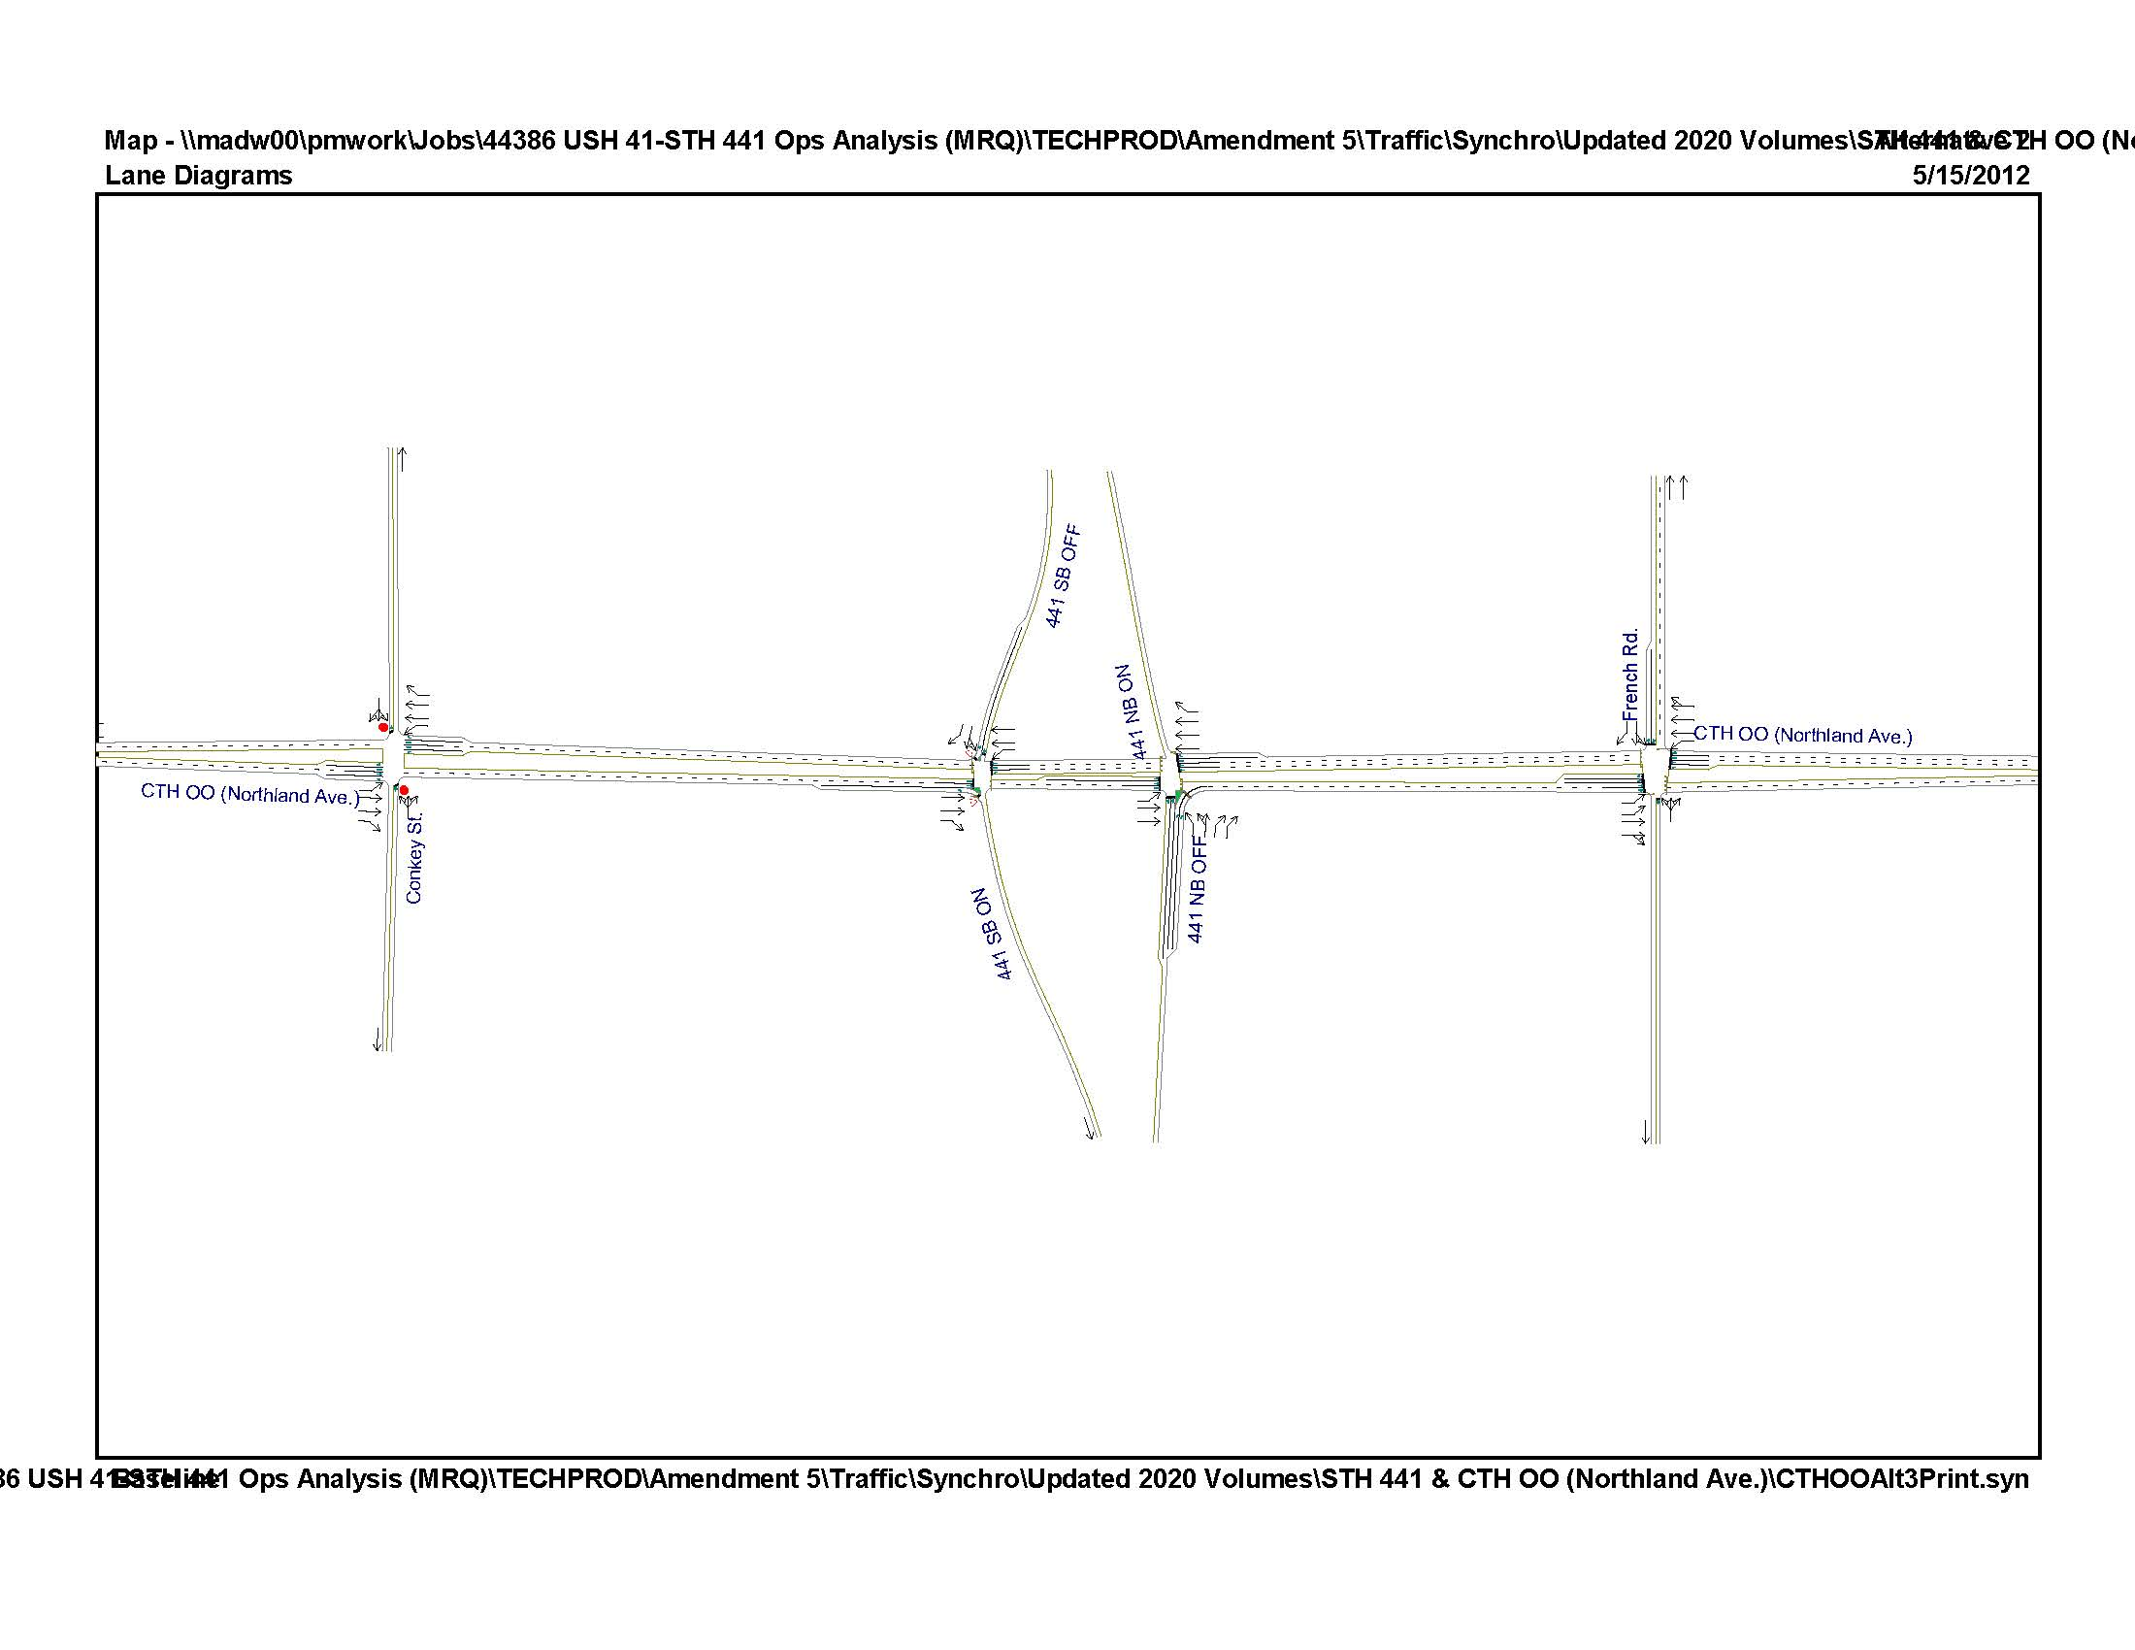

Figure 5: CTH OO Alternative 5

****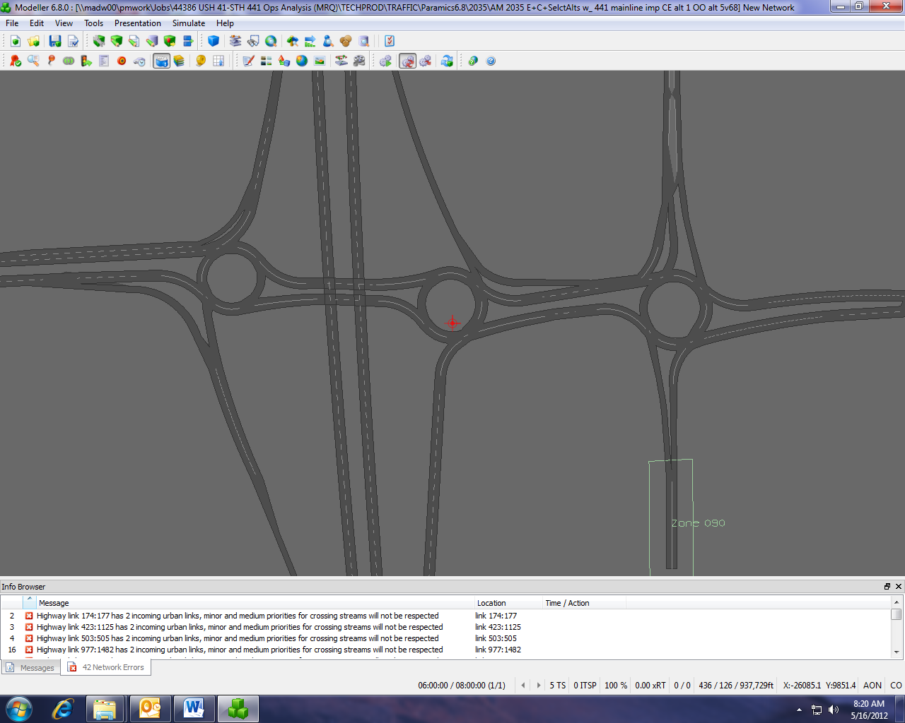

NB Off Ramp

SB Off Ramp

French Rd

SB Off Ramp

NB Off Ramp

CTH OO

Table 6: LOS analysis of CTH OO under Alternative 1 (Phase 1) for forecast year 2020

|  |  |  |  |  |  |  |  |  |  |  |  |  |  |  |
| --- | --- | --- | --- | --- | --- | --- | --- | --- | --- | --- | --- | --- | --- | --- |
| **Intersection** | **Traffic Control** | **Peak Hour** | **Level of Service per Movement by Approach** | | | | | | | | | | | |
| **Eastbound** | | | **Westbound** | | | **Northbound** | | | **Southbound** | | |
| **LT** | **TH** | **RT** | **LT** | **TH** | **RT** | **LT** | **TH** | **RT** | **LT** | **TH** | **RT** |
| CTH OO & Conkey St | Stop Sign | AM | C | A | A | B | A | A | **F** | **F** | **F** | **F** | **F** | **F** |
| 22.7 | 0.0 | 0.0 | 11.0 | 0.0 | 0.0 | **>200** | **>200** | **>200** | **>200** | **>200** | **>200** |
| PM | A | A | A | B | A | A | **F** | **F** | **F** | **F** | **F** | **F** |
| 0.1 | 0.0 | 0.0 | 14.0 | 0.0 | 0.0 | **>200** | **>200** | **>200** | **>200** | **>200** | **>200** |
| CTH OO & WIS 441 SB Off Ramp | Traffic Signal | AM |  | **D** | **D** | A | A |  |  |  |  | **D** | **D** | **D** |
|  | **45.9** | **45.4** | 3.1 | 1.0 |  |  |  |  | **51.4** | **51.4** | **52.3** |
| PM |  | C | **D** | A | A |  |  |  |  | C | C | C |
|  | 31.6 | **50.1** | 7.9 | 1.5 |  |  |  |  | 28.1 | 28.1 | 26.3 |
| CTH OO & WIS 441 NB Off Ramp | Traffic Signal | AM | B | A |  |  | **D** | C | **E** | **E** | C |  |  |  |
| 11.9 | 7.7 |  |  | **49.1** | 30.3 | **55.8** | **56.0** | 34.4 |  |  |  |
| PM | A | A |  |  | **D** | C | C | C | C |  |  |  |
| 5.9 | 7.8 |  |  | **38.4** | 26.0 | 27.4 | 27.4 | 34.1 |  |  |  |
| CTH OO & French Rd | Stop Sign | AM | C | A | A | A | A | A | **F** | **F** | **F** | **F** | **F** | **F** |
| 15.7 | 0.0 | 0.0 | 8.6 | 0.0 | 0.0 | **>200** | **>200** | **>200** | **79.0** | **79.0** | **79.0** |
| PM | A | A | A | A | A | A | **F** | **F** | **F** | **F** | **F** | **F** |
| 2.2 | 0.0 | 0.0 | 0.3 | 0.0 | 0.0 | **>200** | **>200** | **>200** | **>200** | **>200** | **>200** |

Table 7: LOS analysis of CTH OO under Alternative 3 (Phase 2) for forecast year 2038

|  |  |  |  |  |  |  |  |  |  |  |  |  |  |  |
| --- | --- | --- | --- | --- | --- | --- | --- | --- | --- | --- | --- | --- | --- | --- |
| **Intersection** | **Traffic Control** | **Peak Hour** | **Level of Service per Movement by Approach** | | | | | | | | | | | |
| **Eastbound** | | | **Westbound** | | | **Northbound** | | | **Southbound** | | |
| **LT** | **TH** | **RT** | **LT** | **TH** | **RT** | **LT** | **TH** | **RT** | **LT** | **TH** | **RT** |
| CTH OO & Conkey St | Stop Sign | AM | **E** | A | A | B | A | A | **F** | **F** | **F** | **F** | **F** | **F** |
| **38.0** | 0.0 | 0.0 | 14.3 | 0.0 | 0.0 | **>200** | **>200** | **>200** | **>200** | **>200** | **>200** |
| PM | B | A | A | **D** | A | A | **F** | **F** | **F** | **F** | **F** | **F** |
| 12.5 | 0.0 | 0.0 | **29.9** | 0.0 | 0.0 | **>200** | **>200** | **>200** | **>200** | **>200** | **>200** |
| CTH OO & WIS 441 SB Off Ramp | Traffic Signal | AM |  | C | C | **D** | **F** |  |  |  |  | **D** | **D** | C |
|  | 29.7 | 30.2 | **36.8** | **84.5** |  |  |  |  | **35.2** | **35.2** | 32.9 |
| PM |  | **D** | **F** | **F** | B |  |  |  |  | C | C | C |
|  | **47.0** | **90.3** | **114.8** | 18.8 |  |  |  |  | 28.1 | 28.1 | 26.5 |
| CTH OO & WIS 441 NB Off Ramp | Traffic Signal | AM | C | C |  |  | B | A | **F** | **F** | **D** |  |  |  |
| 21.7 | 21.8 |  |  | 14.0 | 2.4 | **176.8** | **176.8** | **44.3** |  |  |  |
| PM | B | B |  |  | B | A | C | C | **F** |  |  |  |
| 14.6 | 18.5 |  |  | 18.0 | 8.0 | 32.0 | 32.0 | **106.9** |  |  |  |
| CTH OO & French Rd | Traffic Signal | AM | C | A | A | **E** | C | C | **E** | **E** | **E** | **D** | **D** | **D** |
| 34.5 | 5.3 | 5.3 | **58.2** | 24.4 | 24.4 | **58.2** | **58.2** | **58.2** | **54.7** | **54.7** | **36.6** |
| PM | C | A | A | **D** | B | B | **D** | **D** | **D** | C | C | C |
| 33.8 | 2.6 | 2.6 | **48.0** | 19.8 | 19.8 | **43.0** | **43.0** | **43.0** | 30.3 | 30.3 | 30.3 |

Table 8: LOS analysis of CTH OO under Alternative 5 for forecast year 2038

|  |  |  |  |  |  |  |
| --- | --- | --- | --- | --- | --- | --- |
| **Intersection** | **Traffic Control** | **Peak Hour** | **Level of Service by Approach** | | | |
| **Eastbound** | **Westbound** | **Northbound** | **Southbound** |
|
| CTH OO & WIS 441 SB Off Ramp | Roundabout | AM | B | **F** |  | **F** |
| 10.5 | **>200** |  | **199.0** |
| PM | **E** | **E** |  | C |
| **39.5** | **45.7** |  | 19.6 |
| CTH OO & WIS 441 NB Off Ramp | Roundabout | AM | A | **F** | **F** |  |
| 7.3 | **>200** | **>200** |  |
| PM | **F** | **E** | **F** |  |
| **51.4** | **37.7** | **>200** |  |

Conkey and French Road intersections continue to have operational issues in alternative 1 and 3. These issues will need to be addressed with local officials. Ramp intersections for Alternative 1 have all turning movements maintaining LOS of E or better in 2020. Alternative 3 has operational issues with year 2038 traffic volumes. Alternative 3 needs to be reassessed to provide for an adequate medium to long term solution. The roundabout alternative (Alternative 5) failed at most of the approaches and is not a feasible alternative as a 2-lane roundabout. Additional 3-lane roundabout analysis using SIDRA is currently underway.

# US 41 and CTH J

The interchange of CTH J with US 41 was recommended for review of short and long term solutions due to an increase in traffic counts from 2008 to 2011 of 150%. The ramp intersections at the CTH J interchange have recently been constructed as single lane roundabouts with no right turn bypass lanes. It was recommended to analyze medium to long term solutions for the recently constructed roundabouts.

HCS 2010 was used to analyze the existing roundabouts (Figure 6) with year 2020 and 2038 forecasted traffic volumes. From WisDOT guidance the critical and follow up headways were set at 4.2 and 2.8 seconds. The approach LOS results are shown in Table 9 and Table 10.

Figure 6: Existing geometry for US 41 and CTH J interchange

****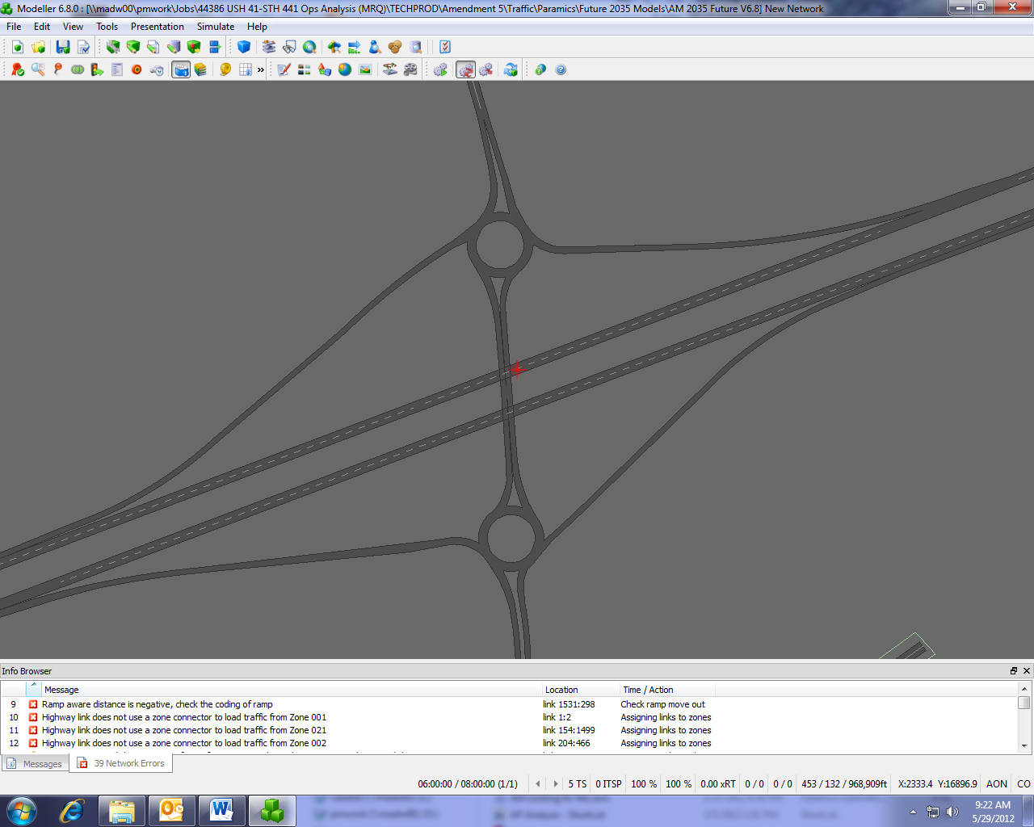

NB Off Ramp

SB Off Ramp

CTH J

Table 9: LOS analysis of CTH J with the existing geometry in year 2020

|  |  |  |  |  |  |  |
| --- | --- | --- | --- | --- | --- | --- |
| **Intersection** | **Traffic Control** | **Peak Hour** | **Level of Service by Approach** | | | |
| **Eastbound** | **Westbound** | **Northbound** | **Southbound** |
|
| CTH J & US 41 SB Off Ramp | Roundabout | AM |  | A | A | B |
|  | 9.1 | 8.2 | 11.3 |
| PM |  | C | A | B |
|  | 16.6 | 6.3 | 10.1 |
| CTH J & US 41 NB Off Ramp | Roundabout | AM | A |  | B | A |
| 8.0 |  | 13.5 | 6.2 |
| PM | B |  | B | B |
| 11.3 |  | 13.5 | 12.3 |

Table 10: LOS analysis of CTH J with the existing geometry in year 2038

|  |  |  |  |  |  |  |
| --- | --- | --- | --- | --- | --- | --- |
| **Intersection** | **Traffic Control** | **Peak Hour** | **Level of Service by Approach** | | | |
| **Eastbound** | **Westbound** | **Northbound** | **Southbound** |
|
| CTH J & US 41 SB Off Ramp | Roundabout | AM |  | B | A | **C** |
|  | 14.6 | 9.0 | **23.0** |
| PM |  | **E** | A | **D** |
|  | **37.6** | 6.8 | **29.1** |
| CTH J & US 41 NB Off Ramp | Roundabout | AM | B |  | **C** | A |
| 10.1 |  | **20.8** | 6.7 |
| PM | C |  | **E** | C |
| 19.6 |  | **35.7** | 15.2 |

During year 2020 both roundabouts maintain LOS C or better. In year 2038 the roundabouts have less than desirable operations with the existing geometry. No short term improvements are needed, but to address long term needs, varying configurations of right turn semi-bypass lanes were analyzed with year 2038 traffic volumes.

The semi-bypass lane improvements analyzed include (results shown in Table 11) :

* SB off ramp:
  + Westbound approach (exit ramp)
  + Southbound approach (CTH J entering the interchange)
  + Combination of westbound and southbound approaches
* NB off ramp
  + Eastbound approach (exit ramp)
  + Northbound approach (CTH J entering the interchange)
  + Combination of eastbound and northbound approaches

Table 11: LOS analysis of CTH J with improvements in year 2038

|  |  |  |  |  |  |  |
| --- | --- | --- | --- | --- | --- | --- |
| **Intersection** | **Traffic Control** | **Peak Hour** | **Level of Service by Approach** | | | |
| **Eastbound** | **Westbound** | **Northbound** | **Southbound** |
|
| CTH J & US 41 SB Off Ramp Semi-bypass West | Roundabout | AM |  | A | A | C |
|  | 7.7 | 9.0 | 23.0 |
| PM |  | C | A | **D** |
|  | 16.0 | 6.8 | **29.1** |
| CTH J & US 41 SB Off Ramp Semi-bypass West/South | Roundabout | AM |  | A | A | A |
|  | 7.7 | 9.0 | 8.5 |
| PM |  | C | A | A |
|  | 16.0 | 6.8 | 8.8 |
| CTH J & US 41 NB Off Ramp Semi-bypass North | Roundabout | AM | B |  | A | A |
| 10.1 |  | 7.6 | 6.7 |
| PM | C |  | A | C |
| 19.6 |  | 9.3 | 15.1 |

The recommended improvement before year 2038 for the NB off ramp is to construct a semi-bypass lane for the northbound approach. This semi-bypass lane scenario has operations of LOS C or better at all approaches. The roundabout at the SB off ramp has LOS of C or better with both the westbound and southbound semi-bypass lanes. However, due to environmental constraints in may only be plausible to build a semi-bypass lane for one approach. From the HCS analysis, the westbound approach semi-bypass lane would be the priority.

# US 41 and WIS 96

Updated traffic counts were collected at the US 41 and WIS 96 interchange on January 16, 2013. Previous traffic counts collected for this study were completed in early December 2011, which was believed to have included abnormially high shopping traffic due to the proximity of the Fox Valley Mall to the WIS 96 interchange.

Recent construction of auxillary lanes along US 41 connecting the WIS 125 and WIS 96 ramps has improved operations within the WIS 96 Interchange. The interchange ramp terminals and adjacent intersections were analyzed with existing geometry and year 2038 traffic forecasts. The AM and PM peak hours LOS results as reported by Synchro’s implementation of HCS 2010 are shown in Table 12.

Table 12: LOS analysis of existing WIS 96 Interchange for forecast year 2038

|  |  |  |  |  |  |  |  |  |  |  |  |  |  |  |
| --- | --- | --- | --- | --- | --- | --- | --- | --- | --- | --- | --- | --- | --- | --- |
| **Intersection** | **Traffic Control** | **Peak Hour** | **Level of Service per Movement by Approach** | | | | | | | | | | | |
| **Eastbound** | | | **Westbound** | | | **Northbound** | | | **Southbound** | | |
| **LT** | **TH** | **RT** | **LT** | **TH** | **RT** | **LT** | **TH** | **RT** | **LT** | **TH** | **RT** |
| Westhill & WIS 96 | Traffic Signal | AM |  | A | A | A | A |  | C |  | C |  |  |  |
|  | 8.4 | 6.5 | 8.2 | 4.7 |  | 27.3 |  | 30.0 |  |  |  |
| PM |  | C | C | **D** | A |  | **D** |  | **D** |  |  |  |
|  | 30.8 | 24.4 | **40.8** | 7.8 |  | **51.3** |  | **42.7** |  |  |  |
| US 41 NB ramp & WIS 96 | Traffic Signal | AM | B | A |  |  | C | C | C | - | A |  |  |  |
| 17.8 | 5.3 |  |  | 27.5 | 22.6 | 34.5 | - | 0.0 |  |  |  |
| PM | C | A |  |  | **D** | C | **D** | - | A |  |  |  |
| 24.2 | 4.3 |  |  | **43.1** | 22.7 | **52.1** | - | 0.0 |  |  |  |
| US 41 SB ramp & WIS 96 | Traffic Signal | AM |  | **D** | A | B | A |  |  |  |  | **D** | | A |
|  | **42.6** | 0.0 | 18.7 | 7.4 |  |  |  |  | **39.3** | | 0.0 |
| PM |  | **D** | A | C | A |  |  |  |  | **D** | | A |
|  | **49.5** | 0.0 | 25.8 | 8.7 |  |  |  |  | **52.0** | | 0.0 |
| Greenville & WIS 96 | Traffic Signal | AM | C | B | B | C | A | A | C | C | B | C | C | A |
| 28.1 | 16.4 | 13.5 | 21.2 | 8.6 | 0.0 | 21.5 | 21.0 | 11.7 | 25.0 | 26.5 | 0.0 |
| PM | **D** | C | B | **D** | B | A | C | C | B | **D** | **D** | A |
| **42.8** | 34.3 | 19.6 | **42.4** | 12.6 | 0.0 | 27.6 | 30.0 | 14.4 | **46.1** | **52.2** | 0.0 |

The operational analysis for WIS 96 shows all turning movements at the ramp terminals and adjacent intersections have acceptable operations of LOS D or better. A queue analysis was also conducted for this interchange using SimTraffic. The analysis suggested excessive queuing during the PM peak at the WB approach of the NB ramp terminal and for the EB and SB approaches at the Greenville/WIS 96 intersection. Geometric improvements at these locations have been identified as part of the long term alternative development process. Those identified improvement will help alleviate queues at the interchange.

# Summary

Traffic counts were taken in 2011 for interchanges within the US 41/ WIS 441 corridor. At five interchanges there were traffic counts that varied by more than 10 % from previous traffic counts taken in 2008 and justified a reassesement of recommended alternatives. The results from the analysis and updated recommendations are summarized below.

* *US 41/ CTH N:* This interchange operates adequately in year 2020 with operational issues occuring in year 2038 (many approaches with LOS D and E) with a no build alternative. The intersection was build to accommodate dual lefts at both the off ramps. Adding the dual lefts greatly improves the operation of the intersection in year 2038. The local intersections: Evergreen Drive/CTH OO and Moasis Drive/CTH OO have turning movements failing in year 2020. These two intersection need to be coordinated with local officials for improvements.
* *US 41/ CTH BB:* Alternative 2 was previously recommended for a short term solution with a useful life through year 2028. With the exception of CTH BB/American Drive intersection, the operation of the interchange in year 2020 maintained LOS of E or better. However, multiple turning movements failed during the 2038 analysis. This alternative can continue to viewed as a short term solution, but a longer term solution should be implemented prior to year 2028. Improvements to the local intersections need to coordinated with local officials; with CTH BB/American Drive having a higher priority over CTH BB/Nothern Road.
* *WIS 441/CTH OO:* Previously this interchange was recommended to have a two phase approach to address short and long term traffic. The recommended first phase (Alternative 1), maintained LOS of E or better in 2020. Phase 2 (Alternative 3), has multiple turning movements with LOS F during 2038. This alternative needs to be reassessed for a long term solution. A 2-lane roundabout alternative (Alternative 5) was analyzed with HCS and had LOS F at most approaches. A 3-lane roundabout analysis using SIDRA is currently underway. Improvements need to be coordinated with local officials for the intersections of CTH OO with Conkey Street and French Road.
* *US 41/ CTH J:* The existing roundabouts constructed at US 41/ CTH J are acceptable (LOS C or better) at year 2020. The roundabouts incur LOS E at a few approaches during 2038. The recommendended long term improvements are to add a semi-bypass lane for the northbound approach at the NB off ramp, and for the SB off ramp adding a semi-bypass lane for the westbound approach.
* *US 41/ WIS 96:* Using the updated traffic forecasts, the operational analysis for the intersections at US 41/WIS 96 suggests the existing geometry provides acceptable operations (LOS D or better) for year 2038 peak hours, but excessive queues may exist during the PM peak hour. The long term improvements identified for year 2038 will help alleviate queues at the interchange.

**Appendix:**

**Updated 2020 and 2038 Traffic Forecasts**

**Updated 2020 traffic forecast for US41/CTH N interchange**

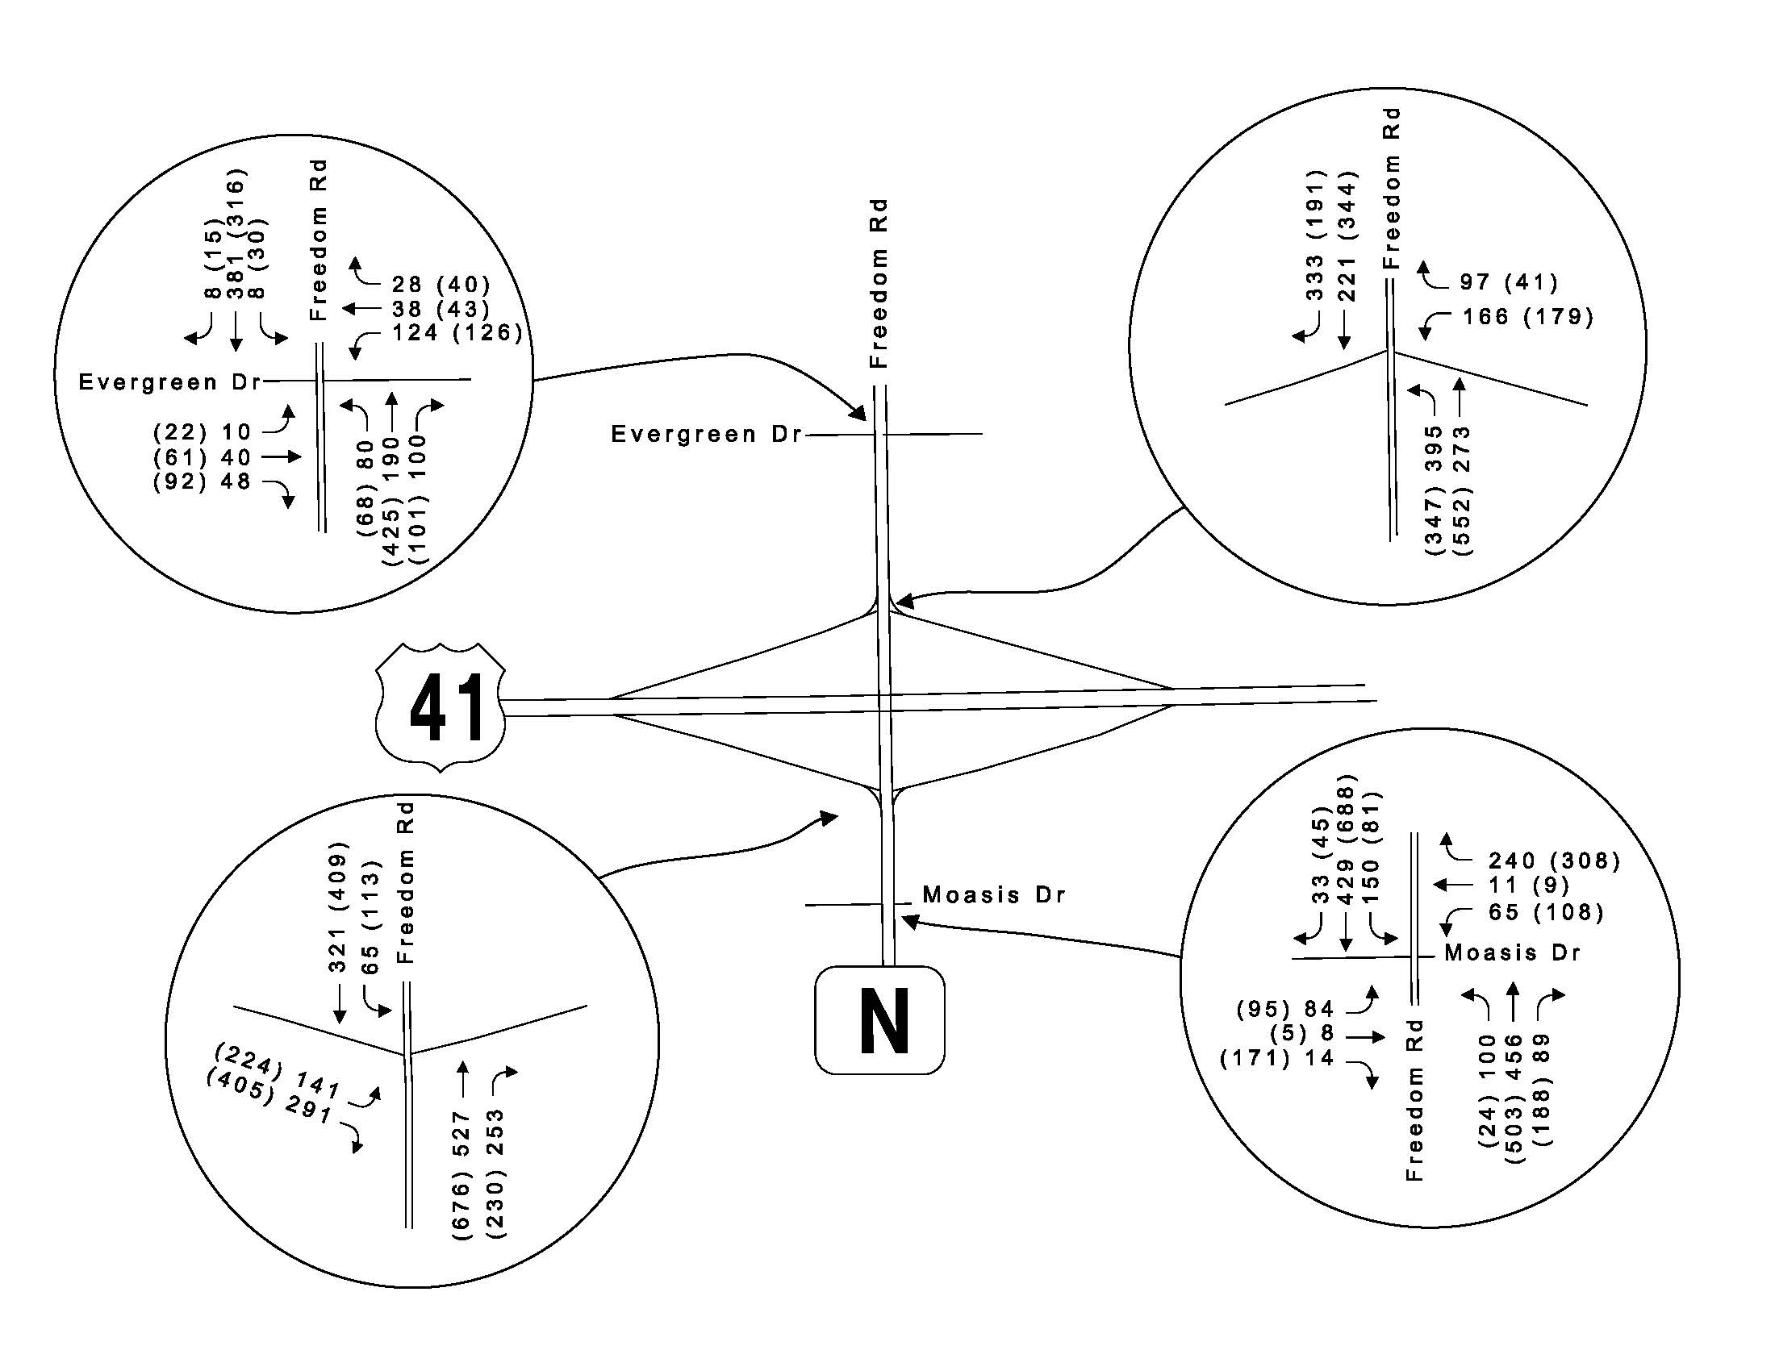

**Traffic volume differences between the updated and old 2020 traffic forecasts for US41/CTHN**

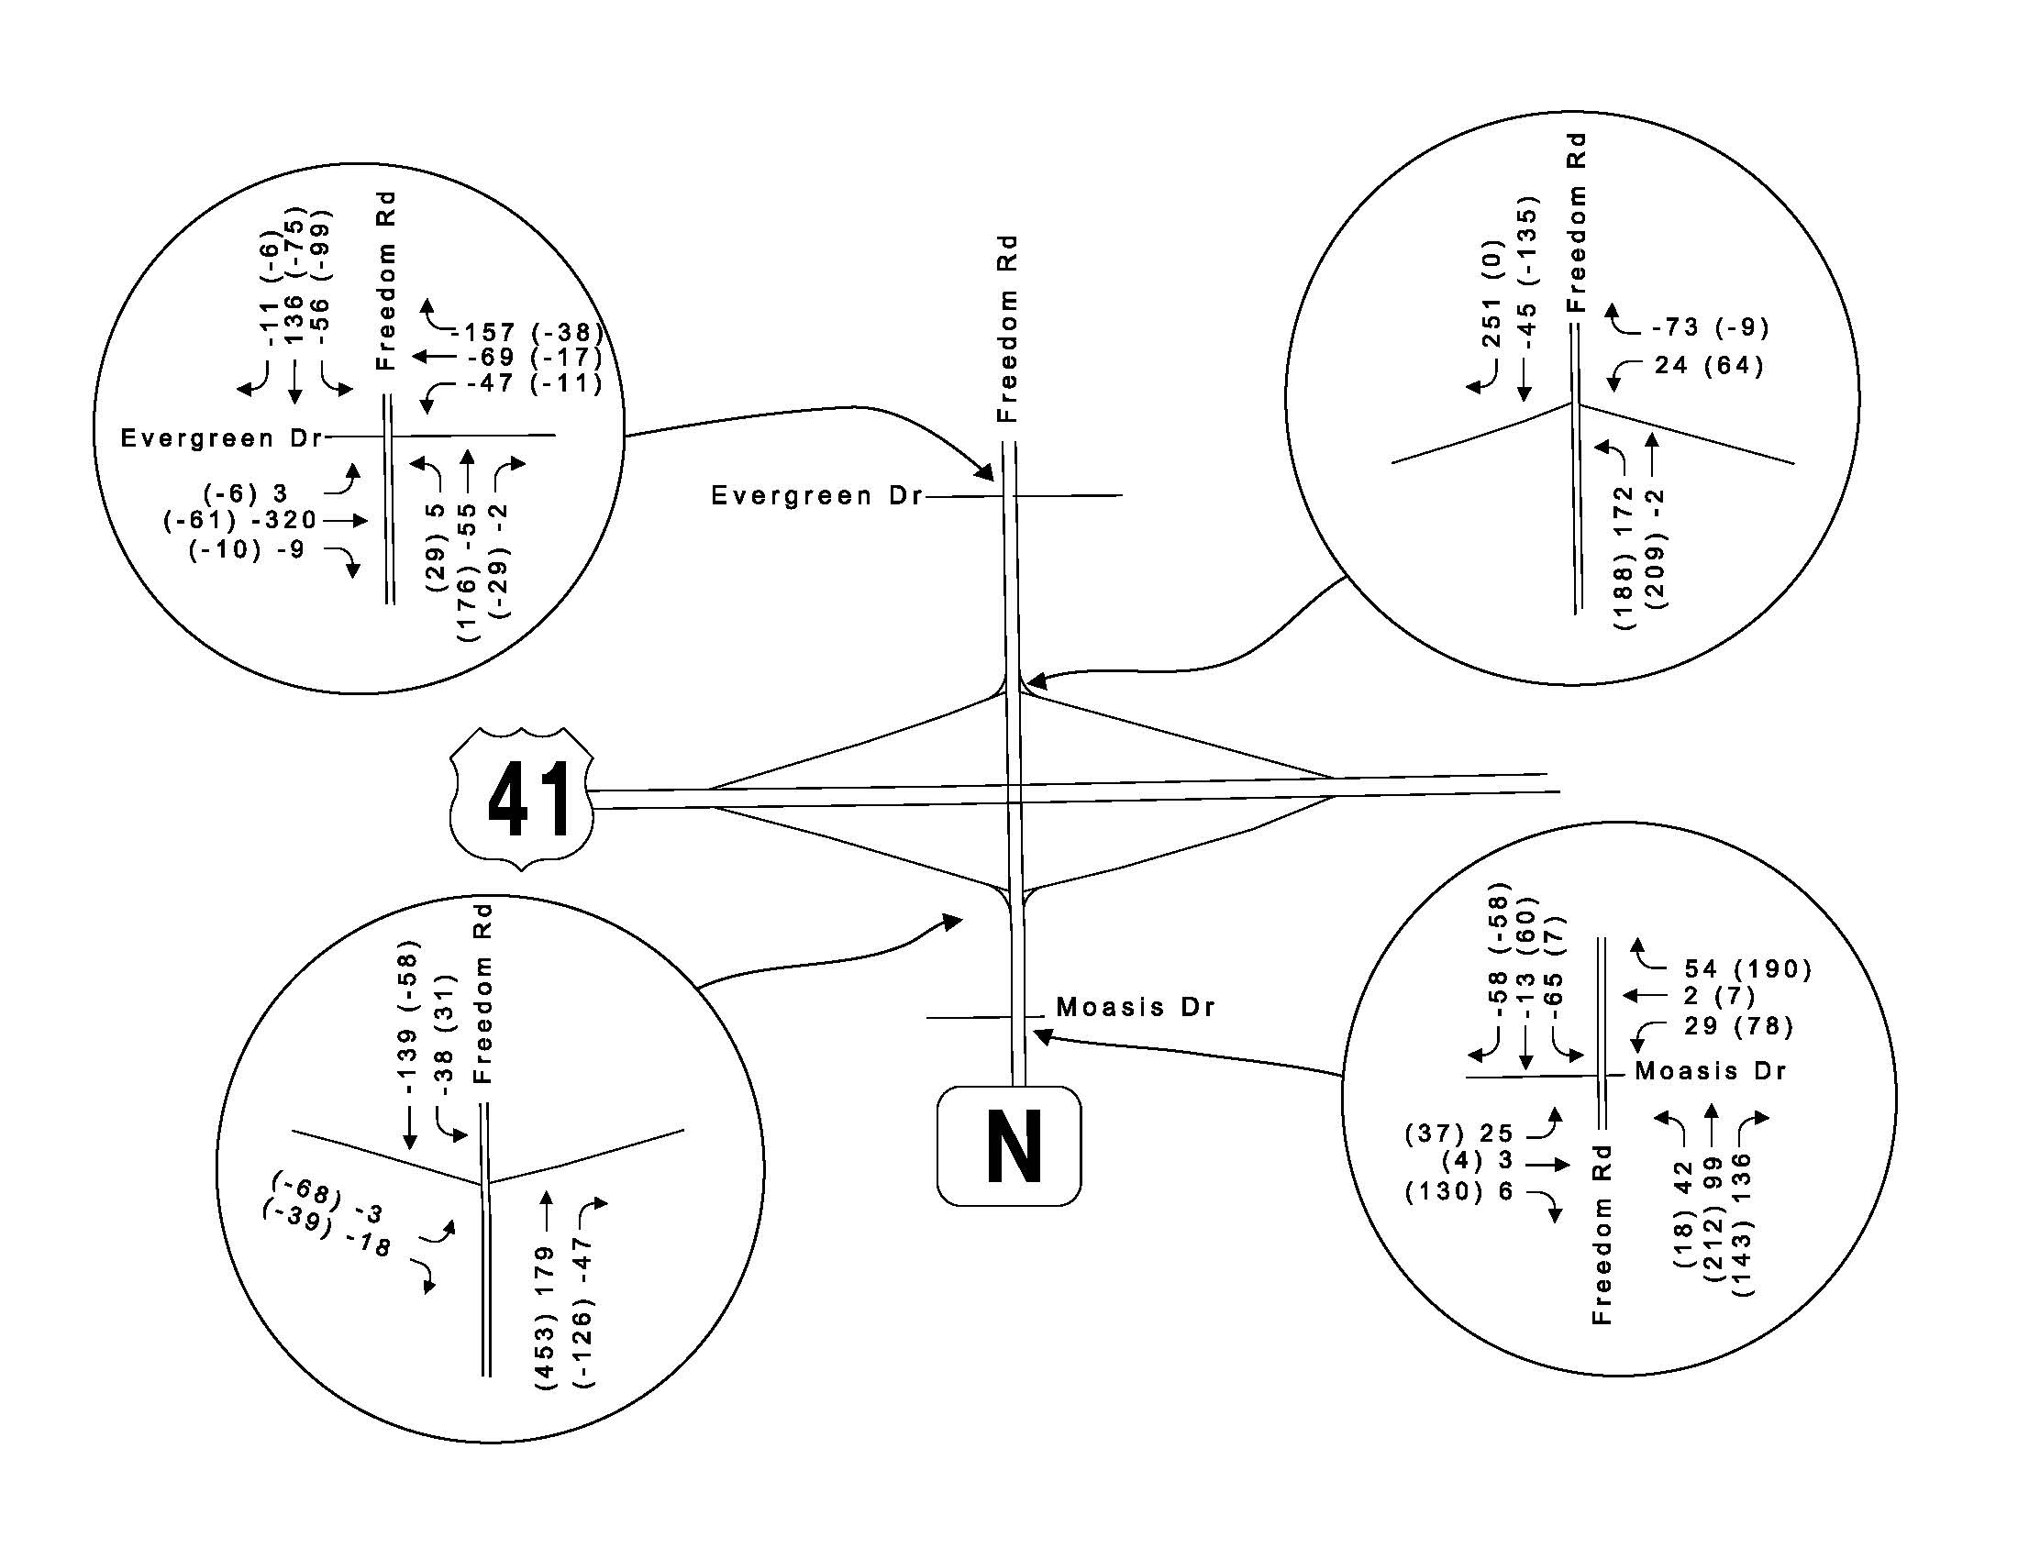

**Year 2038 traffic forecast for US41/CTH N interchange**

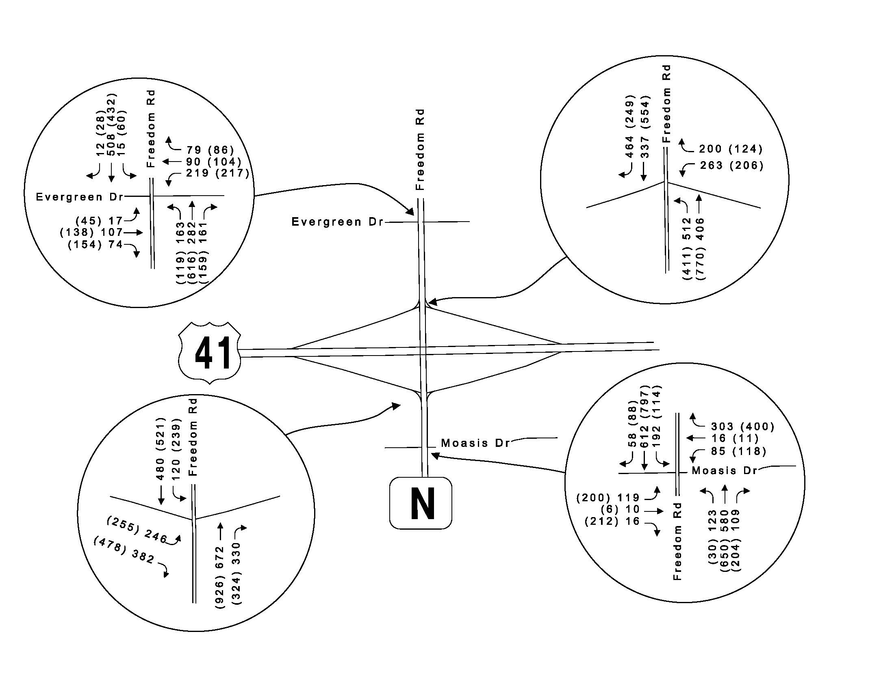

**Updated 2020 traffic forecast for US41/CTH BB interchange**

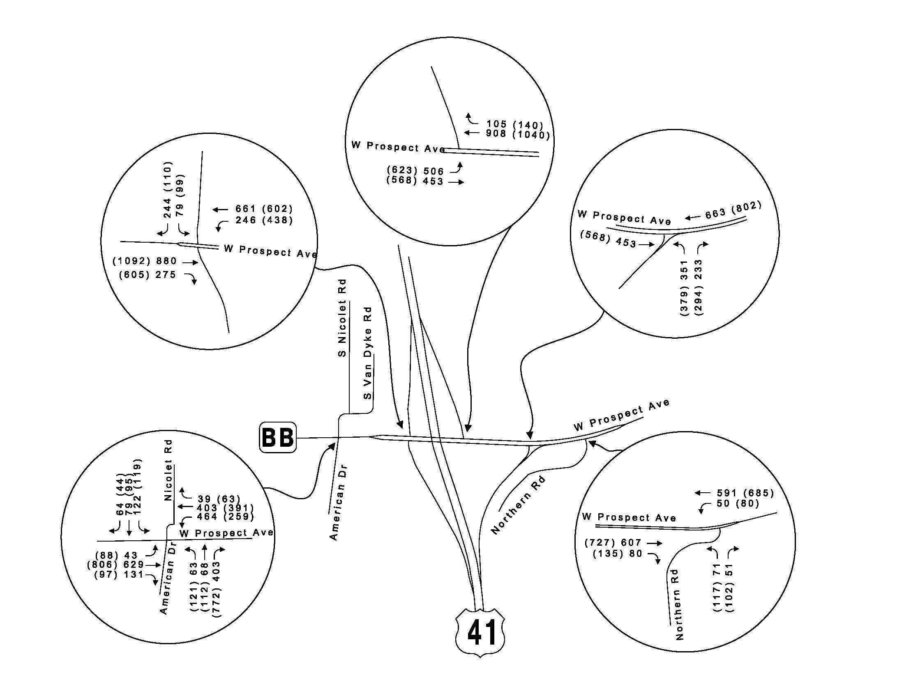

**Traffic volume differences between the updated and old 2020 traffic forecasts for US41/CTHBB**

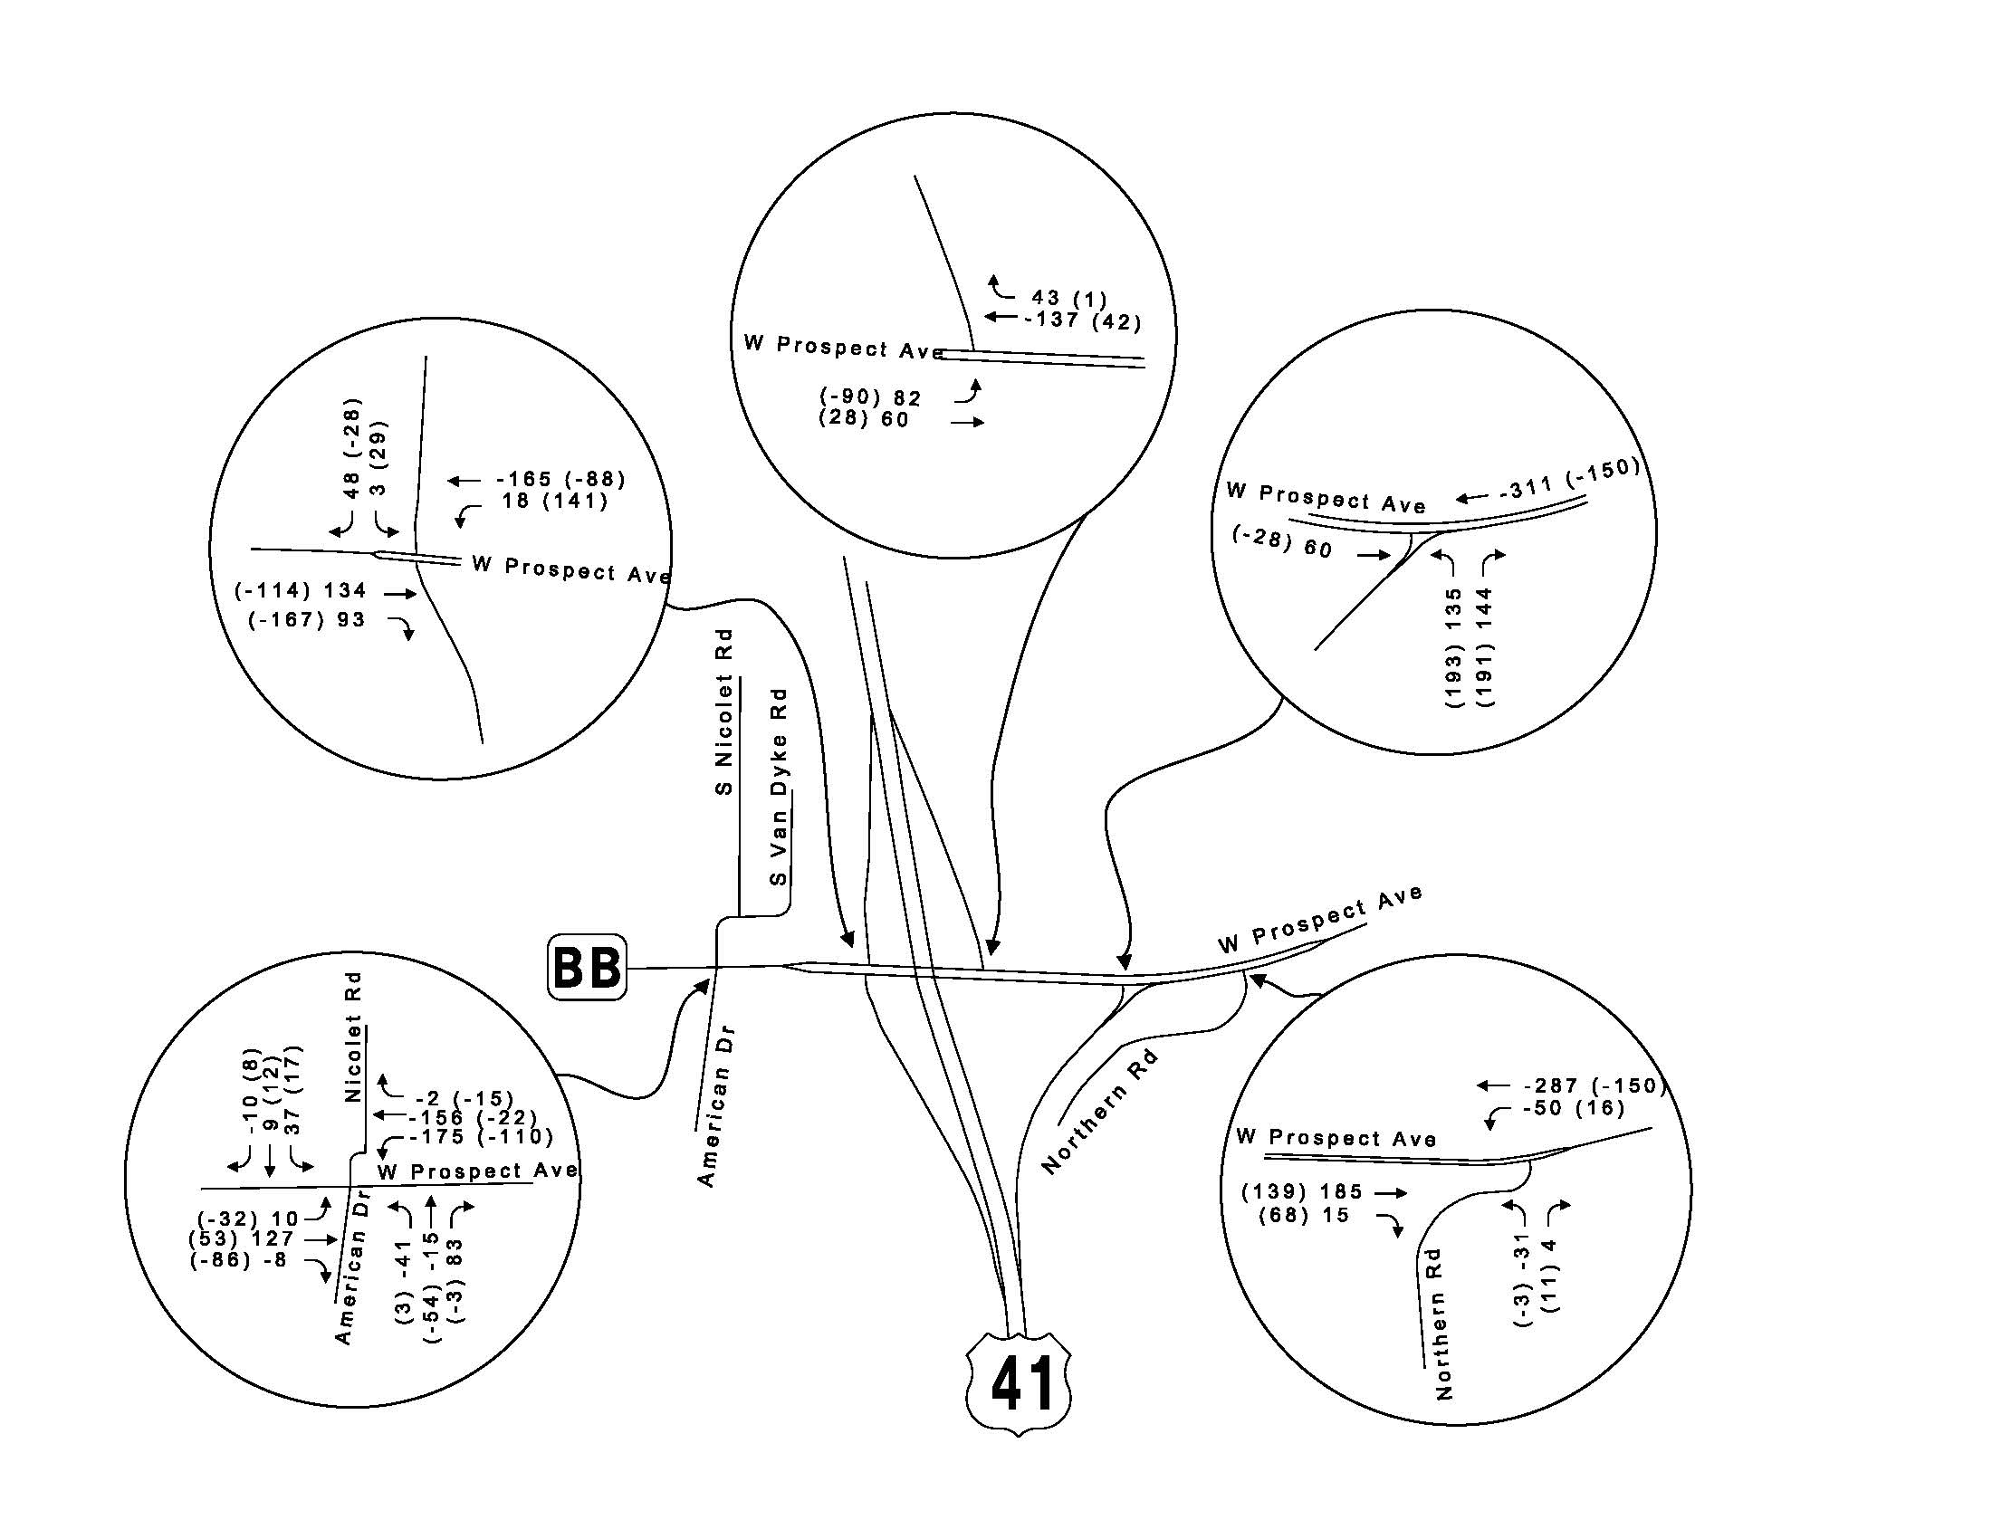

**Year 2038 traffic forecast for US41/CTH N interchange**

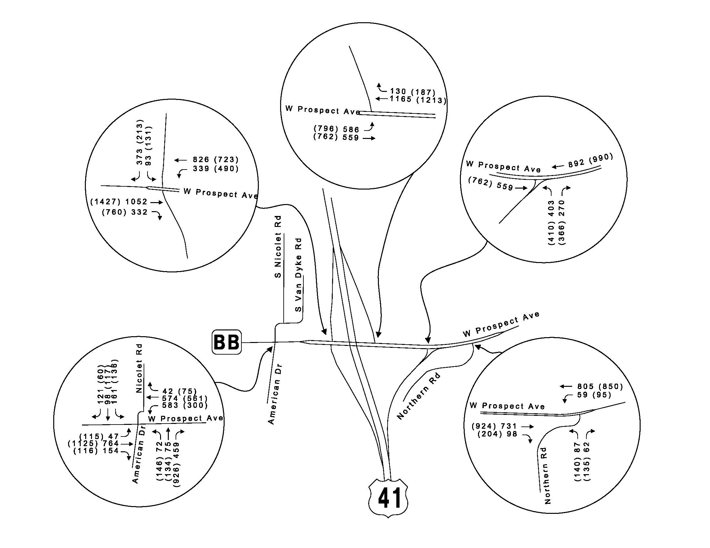

**Updated 2020 traffic forecast for US41/CTH J interchange**

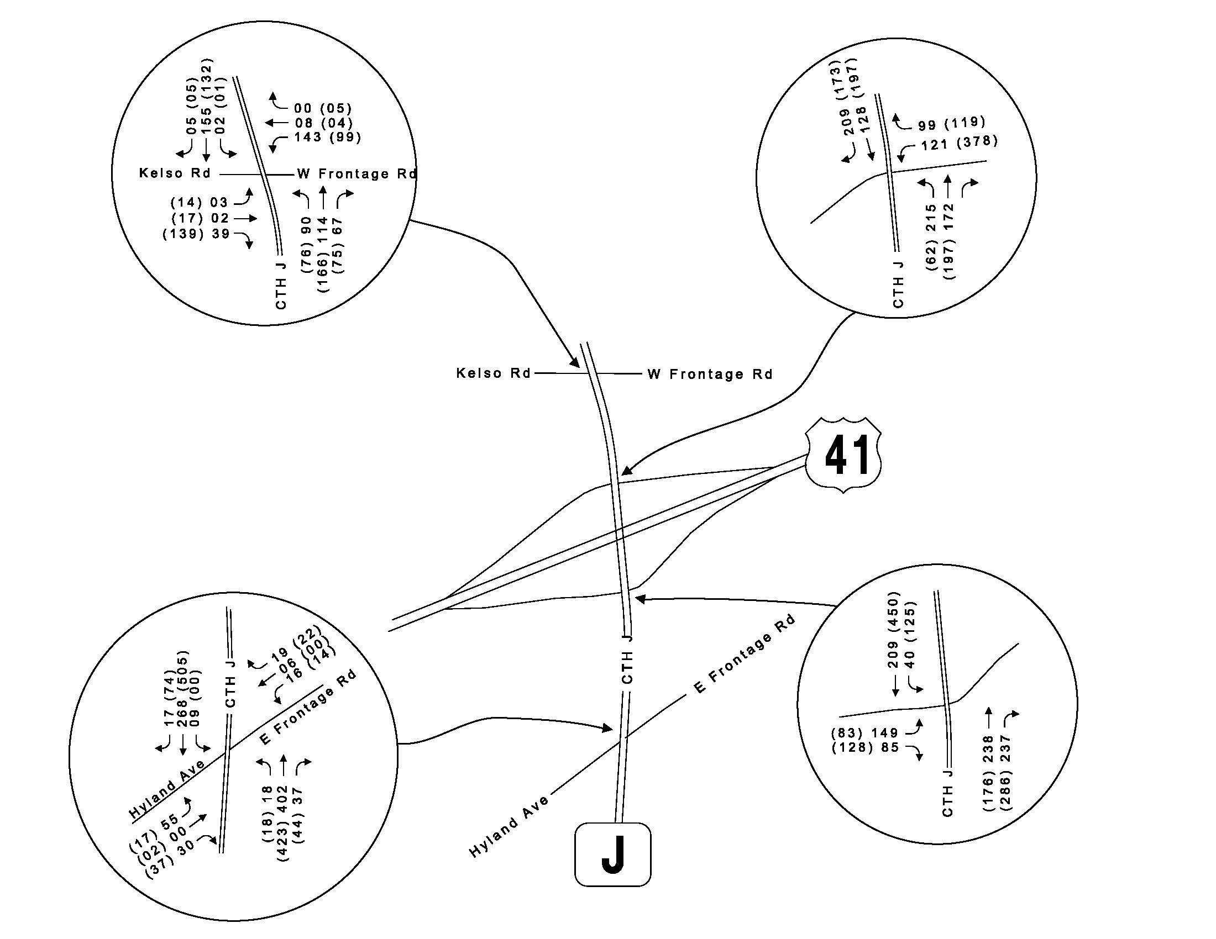

**Traffic volume differences between the updated and old 2020 traffic forecasts for US41/CTHJ**

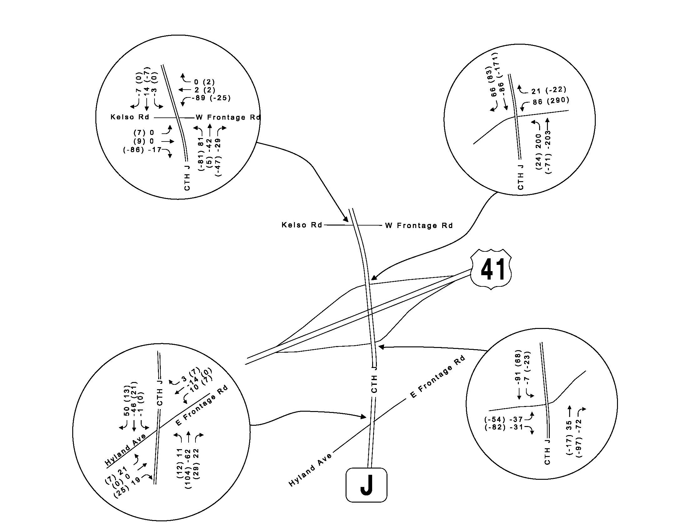

**Year 2038 traffic forecast for US41/CTH J interchange**

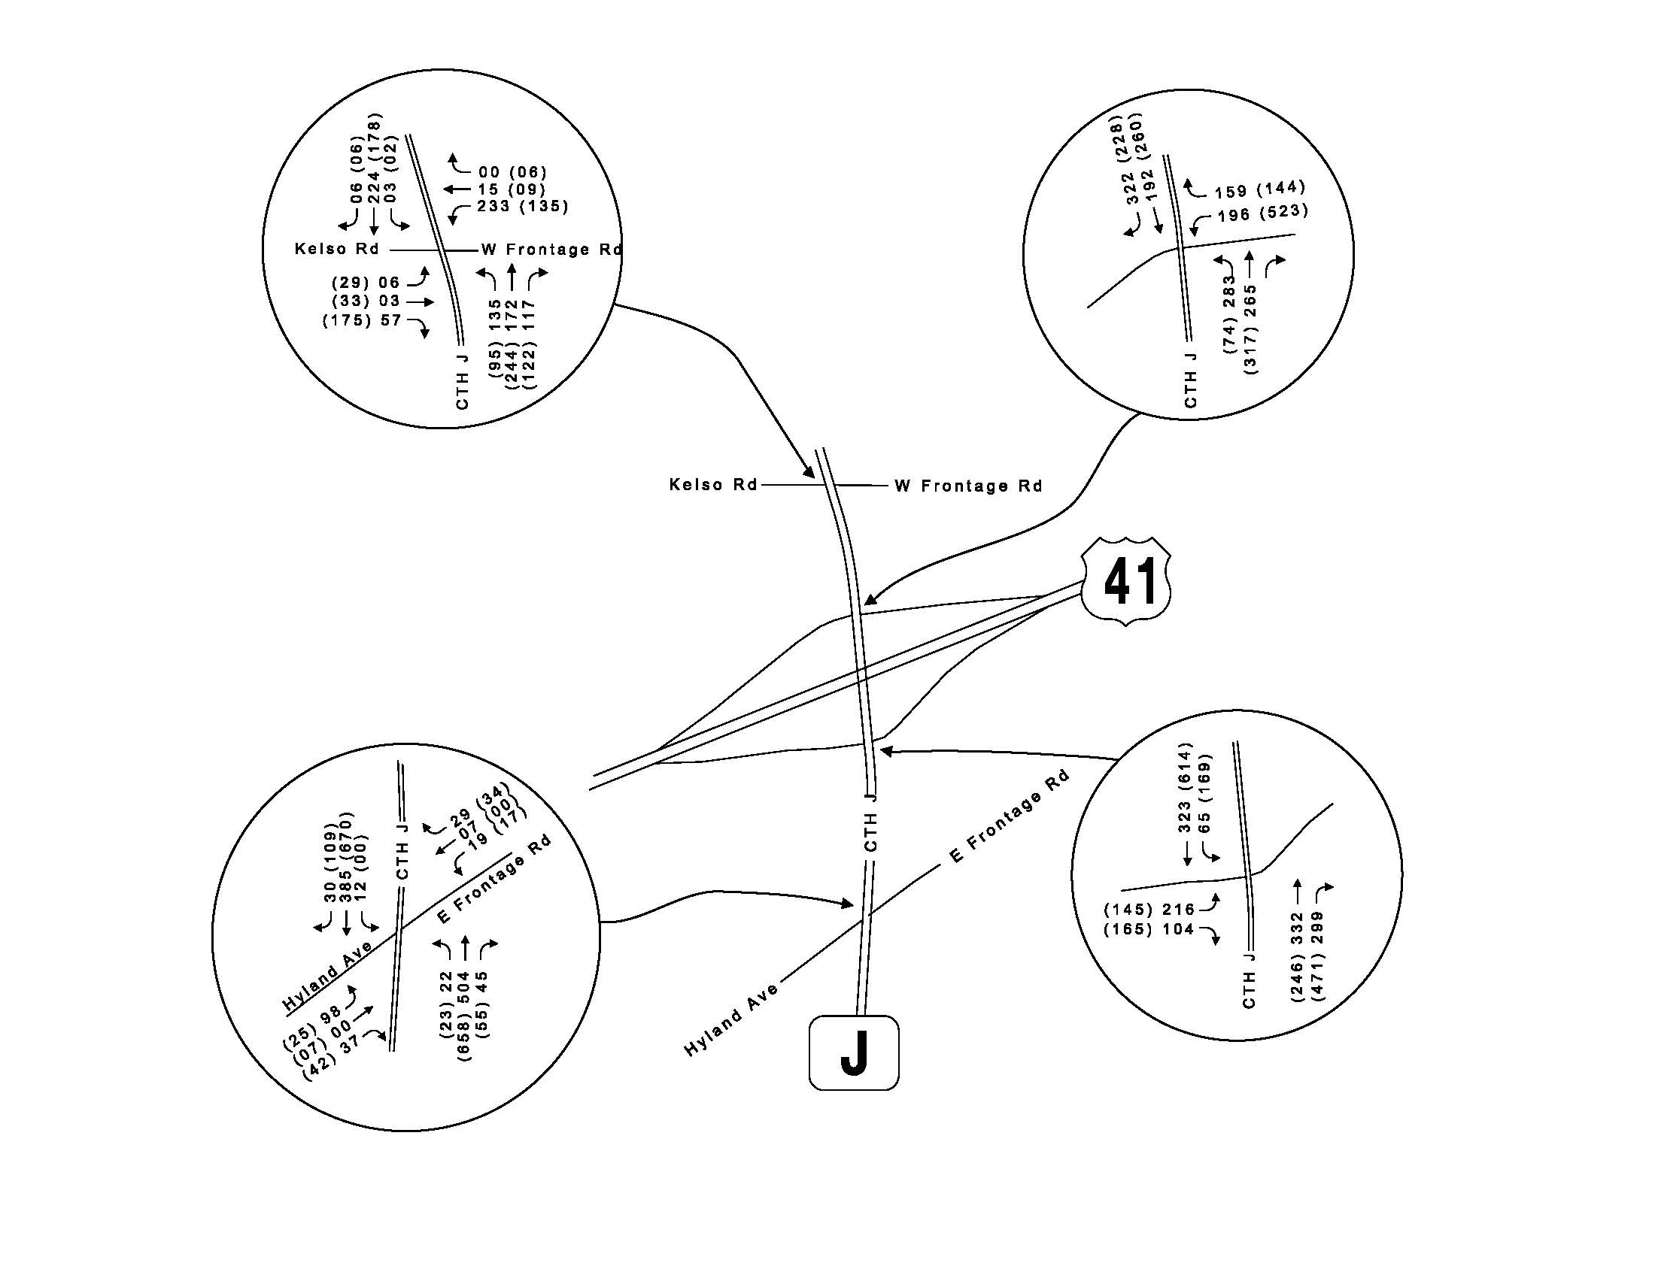

**Updated 2020 traffic forecast for US41/CTH OO interchange**

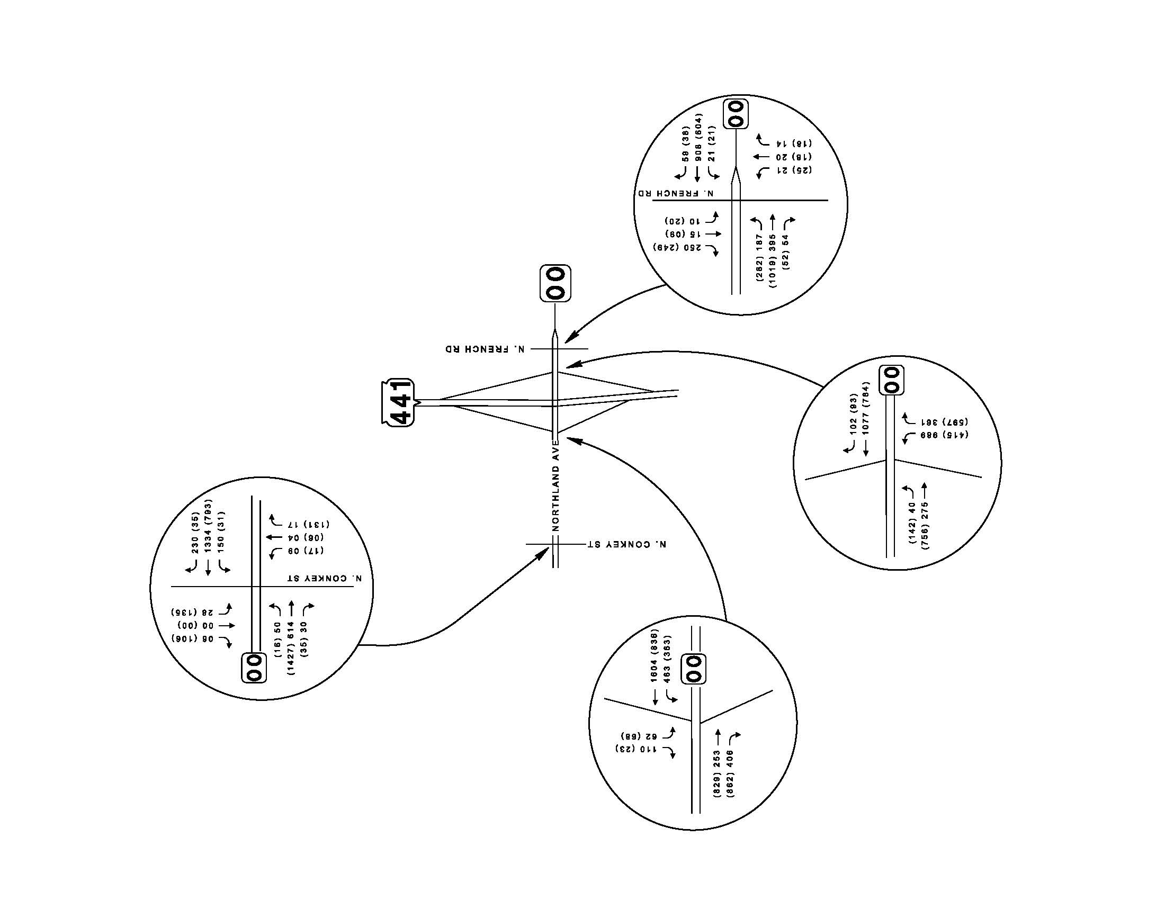

**Traffic volume differences between the updated and old 2020 traffic forecasts for US41/CTHOO**

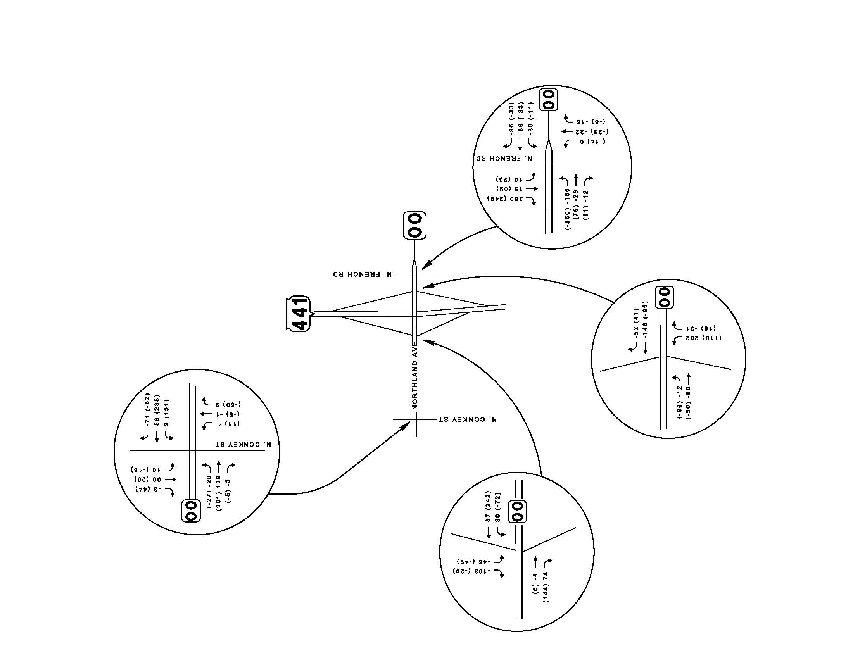

**Year 2038 traffic forecast for US41/CTH OO interchange**

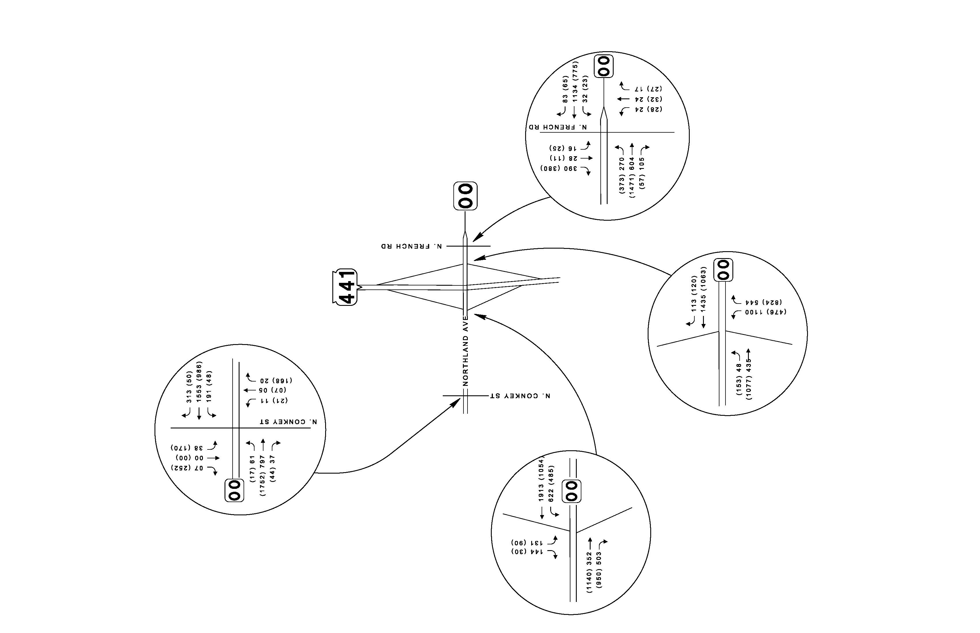

Appendix:

Synchro Outputs

Appendix:

HCS 2010 Roundabout Outputs