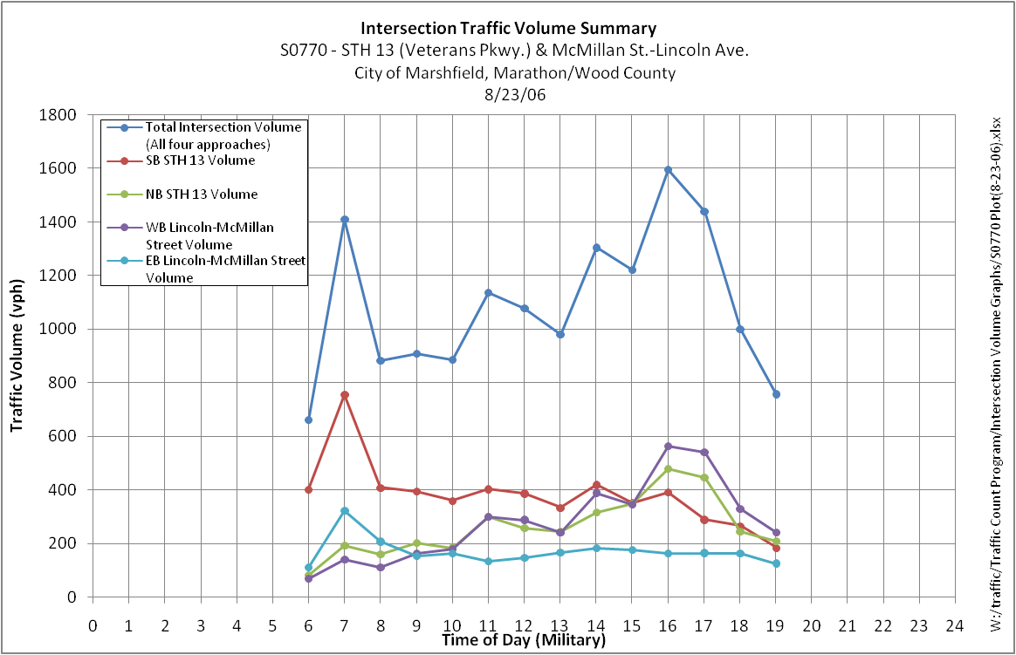

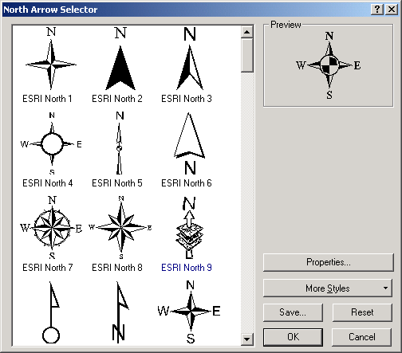

36 269 18

McMillan Street

STH 13

STH 13

Lincoln Avenue

16 63 61

14 156 22

33 342 380

Traffic Count Data – 8/23/06 (Wednesday)

**S0770** – STH 13 (Veterans Pkwy.) & McMillan Street/Lincoln

Avenue

City of Marshfield, Marathon/Wood County

**AM Peak (7:00-8:00 am)**

W:/traffic/Traffic Count Program/Peak Hour Diagrams/S0770 AM.docx



27 93 15

McMillan Street

STH 13

STH 13

Lincoln Avenue

38 119 142

53 207 39

17 232 154

Traffic Count Data – 8/23/06 (Wednesday)

**S0770** – STH 13 (Veterans Pkwy.) & McMillan Street/Lincoln

Avenue

City of Marshfield, Marathon/Wood County

**Mid-Day Peak (11:00am-12:00pm)**

W:/traffic/Traffic Count Program/Peak Hour Diagrams/S0770 Mid-Day.docx



33 105 26

McMillan Street

STH 13

STH 13

Lincoln Avenue

32 233 297

74 362 41

36 237 118

Traffic Count Data – 8/23/06 (Wednesday)

**S0770** – STH 13 (Veterans Pkwy.) & McMillan Street/Lincoln

Avenue

City of Marshfield, Marathon/Wood County

**PM Peak (4:00-5:00 pm)**

W:/traffic/Traffic Count Program/Peak Hour Diagrams/S0770 PM.docx