When you extract the wi-trimble-configuration.zip file, it will default to the C drive and create a folder structure that looks like this:

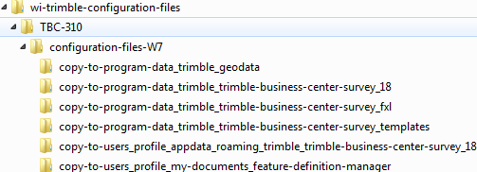

After a consultant has TBC installed on their windows 7 computer, they should be able to follow the directions written into the name of these directories to copy their contents into the proper locations where they should then have access to the WisDOT configuration files.

Note that WisDOT has now moved on to windows 7 and no longer support similar configurations files for Windows XP installs of TGO or TBC.