Creating a WSI File in Trimble Business Center (TBC)

March, 2018

1. Determine where to put the WSI.ocexp file

In Trimble Business Center,

Click the File tab ->Options ->File Locations (below). Note the location of Custom Export Format Definition folder

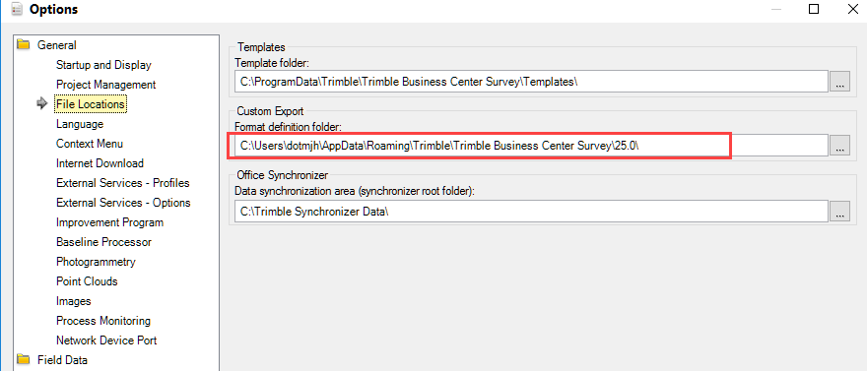

2. Copy attached WSI.ocexp file into the same folder shown above.

* For this example, the file location is: C:\Users\dotmjh\AppData\Roaming\Trimble\Trimble Business Center Survey\25.0\
* The username (dotmjh) and folder number (25.0) will vary depending on the username and version of TBC being used.



3. Open Trimble Business Center (TBC), highlight the points that you wish to export.

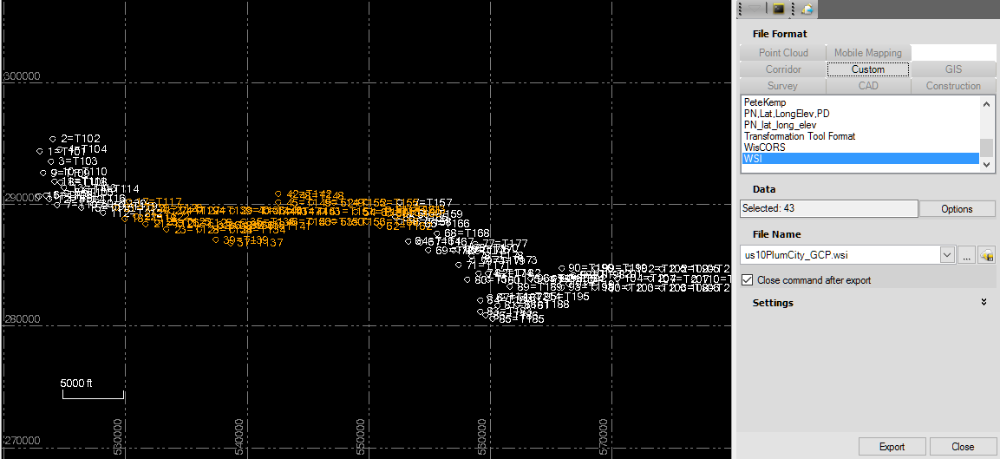

4. Home Tab-->Export-->Custom Tab-->WSI

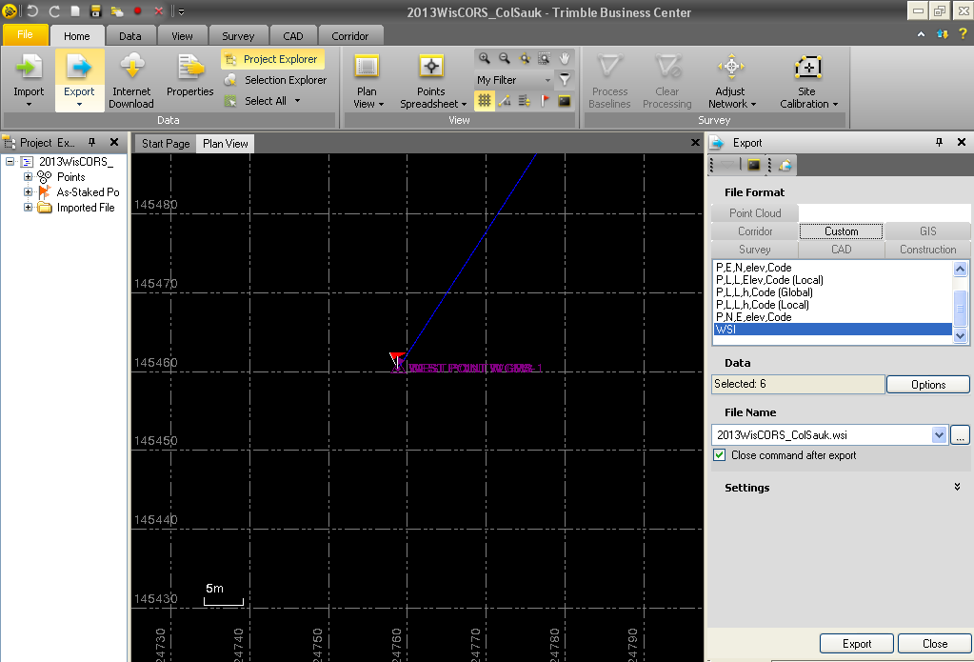

5. Verify that the export location is correct.

6. Click Export tab

7. Navigate to newly created WSI file and double click. If the file does not open, it probably needs to be ‘Associated’; all examples below are associated/opened with Notepad, but any text file editor will work.

The newly created WSI file should look something like this.

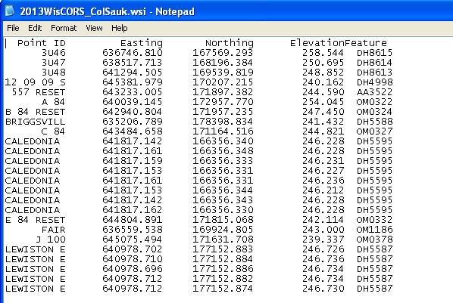

8. Paste the header information in the attached Header.WSI over the first line of your newly created WSI. This will delete the old top line.



A. Open the above Header.WSI file

B. Select All of the text as shown below with <Ctl A> on keyboard or *Edit*-->*Select All* in menu tabs.

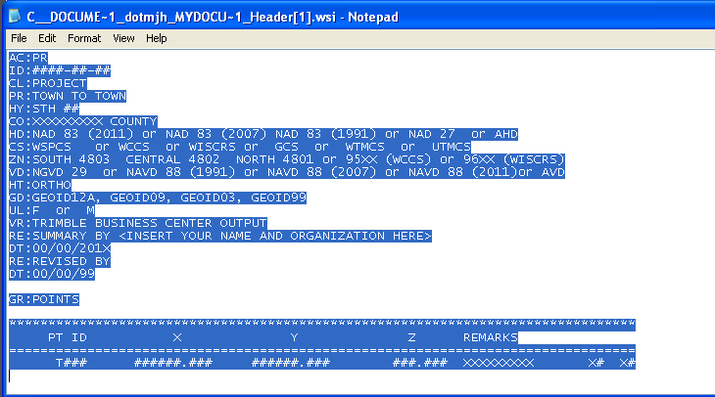

C. Copy and then paste all text into newly created WSI.

D. Highlight the top line of the old header prior to pasting the new header.

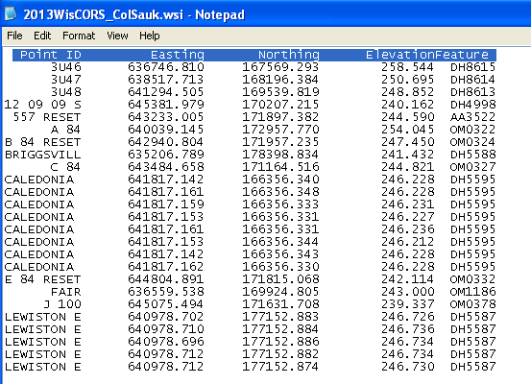

9. After pasting, you should get something like this

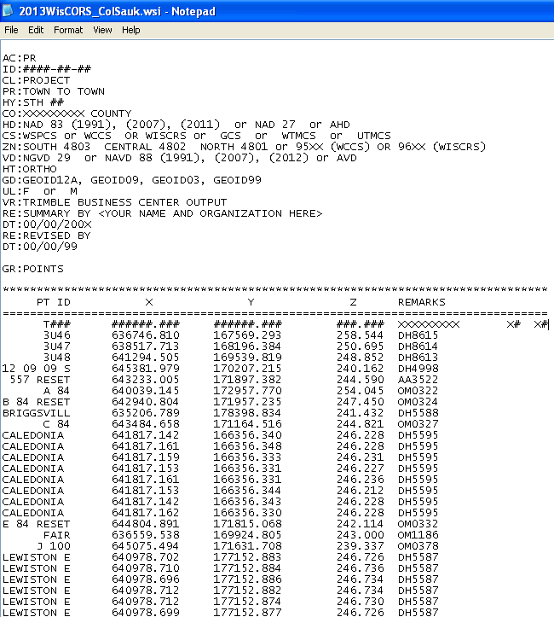

10. The decimal points of the data should line up under the decimal points of the T### line. Point IDs are right justified, and are limited to 10 characters, you will have to edit point names that are longer.

11. When data is lined up correctly, delete the entire T### line.

Also see final example in step 13.

12. CORRECTLY AND COMPLETELY FILL OUT THE METADATA IN THE HEADER

The final product should look something like this.

You can create additional groups by copying and pasting the GR:POINTS line and subsequent header IN NOTEPAD (otherwise the columns will not line up).

The Final Product should look something like this....

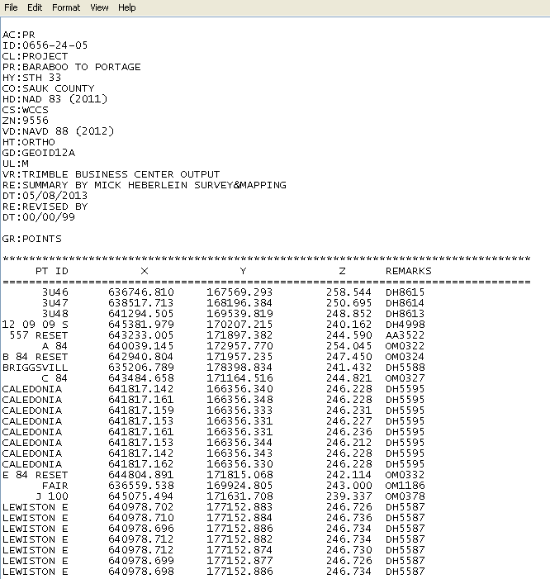

Note: 4 digit number only