USH 45 NB

Milwaukee Area:

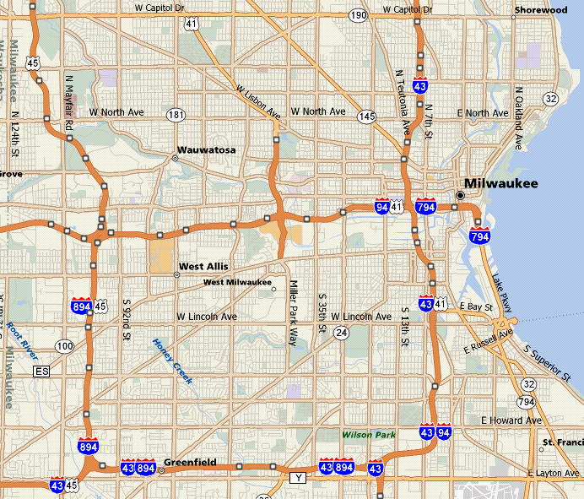

Adhesive Area

Project limits

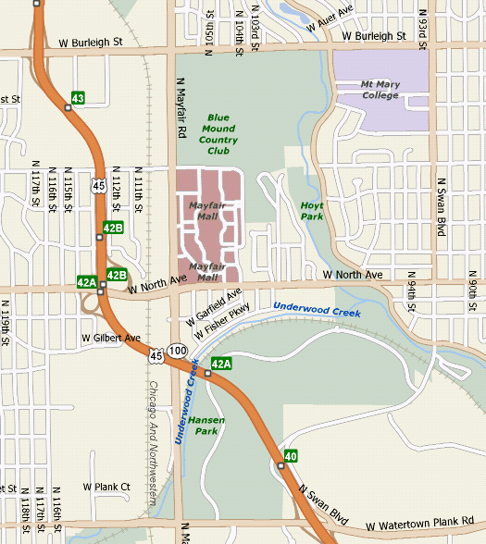

Adhesive Area

STH 16/60

Dodge County:
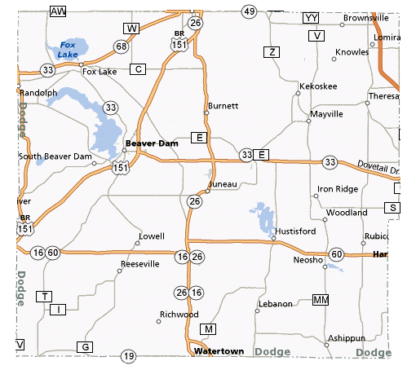

Project limits

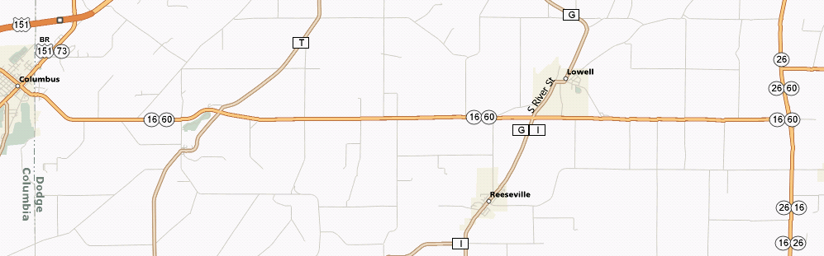
Adhesive
No Adhesive
No Adhesive

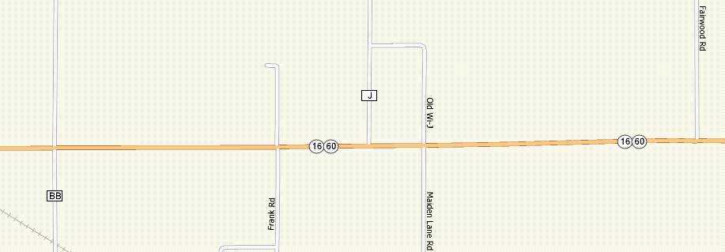
Adhesive

Waukesha County:
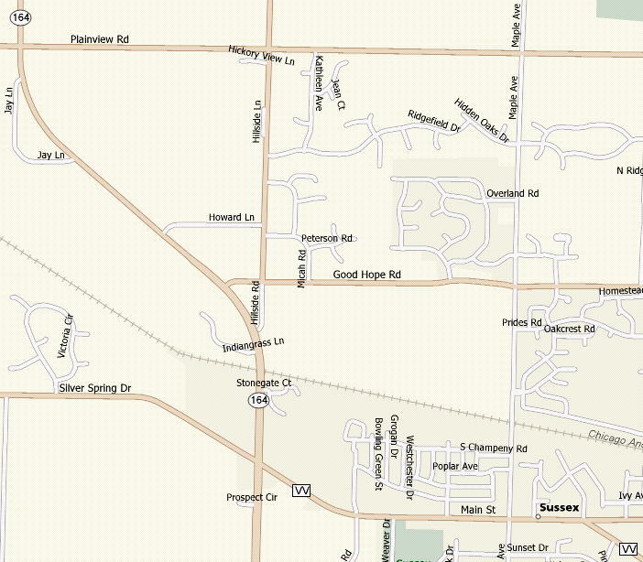
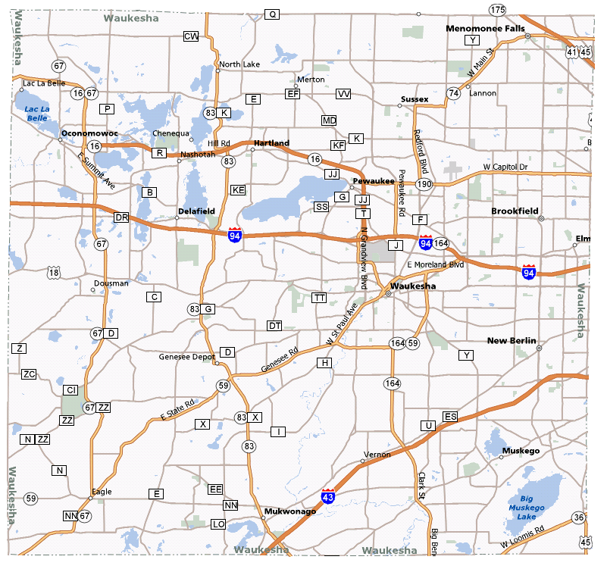
Project Area

Project limits
Adhesive area

