Locating I-94 EB Longitudinal Joint Adhesive Test Sections

Crafco Pavement Joint Adhesive
STA 6 to STA 60 (5400 feet)
This should be the start of construction
Waukesha CL to just after North Golden Road overpass

There’s a sign and a maintenance crossover at Waukesha CL:
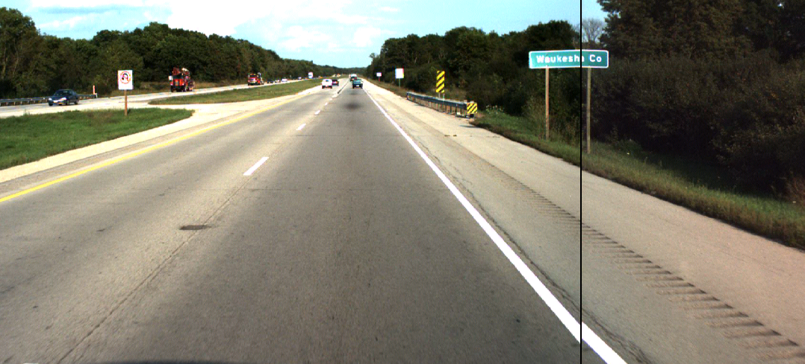

Amoco Oil 64-22 asphalt cement
STA 60 to STA 113 (5300 ft)
Just after North Golden Road overpass to approx. 200’ west of STH 67/Exit 282 sign (also just after Dousman Rd. overpass)

There’s a maintenance crossover near Exit 282:
