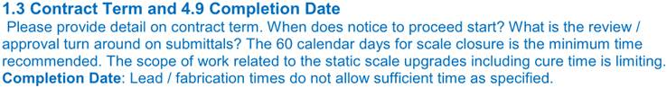

The contract terms have been updated to reflect that the start time begins upon a fully executed contract.  There is a new construction completion date of June 1, 2019 to allow for enough time for all of the submittals/procurement/fabrication necessary now that the entire static scale is getting replaced.

cid:image003.png@01D41CDD.E418AEC0

Enclosures within the SWEF building may be reused provided they are of sufficient size to house the new electronics.  The same holds true for the Ramp WIM cabinet.

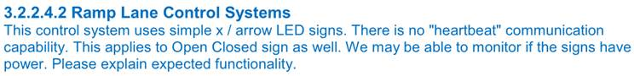

The heartbeat communication statement has been removed.  In addition, section 3.2.2.4.2 has been revised to install 2-way signage for the lane control to allow operators to see if the LCS sign is functioning properly.  No feedback is being required for the OPEN/CLOSED signs.

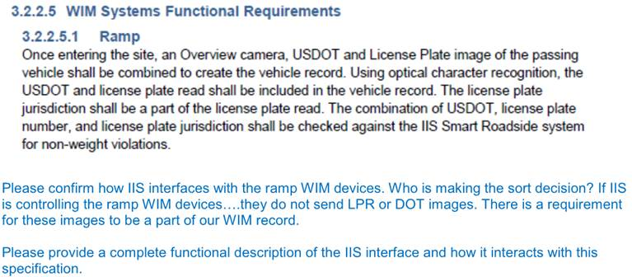

Any mention of IIS has been removed from the spec.  It is expected that the vendor would now provide credential screening.  Any 3rd party software/systems will not be added until after the COT is complete.

cid:image005.jpg@01D42020.18A4E8D0

The enforcement camera system section has been removed

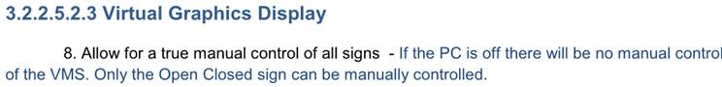

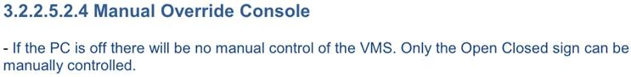

No manual control of the VMS is required.  The intention of this language was for the operators in the SWEF building to be able to manually direct a truck (via the LCS signage) as desired while the site is open.  When the PC is off, the Open/Closed messages should default to Closed.

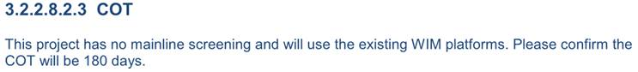

The COT will remain at 180 days.

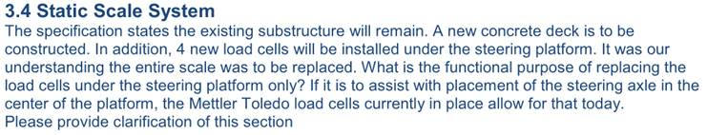

The static scale will now be replaced.  The existing scale pit will remain.

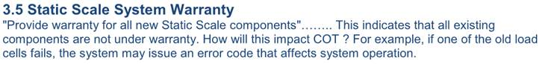

The static scale will now be replaced, so this will not be an issue.