

#### Division of Transportation System Development

#### DOT Briefing Paper

##### Kenosha SWEF Sole Source Emergency Project

##### November 2010

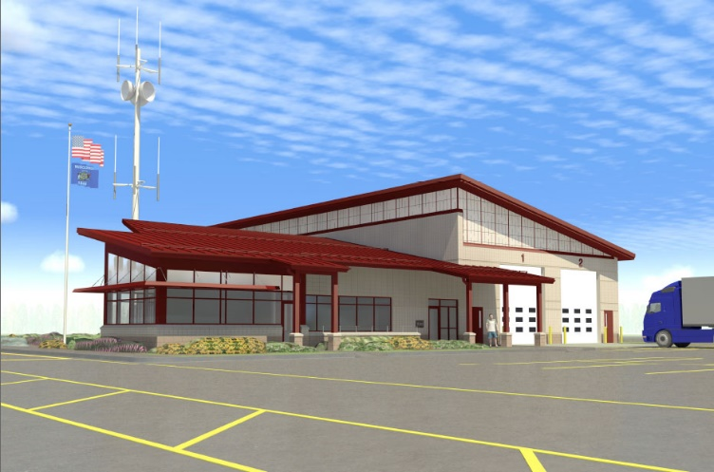

**Existing conditions & current situation**

* + Justify Emergency project

**Proposed Project**

* + include scale fixes while site is closed
  + Recommend new scale vs rehab
    - SEH Report
    - All 4 decks
    - New load cells – include current load cell age (2003?)
    - Hot dipped galvanized
    - Lightening protection
    - Less down time
    - Full warranty
    - Total cost difference
    - Any info on life cycle?
  + Include LPR & USDOT Readers

**Estimate & Schedule**

**Risks**

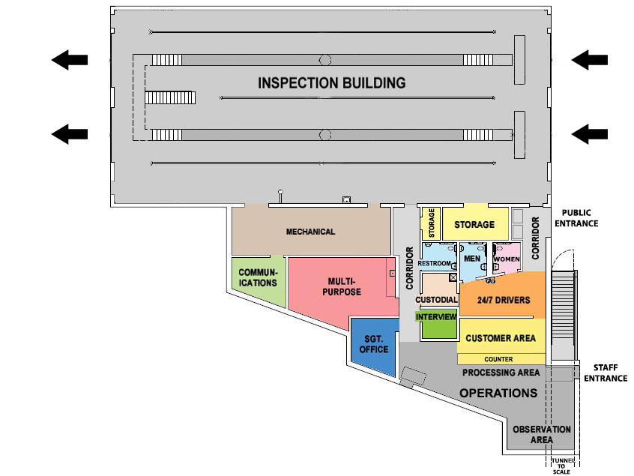

**Contact Info:**

For more information on WisDOT Freight or Roadside Facility initiatives:

Dan Mulder

Freight and Roadside Facilities Chief

[Daniel.Mulder@dot.wi.gov](mailto:Daniel.Mulder@dot.wi.gov)

608-266-3471

For specific information on the WisDOT SWEF Program:

LeAnna Wall, PE

Roadside Facilities Engineer

[LeAnna.Wall@dot.wi.gov](mailto:LeAnna.Wall@dot.wi.gov)

608-266-8665