Adaptive Equipment Types

Examples of adaptive equipment requirements or restrictions that may be recommended for specified physical impairments are provided below.

|  |  |
| --- | --- |
| **Restrictions to Accommodate Physical Impairments** | |
| **Physical Ability** | **Adaptive Equipment/Restrictions** |
| **Coordination  Includes all disorders that limit the driver’s ability to coordinate motion of bodily members. All body members are present, but cannot be adequately controlled.** | * Hand-operated controls (brake and accelerator) * Low effort power steering * Spinner knobs or cuffs (grip on steering wheel) * Left foot accelerator * Steering column mounted dimmer and horn * Right side turn indicator * Electrical lifts and transfer boards * Automatic transmission * Pedal extensions |
| **Range of Motion  Disorders that limit the ability to reach and operate various components of the automobile** | * Hand-operated controls (brake and accelerator) * Low effort power steering * Spinner knobs or cuffs (grip on steering wheel) * Left foot accelerator * Steering column mounted dimmer and horn * Right side turn indicator * Automatic transmission * Pedal extensions * Seat cushions * Prosthetic restrictions |
| **Strength of Motion  Disorders that limit the strength and endurance of the driver.** | * Special mirrors * Mechanical directional signals * Power or low effort steering * Automatic transmission * Spinner knobs * Power brakes |

The Department does not recommend specific vendors/companies nor does the examiner recommend types of adaptive equipment for a customer’s vehicle. Customers should work with their physician, occupational therapist, VA or other health care provider.

The Department advises drivers to get operating instruction from the company that installed the equipment and practice driving with the equipment on their vehicle before their road test.

Homemade equipment is not acceptable; all adaptive equipment must be professionally installed.

DMV cannot restrict an Instruction Permit (REGI), only the physician can add restrictions to an Instruction Permit (REGI). Contact to DMED for assistance on REGI restrictions when needed.

In cases of decreased vision, examples of restrictions that may be recommended. They include, but are not limited to: corrective lenses; daylight driving only; and right outside rearview mirror required.

Examples of restrictions that may be recommended for loss of mental function include, but are not limited to: area restriction ( __ mile radius of driver’s home); road restriction (no driving permitted on ___ street/avenue/route − must be specific); road class restriction (e.g., no freeway driving); speed limit restriction (no driving on roads with posted speed limit of __ mph or higher); driving permitted only within ____ city/village limits; driving not permitted within ___ city/village limits; and driving permitted only between the person’s residence and a named destination (e.g., place of work, doctor’s office, etc.).

Restrictions applied by a DMV examiner must be enforceable. A law enforcement officer must be able to determine if the restriction on the license is being observed. This rule out restrictions such as “must take medication” or “must check blood sugar before driving”.

If adaptive equipment restrictions are to be applied, the equipment must be in place at the time a driving examination is performed. The application ofrestricted driving privileges in such cases is contingent upon successful completion of the skills test demonstrating proper use and vehicle control with the equipment installed.

**Images of Adaptive Equipment**

**Mirrors**

**20/20 extended rearview mirror and extended outside mirror are used for drivers with vision or neck mobility issues**

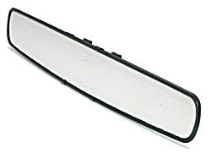

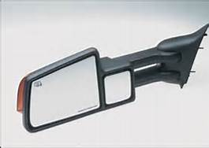

**Steering Knobs**

**Steering Knob with hand controls (brake/gas); Hand controls allow a driver with impaired leg function to drive a vehicle by activating the brake and accelerator with single hand-operated lever.**

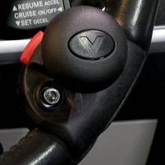

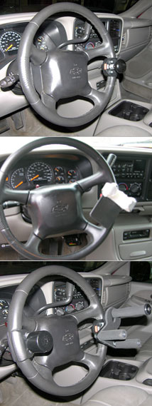

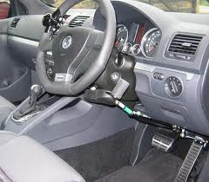

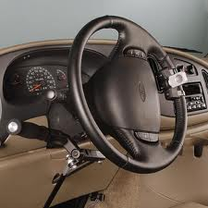

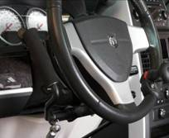

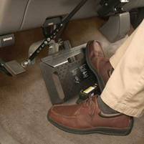

**Brake/gas pedal extension for drivers who are not of average height**

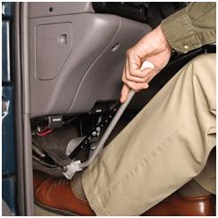

**Emergency brake control for drivers who have leg mobility issues**

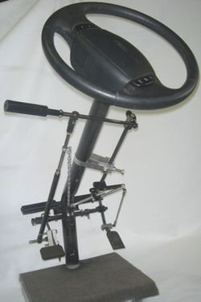

**Pre-Install of push/pull hand controls for customers with leg mobility issues**

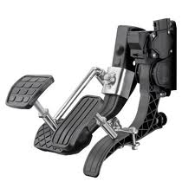

**Pre-Install of extension brake/gas pedal for drivers who are not of average height**

**Wheel Chair accessible van with complete hand controls.**

